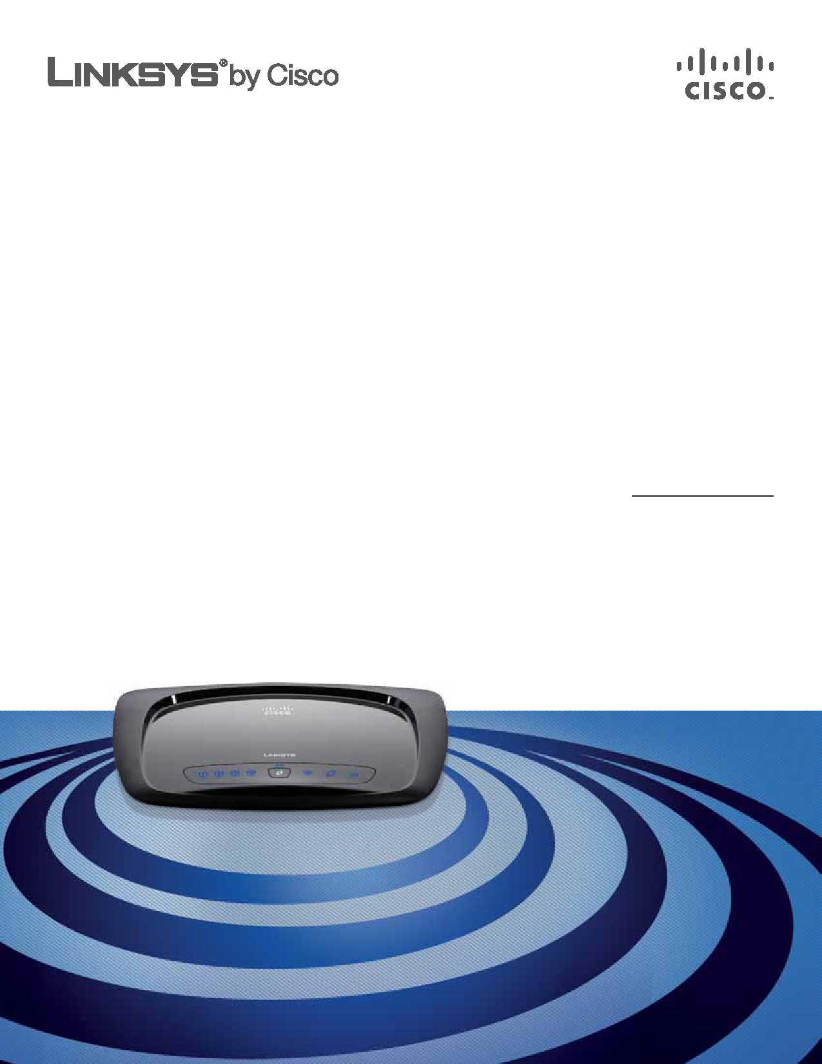
USER GUIDE

Wireless-N Home Router

Model: WRT120N

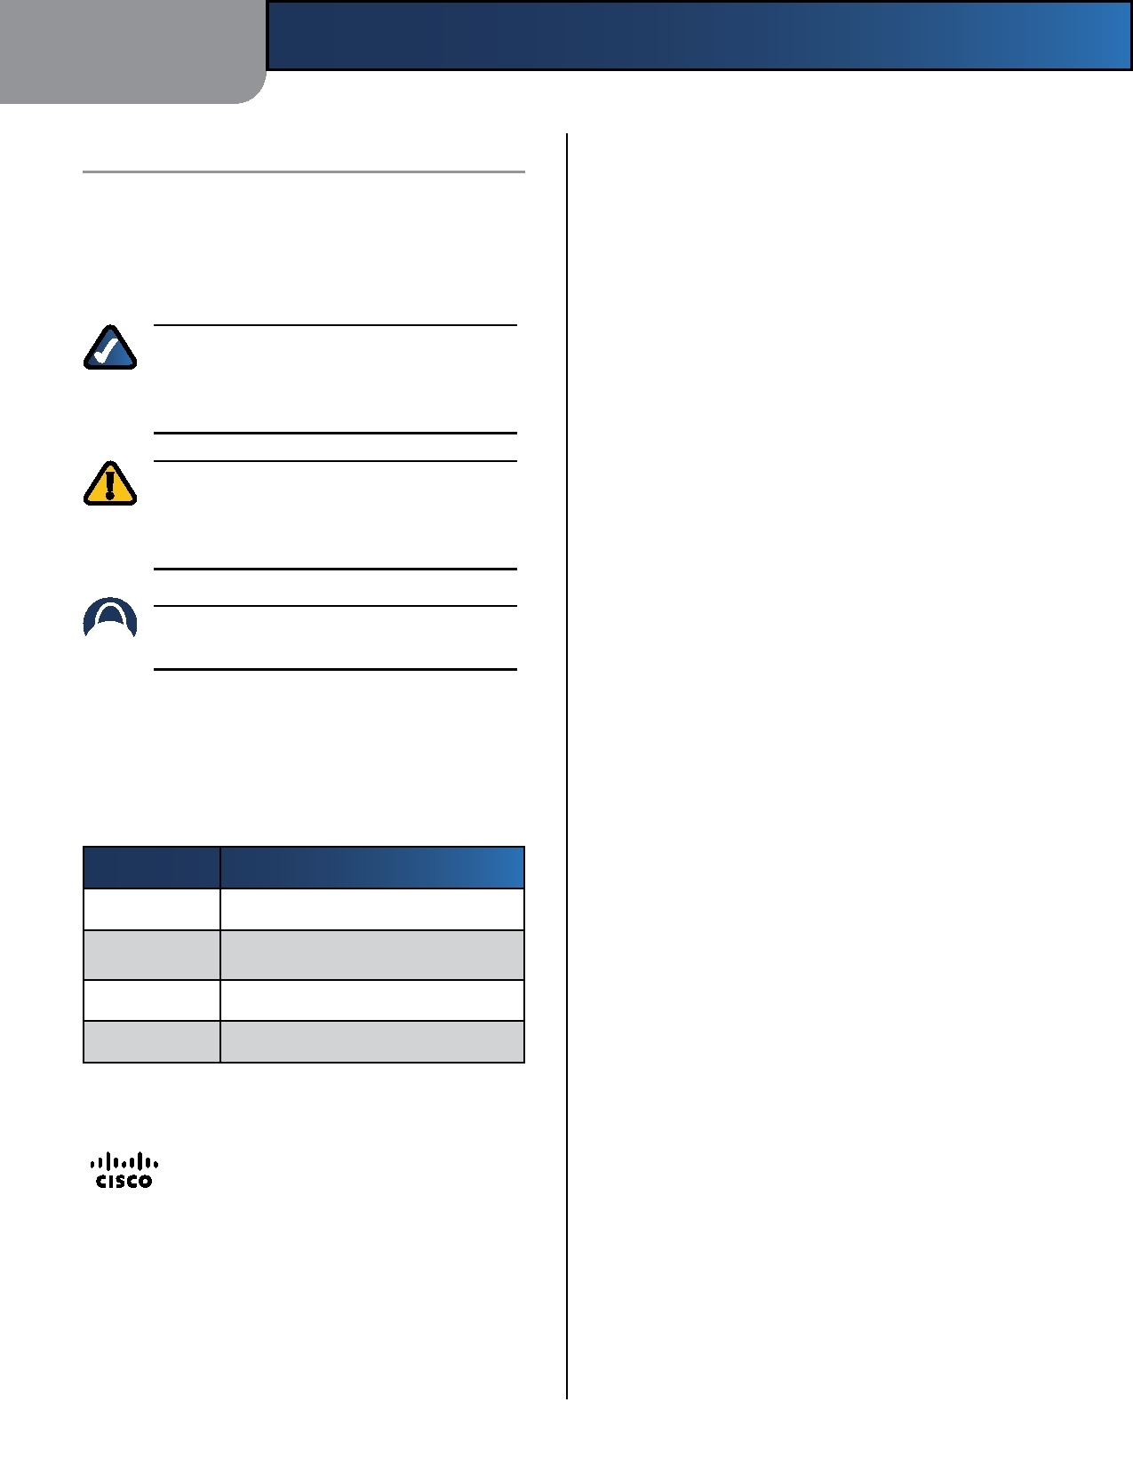

About This Guide

Icon Descriptions
While reading through the User Guide you may see
various icons that call attention to specific items. Below is
a description of these icons:

NOTE: This check mark indicates that there is
a note of interest and is something that you should pay special attention to while using the product.

WARNING: This exclamation point indicates
that there is a caution or warning and it is something that could damage your property or product.

WEB: This globe icon indicates a noteworthy
website address or e-mail address.

Online Resources
Website addresses in this document are listed without
http:// in front of the address because most current web browsers do not require it. If you use an older web browser, you may have to add http:// in front of the web address.
About This Guide

Resource

Linksys

Linksys
International

Glossary

Network Security

Website

www.linksysbycisco.com

www.linksysbycisco.com/international

www.linksysbycisco.com/glossary

www.linksysbycisco.com/security

Copyright and Trademarks

Linksys, Cisco and the Cisco Logo are registered trademarks or trademarks of Cisco Systems, Inc. and/or its affiliates in the U.S. and certain other countries. Other brands and product names are trademarks or registered trademarks of their respective holders. Copyright © 2009 Cisco Systems, Inc. All rights reserved.

Wireless-N Home Router i


Table of Contents

Chapter 1:
Product Overview 1
Front Panel. . . . . . . . . . . . . . . . . . . . . . . . . . . . . . . . . . . . . . . . . . . . . . . . . . 1
Back Panel . . . . . . . . . . . . . . . . . . . . . . . . . . . . . . . . . . . . . . . . . . . . . . . . . . 1
Chapter 2:
Wireless Security Checklist 3
General Network Security Guidelines . . . . . . . . . . . . . . . . . . . . . . . . . . . . . . . . . 3
Additional Security Tips . . . . . . . . . . . . . . . . . . . . . . . . . . . . . . . . . . . . . . . . . 3
Chapter 3:
Advanced Configuration 4
Setup > Basic Setup . . . . . . . . . . . . . . . . . . . . . . . . . . . . . . . . . . . . . . . . . . . . 4
Setup > DDNS. . . . . . . . . . . . . . . . . . . . . . . . . . . . . . . . . . . . . . . . . . . . . . . . 8 Setup > MAC Address Clone. . . . . . . . . . . . . . . . . . . . . . . . . . . . . . . . . . . . . . . 9 Setup > Advanced Routing . . . . . . . . . . . . . . . . . . . . . . . . . . . . . . . . . . . . . . . 9 Wireless > Basic Wireless Settings . . . . . . . . . . . . . . . . . . . . . . . . . . . . . . . . . . .10 Wireless > Wireless Security . . . . . . . . . . . . . . . . . . . . . . . . . . . . . . . . . . . . . . .12 Wireless > Wireless MAC Filter. . . . . . . . . . . . . . . . . . . . . . . . . . . . . . . . . . . . . .14 Wireless > Advanced Wireless Settings . . . . . . . . . . . . . . . . . . . . . . . . . . . . . . . .15 Security > Firewall . . . . . . . . . . . . . . . . . . . . . . . . . . . . . . . . . . . . . . . . . . . . .16 Security > VPN Passthrough . . . . . . . . . . . . . . . . . . . . . . . . . . . . . . . . . . . . . . .17 Access Restrictions > Internet Access . . . . . . . . . . . . . . . . . . . . . . . . . . . . . . . . .17 Applications and Gaming > Single Port Forwarding. . . . . . . . . . . . . . . . . . . . . . . .19 Applications and Gaming > Port Range Forwarding . . . . . . . . . . . . . . . . . . . . . . .19 Applications & Gaming > Port Range Triggering . . . . . . . . . . . . . . . . . . . . . . . . . .20 Applications and Gaming > DMZ . . . . . . . . . . . . . . . . . . . . . . . . . . . . . . . . . . .20 Applications and Gaming > QoS . . . . . . . . . . . . . . . . . . . . . . . . . . . . . . . . . . . .21 Administration > Management. . . . . . . . . . . . . . . . . . . . . . . . . . . . . . . . . . . . .23 Administration > Log . . . . . . . . . . . . . . . . . . . . . . . . . . . . . . . . . . . . . . . . . . .24 Administration > Diagnostics . . . . . . . . . . . . . . . . . . . . . . . . . . . . . . . . . . . . . .24 Administration > Factory Defaults . . . . . . . . . . . . . . . . . . . . . . . . . . . . . . . . . . .25 Administration > Firmware Upgrade . . . . . . . . . . . . . . . . . . . . . . . . . . . . . . . . .25 Status > Router . . . . . . . . . . . . . . . . . . . . . . . . . . . . . . . . . . . . . . . . . . . . . . .26 Status > Local Network . . . . . . . . . . . . . . . . . . . . . . . . . . . . . . . . . . . . . . . . . .26 Status > Wireless Network . . . . . . . . . . . . . . . . . . . . . . . . . . . . . . . . . . . . . . . .27
Appendix A:
Troubleshooting 28
Appendix B:
Specifications 30
Appendix E:

Wireless-N Home Router ii
Table of Contents

Warranty Information 31
Limited Warranty . . . . . . . . . . . . . . . . . . . . . . . . . . . . . . . . . . . . . . . . . . . . . .31
Exclusions and Limitations . . . . . . . . . . . . . . . . . . . . . . . . . . . . . . . . . . . . . . .31 Obtaining Warranty Service . . . . . . . . . . . . . . . . . . . . . . . . . . . . . . . . . . . . . . .31 Technical Support . . . . . . . . . . . . . . . . . . . . . . . . . . . . . . . . . . . . . . . . . . . . .32
Appendix D:
Regulatory Information 33
FCC Statement . . . . . . . . . . . . . . . . . . . . . . . . . . . . . . . . . . . . . . . . . . . . . . .33
Safety Notices. . . . . . . . . . . . . . . . . . . . . . . . . . . . . . . . . . . . . . . . . . . . . . . .33 Industry Canada Statement . . . . . . . . . . . . . . . . . . . . . . . . . . . . . . . . . . . . . . .34 Wireless Disclaimer . . . . . . . . . . . . . . . . . . . . . . . . . . . . . . . . . . . . . . . . . . . .34 Avis de non-responsabilité concernant les appareils sans fil . . . . . . . . . . . . . . . . . .34 Declaration of Conformity with Regard to EU Directive 1999/5/EC (R&TTE Directive) . .35 Wireless Equipment (Wireless-N/G/A/B Products) . . . . . . . . . . . . . . . . . . . . . . . . .36 CE Marking . . . . . . . . . . . . . . . . . . . . . . . . . . . . . . . . . . . . . . . . . . . . . . . . .36 National Restrictions . . . . . . . . . . . . . . . . . . . . . . . . . . . . . . . . . . . . . . . . . . .36 Product Usage Restrictions . . . . . . . . . . . . . . . . . . . . . . . . . . . . . . . . . . . . . . .37
Technical Documents on
www.linksysbycisco.com/international . . . . . . . . . . . . . . . . . . . . . . . . . . . . . . . .37
User Information for Consumer Products Covered by EU Directive 2002/96/EC on Waste
Electric and Electronic Equipment (WEEE) . . . . . . . . . . . . . . . . . . . . . . . . . . . . . .38
Appendix E: Software End User License Agreement 42
Cisco Products . . . . . . . . . . . . . . . . . . . . . . . . . . . . . . . . . . . . . . . . . . . . . . .42
Software Licenses . . . . . . . . . . . . . . . . . . . . . . . . . . . . . . . . . . . . . . . . . . . . .42

Wireless-N Home Router iii

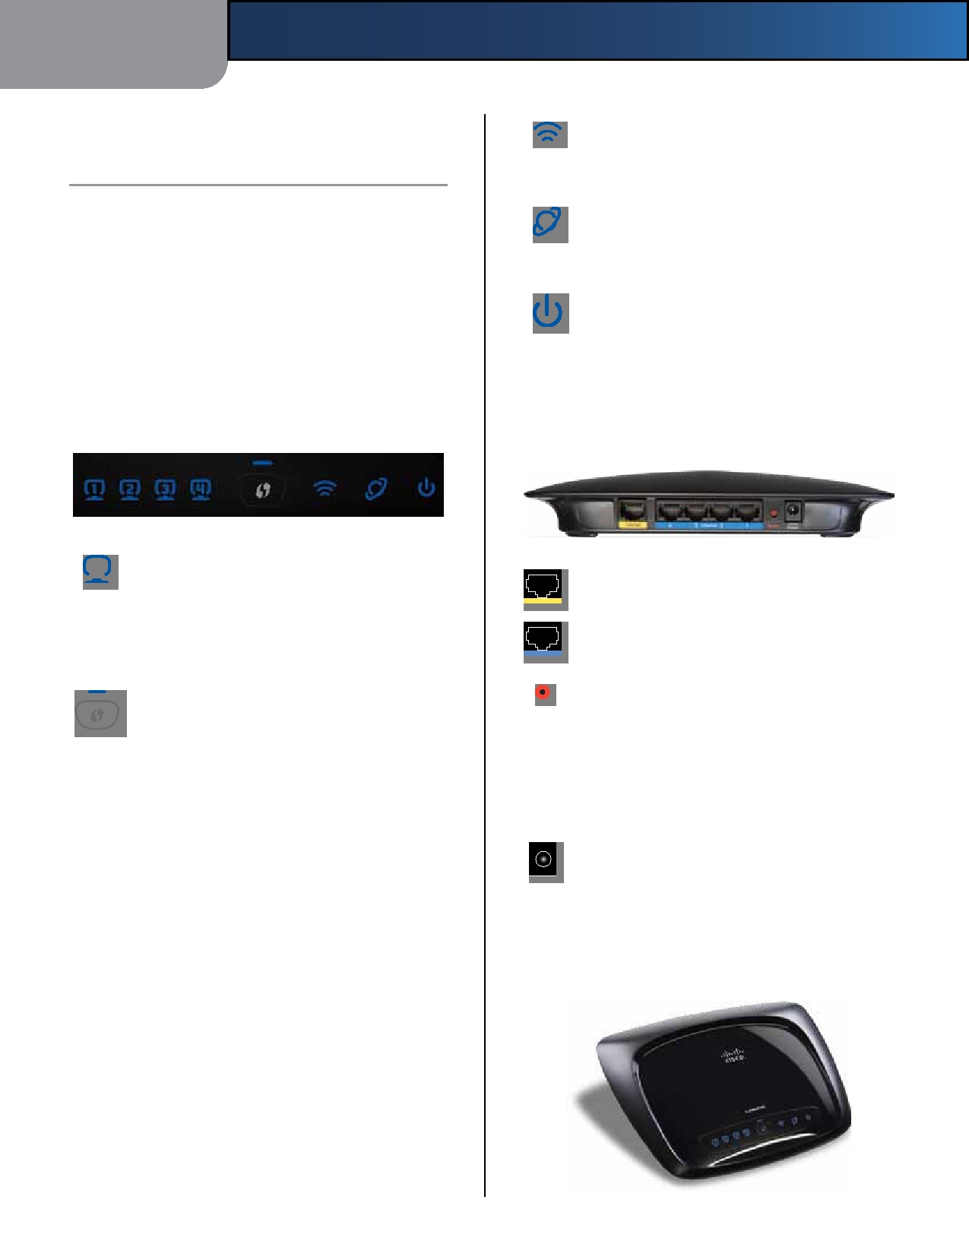
Chapter 1

Chapter 1:
Product Overview

Thank you for choosing the Linksys by Cisco Wireless-N Home Router. The Router lets you access the Internet via a wireless connection or through one of its four switched ports. You can also use the Router to share resources such as computers, printers and files. A variety of security features help to protect your data and your privacy while you are online. Security features include WPA2 security, a Stateful Packet Inspection (SPI) firewall, and NAT technology. Configuring the Router is easy using the provided browser-based utility.
Front Panel
Product Overview

Wireless (Blue) The Wireless LED lights up
when the wireless feature is enabled. If the LED is flashing, the Router is sending or receiving data over the network.
Internet (Blue) The Internet LED lights up
when there is a connection made through the Internet port. It flashes to indicate network activity over the Internet port.
Power (Blue) The Power LED lights up and will
stay on while the Router is powered on. When the Router goes through its self-diagnostic mode during every boot-up, this LED will flash. When the diagnostic is complete, the LED will be solidly lit.
Back Panel

1, 2, 3, 4 (Blue) These numbered LEDs,
corresponding with the numbered ports on the Router's back panel, serve two purposes. If the LED is continuously lit, the Router is successfully connected to a device through that port. A flashing LED indicates network activity over that port.
Wi-Fi Protected Setup Button If you have
client devices, such as wireless adapters, that support Wi-Fi Protected Setup, then you can use Wi-Fi Protected Setup to automatically configure wireless security for your wireless network.
To use Wi-Fi Protected Setup, run the Setup
Wizard, or refer to Wi-Fi Protected Setup, page 11.

Internet The Internet port is where you will
connect your cable or DSL Internet connection.

4, 3, 2, 1 These Ethernet ports (4, 3, 2, 1)
connect the Router to computers on your wired network and other Ethernet network devices.
Reset The Reset button is located on the
right side of the product label. There are two ways to reset the Router to its factory defaults. Either press and hold the Reset button for approximately five seconds, or restore the defaults from the Administration > Factory Defaults screen of the Router's browser-based utility.
Power The Power port connects to the included
power adapter.

Wi-Fi Protected Setup LED (Blue/

Amber) The LED lights up blue when wireless security is enabled. It flashes blue for two minutes during Wi-Fi Protected Setup.

The LED lights up amber if there is an error during the Wi-Fi Protected Setup process. Make sure the client device supports Wi-Fi Protected Setup.Wait until the LED is off, and then try again.

The LED flashes when a Wi-Fi Protected Setup session is active. The Router supports one session at a time. Wait until the LED is solidly lit, or off before starting the next Wi-Fi Protected Setup session.

Wireless-N Home Router
Horizontal Placement
The Router has four rubber feet on its bottom panel. Place
the Router on a level surface near an electrical outlet.

1

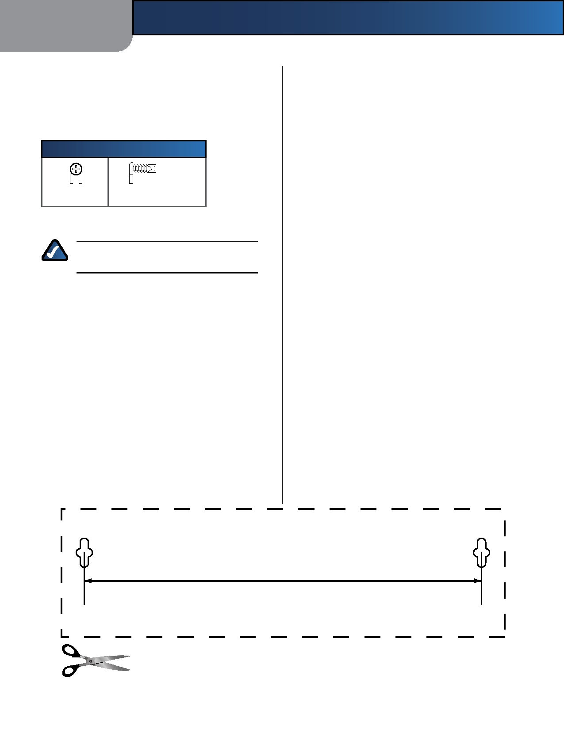
Chapter 1
2.5-3.0 mm

Wall-Mounting Placement
The Router has two wall-mount slots on its bottom
panel. The distance between the slots is 152 mm (6 inches).
Two screws are needed to mount the Router.

Suggested Mounting Hardware
Product Overview

4-5 mm 1-1.5 mm

†Note: Mounting hardware illustrations are not
true to scale.

NOTE: Linksys is not responsible for damages
incurred by insecure wall-mounting hardware.

Follow these instructions:
1. Determine where you want to mount the Router. Make
sure that the wall you use is smooth, flat, dry, and sturdy. Also make sure the location is within reach of an electrical outlet.
2. Drill two holes into the wall. Make sure the holes are
152 mm (6 inches) apart.
3. Insert a screw into each hole and leave 3 mm
(0.12 inches) of its head exposed.
4. Maneuver the Router so the wall-mount slots line up
with the two screws.
5. Place the wall-mount slots over the screws and slide
the Router down until the screws fit snugly into the wall-mount slots.

152 mm

Print this page at 100% size.
Cut along the dotted line, and place on the wall to drill precise spacing.

Wall-Mounting Template

Wireless-N Home Router 2

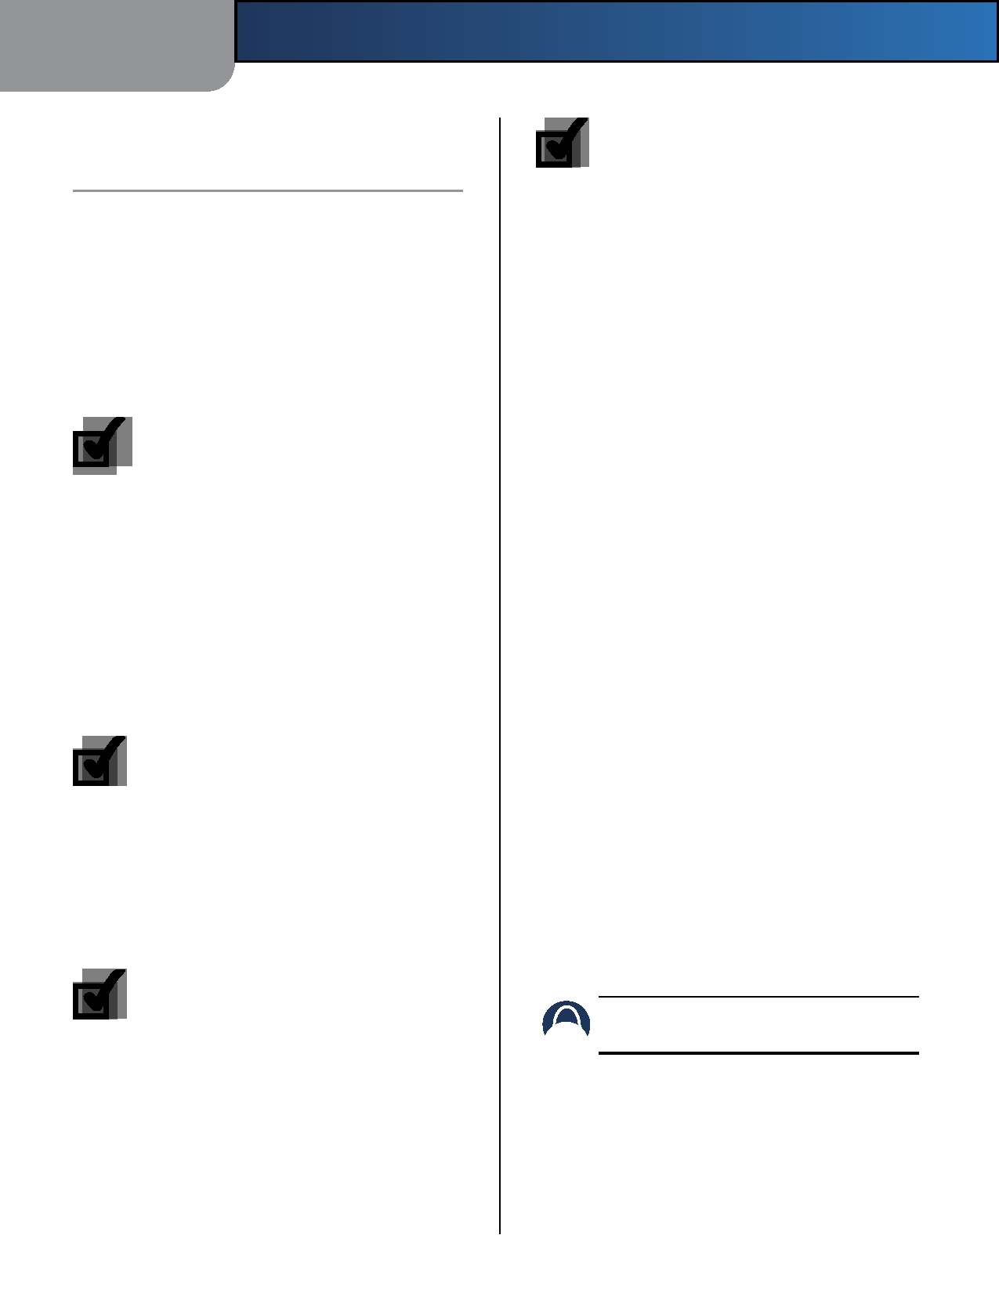
Chapter 2

Chapter 2:
Wireless Security Checklist

Wireless networks are convenient and easy to install, so homes with high-speed Internet access are adopting them at a rapid pace. Because wireless networking operates by sending information over radio waves, it can be more vulnerable to intruders than a traditional wired network. Like signals from your cellular or cordless phones, signals from your wireless network can also be intercepted. Since you cannot physically prevent someone from connecting to your wireless network, you need to take some additional steps to keep your network secure.

1. Change the default wireless
network name or SSID

Wireless devices have a default wireless network name or Service Set Identifier (SSID) set by the factory. This is the name of your wireless network, and can be up
Wireless Security Checklist

4. Enable encryption

Encryption protects data transmitted over a wireless network. Wi-Fi Protected Access (WPA/WPA2) and Wired Equivalent Privacy (WEP) offer different levels of security for wireless communication.
A network encrypted with WPA/WPA2 is more secure
than a network encrypted with WEP, because WPA/WPA2 uses dynamic key encryption. To protect the information as it passes over the airwaves, you should enable the highest level of encryption supported by your network equipment.

WEP is an older encryption standard and may be the only option available on some older devices that do not support WPA.
General Network Security Guidelines
Wireless network security is useless if the underlying
network is not secure.

to 32 characters in length. Linksys wireless products use linksys as the default wireless network name. You should change the wireless network name to something unique to distinguish your wireless network from other wireless networks that may exist around you, but do not use personal information (such as your Social Security number) because this information may be available for anyone to see when browsing for wireless networks.
•

•
•

•
Password protect all computers on the network and
individually password protect sensitive files.
Change passwords on a regular basis.
Install anti-virus software and personal firewall
software.
Disable file sharing (peer-to-peer). Some applications
may open file sharing without your consent and/or knowledge.

2. Change the default password
Additional Security Tips

For wireless products such as access points and routers,
you will be asked for a password when you want to change their settings. These devices have a default password set by the factory. The Linksys default password is admin. Hackers know these defaults and may try to use them to access your wireless device and change your network settings. To thwart any unauthorized changes, customize the device's password so it will be hard to guess.

3. Enable MAC address filtering

Linksys routers give you the ability to enable Media Access Control (MAC) address filtering. The MAC address is a unique series of numbers and letters assigned to every networking device. With MAC address filtering enabled, wireless network access is provided solely for wireless devices with specific MAC addresses. For example, you can specify the MAC address of each computer in your home so that only those computers can access your wireless network.

Wireless-N Home Router

•

•

•
Keep wireless routers, access points, or gateways away
from exterior walls and windows.
Turn wireless routers, access points, or gateways
off when they are not being used (at night, during vacations).
Use strong passphrases that are at least eight characters
in length. Combine letters and numbers to avoid using standard words that can be found in the dictionary.

WEB: For more information on wireless security,
visit www.linksysbycisco.com/security

3

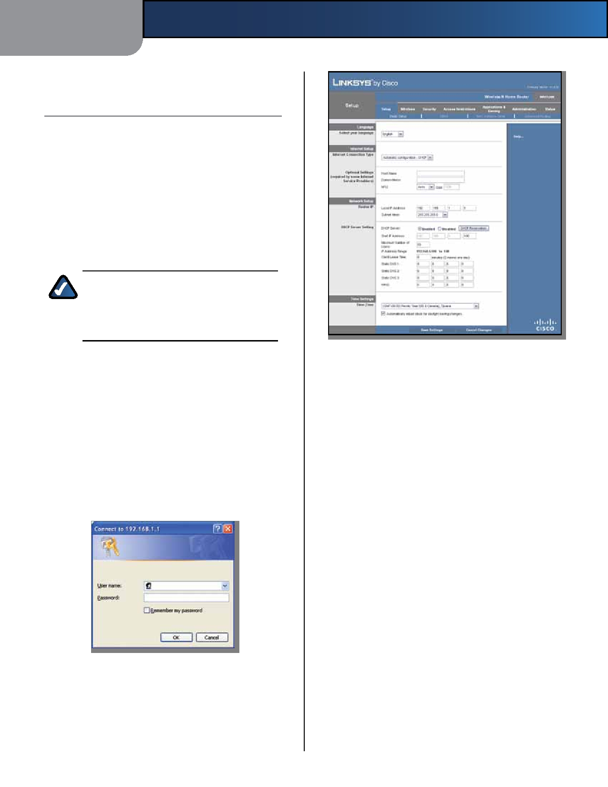
Chapter 3

Chapter 3:
Advanced Configuration

After setting up the Router with the Setup Wizard (located on the CD-ROM), the Router will be ready for use. However, if you want to change its advanced settings, use the Router's browser-based utility. This chapter describes each web page of the utility and each page's key functions. You can access the utility via a web browser on a computer connected to the Router.
The browser-based utility has these main tabs: Setup,
Wireless, Security, Access Restrictions, Applications & Gaming, Administration, and Status. Additional tabs will be available after you click one of the main tabs.

NOTE: When first installing the Router, you
should use the Setup Wizard on the Setup CD-ROM. If you want to configure advanced settings, use this chapter to learn about the browser-based utility.

Access the Browser-Based Utility

Language
Advanced Configuration

Setup > Basic Setup

To access the browser-based utility, launch the web
browser on your computer, and enter the Router's default IP address, 192.168.1.1, in the Address field. Then press Enter.
A login screen will appear. (Non-Windows XP users will
see a similar screen.) Leave the User name field blank. The first time you open the browser-based utility, use the default password admin. (You can set a new password from the Administration > Management screen.) Click OK to continue.
Select your language To use a different language, select
one from the drop-down menu. The language of the browser-based utility will change five seconds after you select another language.
Click Save Settings to apply your changes, or click Cancel
Changes to clear your changes.
Internet Setup
The Internet Setup section configures the Router to your
Internet connection. Most of this information can be
obtained through your Internet Service Provider (ISP).
Internet Connection Type
Select the type of Internet connection your ISP provides
from the drop-down menu. These are the available types:

• Automatic Configuration - DHCP
• Static IP
• PPPoE
• PPTP

Login Screen

•
L2TP

Setup > Basic Setup
The first screen that appears is the Basic Setup screen. This
allows you to change the Router's general settings.

•
Telstra Cable

Wireless-N Home Router 4

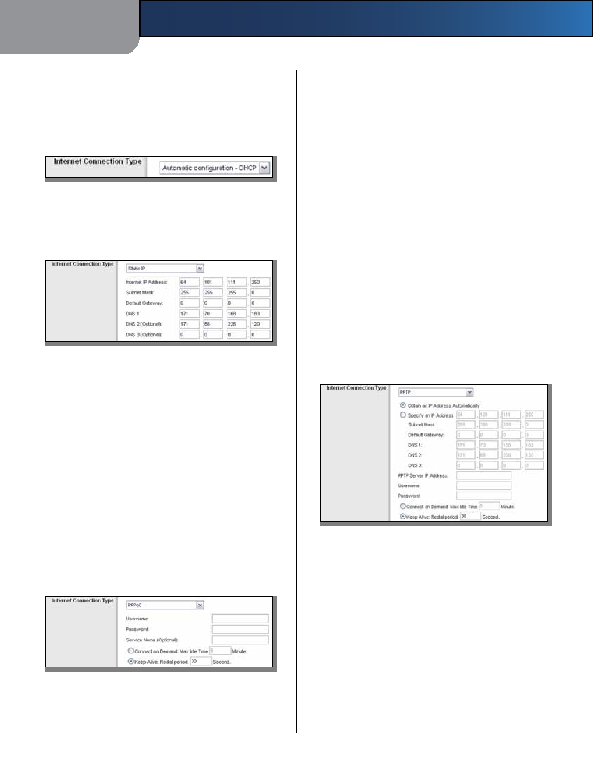
Chapter 3

Automatic Configuration - DHCP
By default, the Router's Internet Connection Type is set
to Automatic configuration - DHCP, which should be kept only if your ISP supports DHCP or you are connecting through a dynamic IP address. (This option usually applies
to cable connections.)

Internet Connection Type > Automatic Configuration - DHCP

Static IP
If you are required to use a permanent IP address to
connect to the Internet, select Static IP.

Internet Connection Type > Static IP

Internet IP Address This is the Router's IP address, when
seen from the Internet. Your ISP will provide you with the IP Address you need to specify here.
Subnet Mask This is the Router's Subnet Mask, as seen
by users on the Internet (including your ISP). Your ISP will provide you with the Subnet Mask.
Default Gateway Your ISP will provide you with the IP
address of the ISP server.
DNS 1-3 Your ISP will provide you with at least one DNS
(Domain Name System) server IP address.
PPPoE
Some DSL-based ISPs use PPPoE (Point-to-Point Protocol
over Ethernet) to establish Internet connections. If you are connected to the Internet through a DSL line, check with your ISP to see if they use PPPoE. If they do, you will have to enable PPPoE.
Advanced Configuration

Service Name (Optional) If provided by your ISP, enter
the Service Name.
Connect on Demand: Max Idle Time You can configure
the Router to cut the Internet connection after it has been inactive for a specified period of time (Max Idle Time). If your Internet connection has been terminated due to inactivity, Connect on Demand enables the Router to automatically re-establish your connection as soon as you attempt to access the Internet again. To use this option, select Connect on Demand. In the Max Idle Time field, enter the number of minutes you want to have elapsed before your Internet connection terminates. The default Max Idle Time is 5 minutes.
Keep Alive: Redial Period If you select this option,
the Router will periodically check your Internet connection. If you are disconnected, then the Router will automatically re-establish your connection. To use this option, select Keep Alive. In the Redial Period field, you specify how often you want the Router to check the Internet connection. The default Redial Period is 30 seconds.
PPTP
Point-to-Point Tunneling Protocol (PPTP) is a service that
applies to connections in Europe only.

Internet Connection Type > PPTP

If your ISP supports DHCP or you are connecting through a dynamic IP address, then select Obtain an IP Address Automatically. If you are required to use a permanent IP address to connect to the Internet, then select Specify an
IP Address. Then configure the following:

• Specify an IP Address This is the Router's IP address,
as seen from the Internet. Your ISP will provide you with the IP Address you need to specify here.
• Subnet Mask This is the Router's Subnet Mask, as
seen by users on the Internet (including your ISP). Your

Internet Connection Type > PPPoE

Username and Password Enter the Username and
Password provided by your ISP.

Wireless-N Home Router

•
ISP will provide you with the Subnet Mask.
Default Gateway Your ISP will provide you with the
IP address of the ISP server.

5

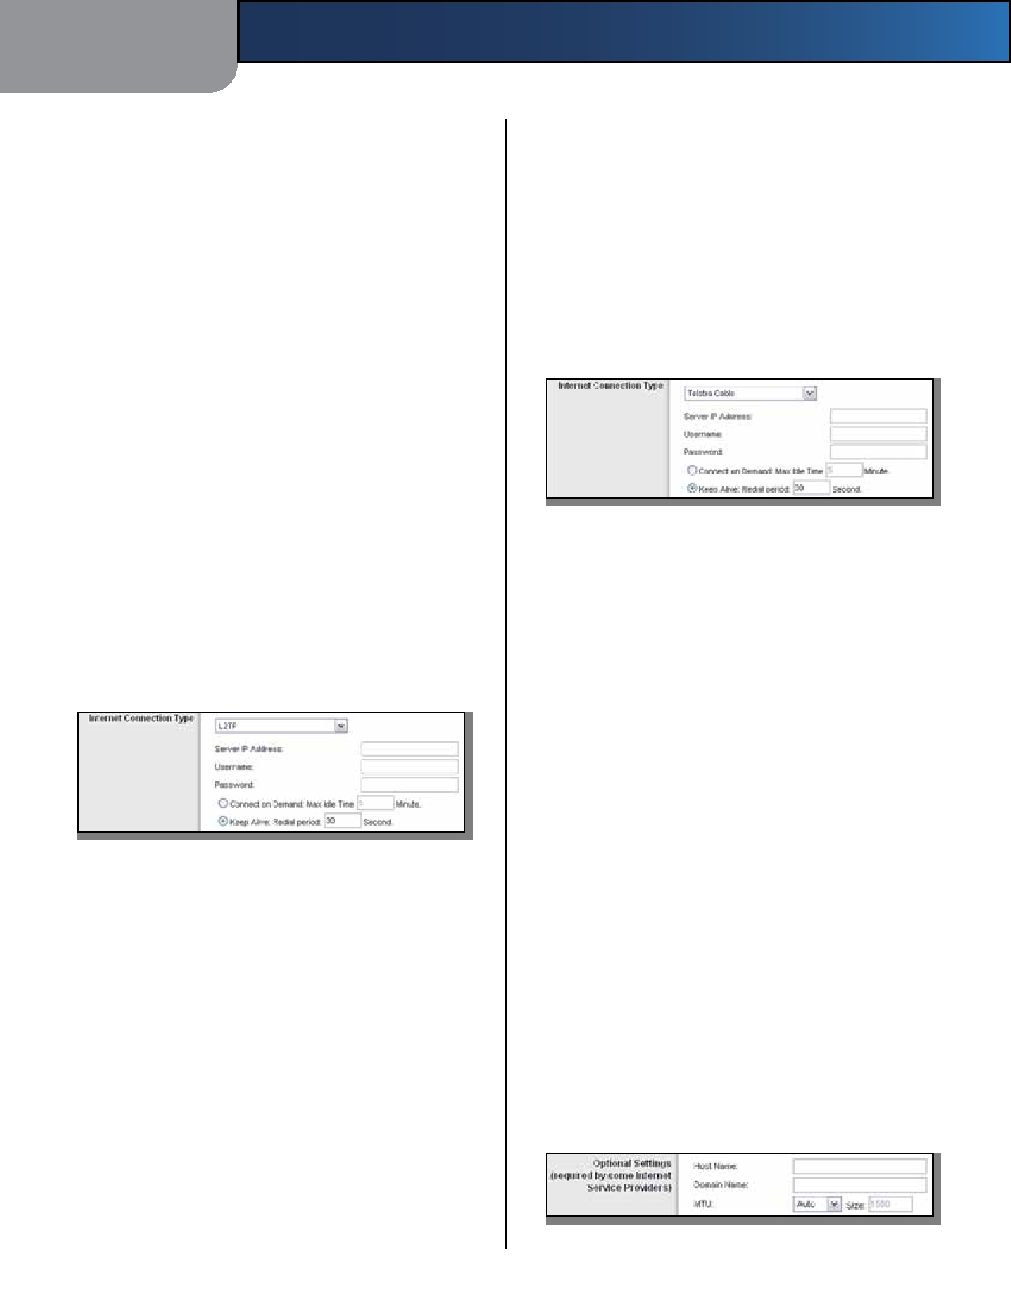
Chapter 3 Advanced Configuration

• DNS 1-3 Your ISP will provide you with at least one Keep Alive: Redial Period If you select this option,
DNS (Domain Name System) server IP address. the Router will periodically check your Internet
connection. If you are disconnected, then the Router

PPTP Server IP Address Your ISP will provide you with
the IP address of the PPTP server.
Username and Password Enter the Username and
Password provided by your ISP.
Connect on Demand: Max Idle Time You can configure
the Router to cut the Internet connection after it has been inactive for a specified period of time (Max Idle Time). If your Internet connection has been terminated due to inactivity, Connect on Demand enables the Router to automatically re-establish your connection as soon as you attempt to access the Internet again. To use this option, select Connect on Demand. In the Max Idle Time field, enter the number of minutes you want to have elapsed before your Internet connection terminates. The default Max Idle Time is 5 minutes.
Keep Alive: Redial Period If you select this option, the
Router will periodically check your Internet connection. If you are disconnected, then the Router will automatically re-establish your connection. To use this option, select Keep Alive. In the Redial Period field, you specify how often you want the Router to check the Internet connection. The default value is 30 seconds.
L2TP
L2TP is a service that applies to connections in Israel only.

Internet Connection Type > L2TP

Server IP Address This is the IP address of the L2TP
Server. Your ISP will provide you with the IP Address you need to specify here.
Username and Password Enter the Username and
Password provided by your ISP.
Connect on Demand: Max Idle Time You can configure
the Router to cut the Internet connection after it has been inactive for a specified period of time (Max Idle Time). If your Internet connection has been terminated due to inactivity, Connect on Demand enables the Router to automatically re-establish your connection as soon as you attempt to access the Internet again. To use this option, select Connect on Demand. In the Max Idle Time field, enter the number of minutes you want to have elapsed before your Internet connection terminates. The default Max Idle Time is 5 minutes.

Wireless-N Home Router
will automatically re-establish your connection. To use this option, select Keep Alive. In the Redial Period field, you specify how often you want the Router to check the Internet connection. The default Redial Period is 30 seconds.
Telstra Cable
Telstra Cable is a service that applies to connections in
Australia only.

Internet Connection Type > Telstra Cable

Server IP Address This is the IP address of the Heartbeat
Server. Your ISP will provide you with the IP Address you need to specify here.
Username and Password Enter the Username and
Password provided by your ISP.
Connect on Demand: Max Idle Time You can configure
the Router to cut the Internet connection after it has been inactive for a specified period of time (Max Idle Time). If your Internet connection has been terminated due to inactivity, Connect on Demand enables the Router to automatically re-establish your connection as soon as you attempt to access the Internet again. To use this option, select Connect on Demand. In the Max Idle Time field, enter the number of minutes you want to have elapsed before your Internet connection terminates. The default Max Idle Time is 5 minutes.
Keep Alive: Redial Period If you select this option,
the Router will periodically check your Internet connection. If you are disconnected, then the Router will automatically re-establish your connection. To use this option, select Keep Alive. In the Redial Period field, you specify how often you want the Router to check the Internet connection. The default Redial Period is 30 seconds.
Optional Settings
Some of these settings may be required by your ISP. Verify
with your ISP before making any changes.

Optional Settings

6

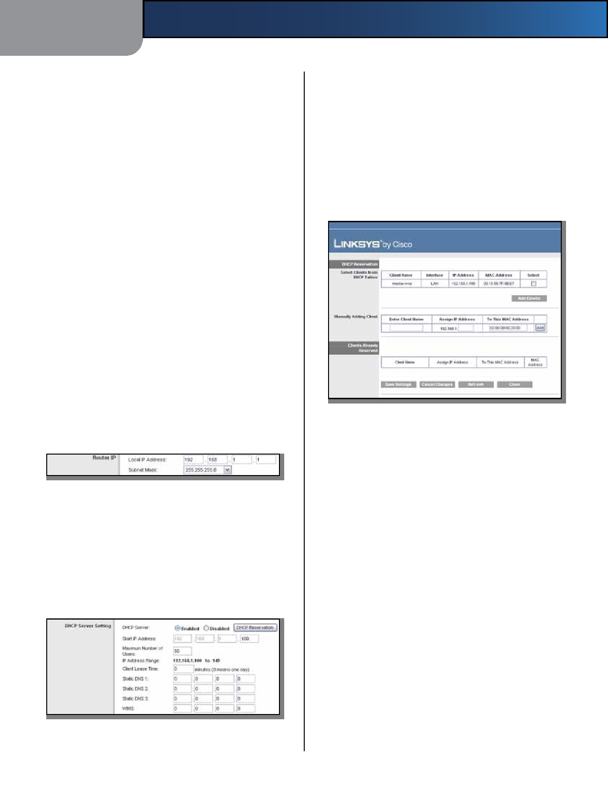
Chapter 3

Host Name and Domain Name These fields allow you to
supply a host and domain name for the Router. Some ISPs, usually cable ISPs, require these names as identification. You may have to check with your ISP to see if your broadband Internet service has been configured with a host and domain name. In most cases, leaving these fields blank will work.
MTU MTU is the Maximum Transmission Unit. It specifies
the largest packet size permitted for Internet transmission. Select Manual if you want to manually enter the largest packet size that is transmitted. To have the Router select the best MTU for your Internet connection, keep the default, Auto.
Size When Manual is selected in the MTU field, this option
is enabled. Leave this value in the 1200 to 1500 range. The
default size depends on the Internet Connection Type:
Advanced Configuration

DHCP Server DHCP is enabled by factory default. If you
already have a DHCP server on your network, or you do not want a DHCP server, then select Disabled (no other DHCP features will be available).
DHCP Reservation Click this button if you want to assign
a fixed local IP address to a MAC address.
DHCP Reservation
You will see a list of DHCP clients with the following
information: Client Name, Interface, IP Address, and MAC Address.

• DHCP, Static IP, or Telstra: 1500
• PPPoE: 1492
• PPTP or L2TP: 1460

Network Setup
The Network Setup section changes the settings of the
local network. Wireless setup is performed through the Wireless tab.
Router IP
This presents both the Router's Local IP Address and
Subnet Mask as seen by your network.

Router IP

DHCP Server Setting
The settings allow you to configure the Router's Dynamic

•

•

DHCP Reservation

Select Clients from DHCP Table Click the Select
check box to reserve a client's IP address. Then click Add Clients.
Manually Adding Client To manually assign an IP
address, enter the client's name in the Enter Client Name field. Enter the IP address you want it to have in the Assign IP Address field. Enter its MAC address in the To This MAC Address field. Then click Add.

Host Configuration Protocol (DHCP) server function. The Router can be used as a DHCP server for your network. A DHCP server automatically assigns an IP address to each computer on your network. If you choose to enable the Router's DHCP server option, make sure there is no other DHCP server on your network.

DHCP Server Setting

Wireless-N Home Router
Clients Already Reserved
A list of DHCP clients and their fixed local IP addresses
will be displayed at the bottom of the screen. If you
want to remove a client from this list, click Remove.
Click Save Settings to apply your changes, or click
Cancel Changes to clear your changes. To update the on-screen information, click Refresh. To exit this screen and return to the Basic Setup screen, click Close.
Start IP Address Enter a value for the DHCP server to
start with when issuing IP addresses. Because the Router's default IP address is 192.168.1.1, the Start IP Address must be 192.168.1.2 or greater, but smaller than 192.168.1.253. The default is 192.168.1.100.
Maximum Number of Users Enter the maximum number
of computers that you want the DHCP server to assign IP

7

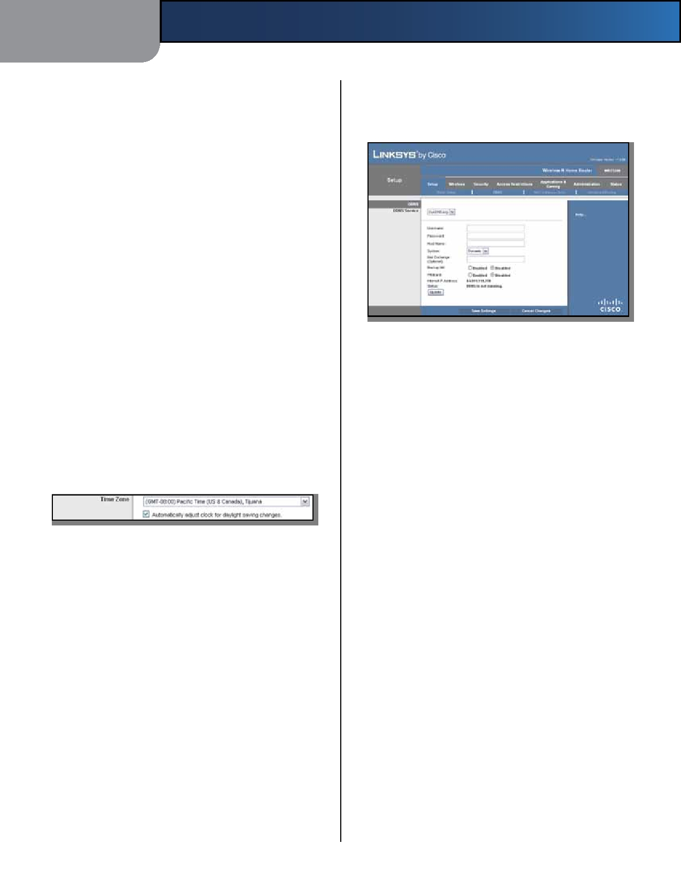
Chapter 3

addresses to. This number cannot be greater than 253. The default is 50.
IP Address Range Displayed here is the range of available
IP addresses.
Client Lease Time The Client Lease Time is the amount
of time a network user will be allowed connection to the Router with their current dynamic IP address. Enter the amount of time, in minutes, that the user will be "leased" this dynamic IP address. After the time has expired, the user will be automatically assigned a new dynamic IP address, or the lease will be renewed. The default is 0 minutes, which means one day.
Static DNS 1-3 The Domain Name System (DNS) is how
the Internet translates domain or website names into Internet addresses or URLs. Your ISP will provide you with at least one DNS Server IP Address. If you wish to use another, enter that IP Address in one of these fields. You can enter up to three DNS Server IP Addresses here. The Router will use these for quicker access to functioning DNS servers.
WINS The Windows Internet Naming Service (WINS)
manages each computer's interaction with the Internet. If you use a WINS server, enter that server's IP Address here. Otherwise, leave this blank.
Time Settings
Time Zone Select the time zone in which your network
functions from this drop-down menu. (You can even
automatically adjust for daylight saving time.)

Time Settings

Click Save Settings to apply your changes, or click Cancel
Changes to clear your changes.
Setup > DDNS
The Router offers a Dynamic Domain Name System (DDNS)
feature. DDNS lets you assign a fixed host and domain name to a dynamic Internet IP address. It is useful when you are hosting your own website, FTP server, or other server behind the Router.
Before you can use this feature, you need to sign
up for DDNS service with a DDNS service provider, www.dyndns.org or www.TZO.com. If you do not want to use this feature, keep the default, Disabled.
DDNS
DDNS Service
If your DDNS service is provided by DynDNS.org, then
select DynDNS.org from the drop-down menu. If your DDNS service is provided by TZO, then select TZO.com.

Wireless-N Home Router
Advanced Configuration

The features available on the DDNS screen will vary, depending on which DDNS service provider you use.
DynDNS.org

Setup > DDNS > DynDNS

Username Enter the Username for your DDNS account.
Password Enter the Password for your DDNS account.
Host Name The is the DDNS URL assigned by the DDNS
service.
System Select the DynDNS service you use: Dynamic,
Static, or Custom. The default selection is Dynamic.
Mail Exchange (Optional) Enter the address of your mail
exchange server, so e-mails to your DynDNS address go to your mail server.
Backup MX This feature allows the mail exchange server
to be a backup. To disable this feature, keep the default, Disabled. To enable the feature, select Enabled. If you are not sure which setting to select, keep the default, Disabled.
Wildcard This setting enables or disables wildcards
for your host. For example, if your DDNS address is myplace.dyndns.org and you enable wildcards, then x.myplace.dyndns.org will work as well (x is the wildcard). To disable wildcards, keep the default, Disabled. To enable wildcards, select Enabled. If you are not sure which setting to select, keep the default, Disabled.
Internet IP Address The Router's Internet IP address is
displayed here. Because it is dynamic, it will change.
Status The status of the DDNS service connection is
displayed here.
Update To manually trigger an update, click this button. Click Save Settings to apply your changes, or click Cancel
Changes to clear your changes.

8

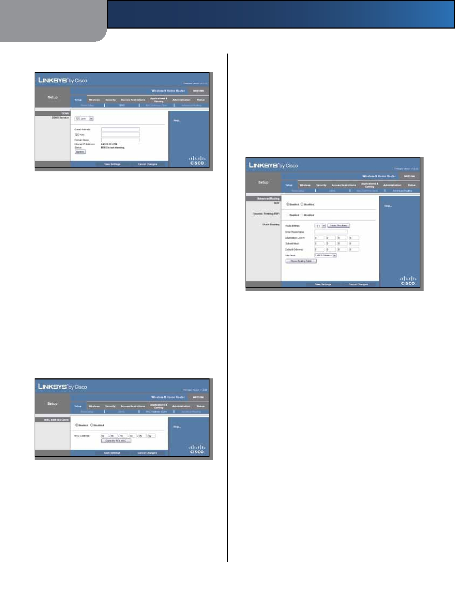
Chapter 3

TZO.com

Setup > DDNS > TZO
Advanced Configuration

Click Save Settings to apply your changes, or click Cancel
Changes to clear your changes.
Setup > Advanced Routing
This screen is used to set up the Router's advanced
functions. Operating Mode allows you to select the type(s) of advanced functions you use. Dynamic Routing automatically adjusts how packets travel on your network. Static Routing sets up a fixed route to another network destination.

E-mail Address, TZO Key, and Domain Name Enter the
settings of the account you set up with TZO.
Internet IP Address The Router's Internet IP address is
displayed here. Because it is dynamic, it will change.
Status The status of the DDNS service connection is
displayed here.
Update To manually trigger an update, click this button. Click Save Settings to apply your changes, or click Cancel
Changes to clear your changes.
Setup > MAC Address Clone
A MAC address is a 12-digit code assigned to a unique
piece of hardware for identification. Some ISPs will require you to register a MAC address in order to access the Internet. If you do not wish to re-register the MAC address

Advanced Routing
NAT

Setup > Advanced Routing

with your ISP, you may assign the MAC address you have currently registered with your ISP to the Router with the MAC Address Clone feature.

Setup > MAC Address Clone

MAC Address Clone
Enabled/Disabled To have the MAC Address cloned,
select Enabled.
MAC Address Enter the MAC Address registered with
your ISP here.
Clone My PC's MAC Click this button to clone the MAC
address of the computer you are using.

Wireless-N Home Router
Enabled/Disabled If this Router is hosting your network's
connection to the Internet, keep the default, Enabled. If another router exists on your network, select Disabled. When the NAT setting is disabled, dynamic routing will be enabled.
Dynamic Routing (RIP)
Enabled/Disabled This feature enables the Router to
automatically adjust to physical changes in the network's layoutandexchangeroutingtableswiththeotherrouter(s). The Router determines the network packets' route based on the fewest number of hops between the source and the destination. When the NAT setting is enabled, the Dynamic Routing feature is automatically disabled. When the NAT setting is disabled, this feature is available. Select Enabled to use the Dynamic Routing feature.
Static Routing
A static route is a pre-determined pathway that network
information must travel to reach a specific host or network. Enter the information described below to set up a new static route.

9

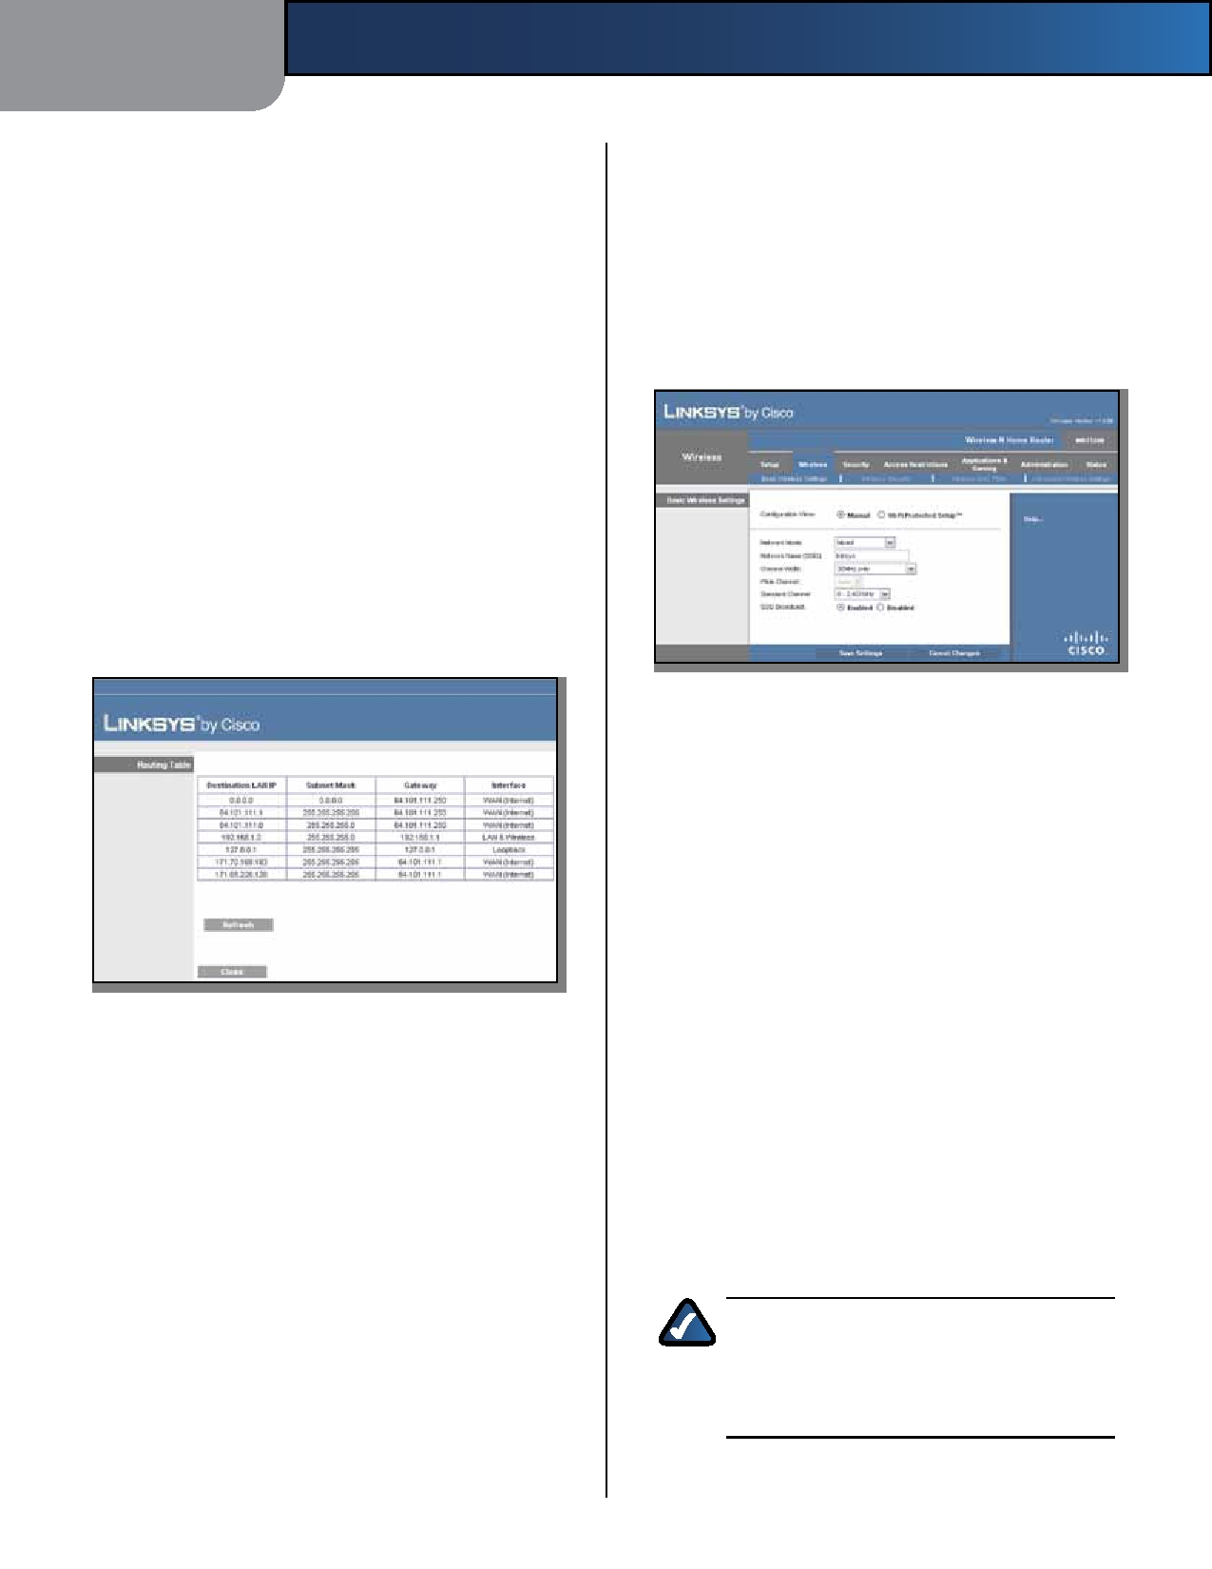
Chapter 3

Route Entries To set up a static route between the Router
and another network, select a number from the drop- down list. Click Delete This Entry to delete a static route.
Enter Route Name Enter a name for the Route here,
using a maximum of 25 alphanumeric characters.
Destination LAN IP The Destination LAN IP is the address
of the remote network or host to which you want to assign a static route.
Subnet Mask The Subnet Mask determines which
portion of a Destination LAN IP address is the network portion, and which portion is the host portion.
Default Gateway This is the IP address of the gateway
device that allows for contact between the Router and the remote network or host.
Interface This interface tells you whether the Destination
IP Address is on the LAN & Wireless (Ethernet and wireless networks) or the WAN (Internet).
Click Show Routing Table to view the static routes you
have already set up.

Advanced Routing > Routing Table

Routing Table
For each route, the Destination LAN IP address, Subnet
Mask, Gateway, and Interface are displayed. To update the information, click Refresh. To exit this screen and return to the Advanced Routing screen, click Close.
Click Save Settings to apply your changes, or click Cancel
Changes to clear your changes.
Wireless > Basic Wireless Settings
The basic settings for wireless networking are set on this
screen.
There are two ways to configure the Router's wireless
network(s), manual and Wi-Fi Protected Setup.
Wi-Fi Protected Setup is a feature that makes it easy to set
up your wireless network. If you have client devices, such

Wireless-N Home Router
Advanced Configuration

as wireless adapters, that support Wi-Fi Protected Setup, then you can use Wi-Fi Protected Setup.
Configuration View To manually configure your wireless
network, select Manual. Proceed to Basic Wireless Settings (Manual), page 10. To use Wi-Fi Protected Setup, select Wi-Fi Protected Setup. Proceed to Wi-Fi Protected Setup, page 11.
Basic Wireless Settings (Manual)

Wireless > Basic Wireless Settings (Manual Setup)

Network Mode From this drop-down menu, you can
select the wireless standards running on your network. If you have Wireless-N, Wireless-G, and Wireless-B devices in your network, keep the default, Mixed. If you have only Wireless-G and Wireless-B devices in your network, select BG-Mixed. If you have only Wireless-N devices, select Wireless-N Only. If you have only Wireless-G devices, select Wireless-G Only. If you have only Wireless-B devices, select Wireless-B Only. If you do not have any wireless devices in your network, select Disabled.
Network Name (SSID) The SSID is the network name
shared among all points in a wireless network. The SSID must be identical for all devices in the wireless network. It is case-sensitive and must not exceed 32 characters (use any of the characters on the keyboard). Make sure this setting is the same for all points in your wireless network. For added security, you should change the default SSID (linksys) to a unique name.
Channel Width For best performance in a Wireless-N
network, select 40MHz only. For Wireless-G and Wireless-B networking only, keep the default, 20MHz only. If you are not sure which option to use, select Auto (20MHz or 40MHz).

NOTE: If you select 40MHz only for the Channel
Width setting, then Wireless-N can use two channels: a primary one (Wide Channel) and a secondary one (Standard Channel). This will enhance Wireless-N performance.

Wide Channel If 40MHz only is the Channel Width
setting, then this setting will be available for your primary

10

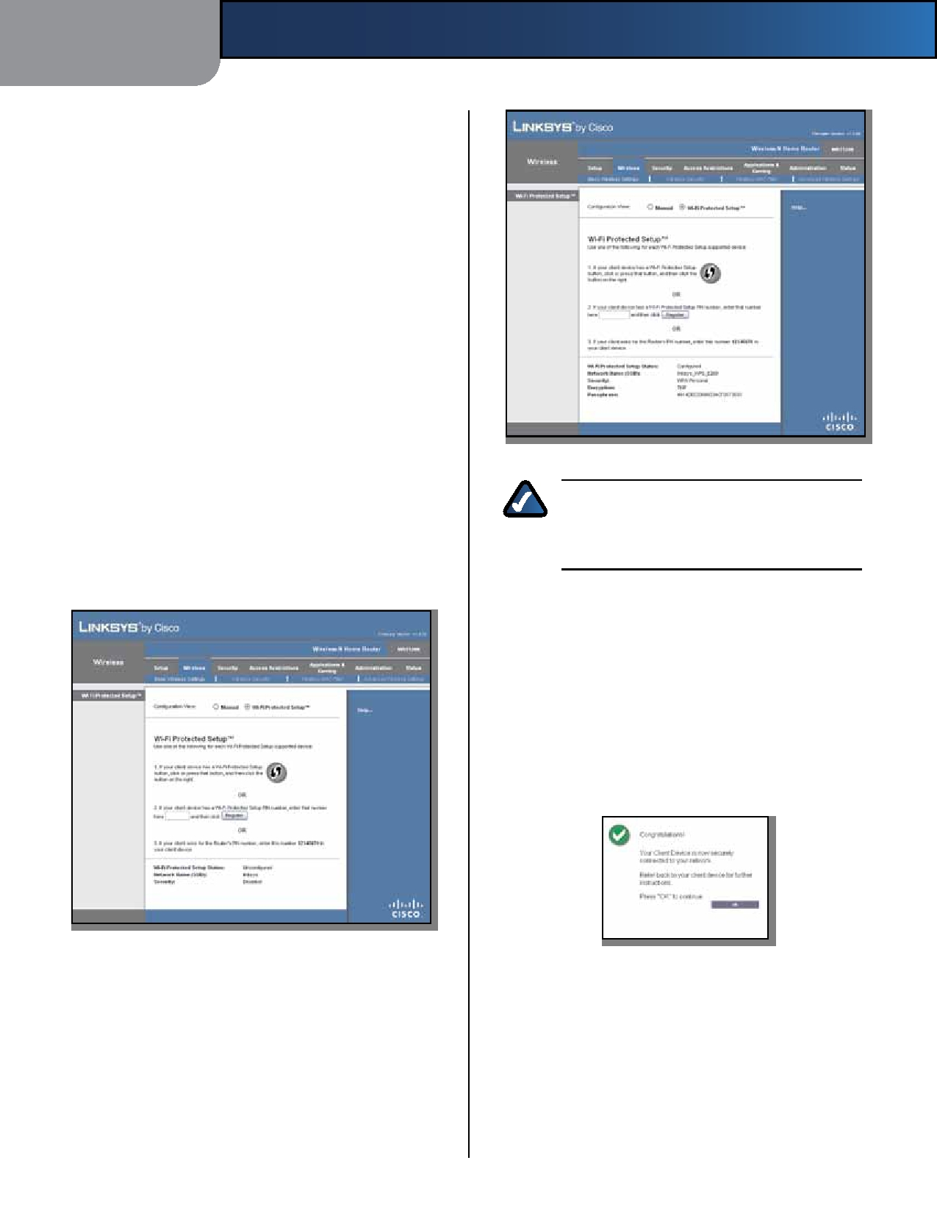
Chapter 3

Wireless-N channel. Select any channel from the drop- down menu. If you are not sure which channel to select, keep the default, Auto.
Standard Channel If 20MHz only is the Channel Width
setting, then select the appropriate channel for your wireless network. If you are not sure which channel to select, then keep the default, Auto.
If 40MHz only is the Channel Width setting, then the
Standard Channel will be a secondary channel for Wireless-N (2.4 GHz). If you selected a specific channel for the Wide Channel setting, then the Standard Channel options will be available. Select the appropriate channel for your wireless network.
SSID Broadcast When wireless clients survey the local
area for wireless networks to associate with, they will detect the SSID broadcast by the Router. To broadcast the Router's SSID, keep the default, Enabled. If you do not want to broadcast the Router's SSID, then select Disabled.
Click Save Settings to apply your changes, or click Cancel
Changes to clear your changes.
Wi-Fi Protected Setup
There are three methods available. Use the method that
applies to the client device you are configuring.

Method #1
Advanced Configuration

Wi-Fi Protected Setup Configured

NOTE: Wi-Fi Protected Setup configures one
client device at a time. Repeat the instructions for each client device that supports Wi-Fi Protected Setup.

Use this method if your client device has a Wi-Fi Protected
Setup button.
1. Click or press the Wi-Fi Protected Setup button on
the client device.
2. Click the Wi-Fi Protected Setup button on this
screen.
3. After the client device has been configured, click
OK. Then refer back to your client device or its documentation for further instructions.

Wireless > Basic Wireless Settings (Wi-Fi Protected Setup)
Wi-Fi Protected Setup > Congratulations

Method #2
Use this method if your client device has a Wi-Fi Protected
Setup PIN number.
1. Enter the PIN number in the field on this screen.
2. Click Register.
3. After the client device has been configured, click
OK. Then refer back to your client device or its documentation for further instructions.
Wireless-N Home Router 11

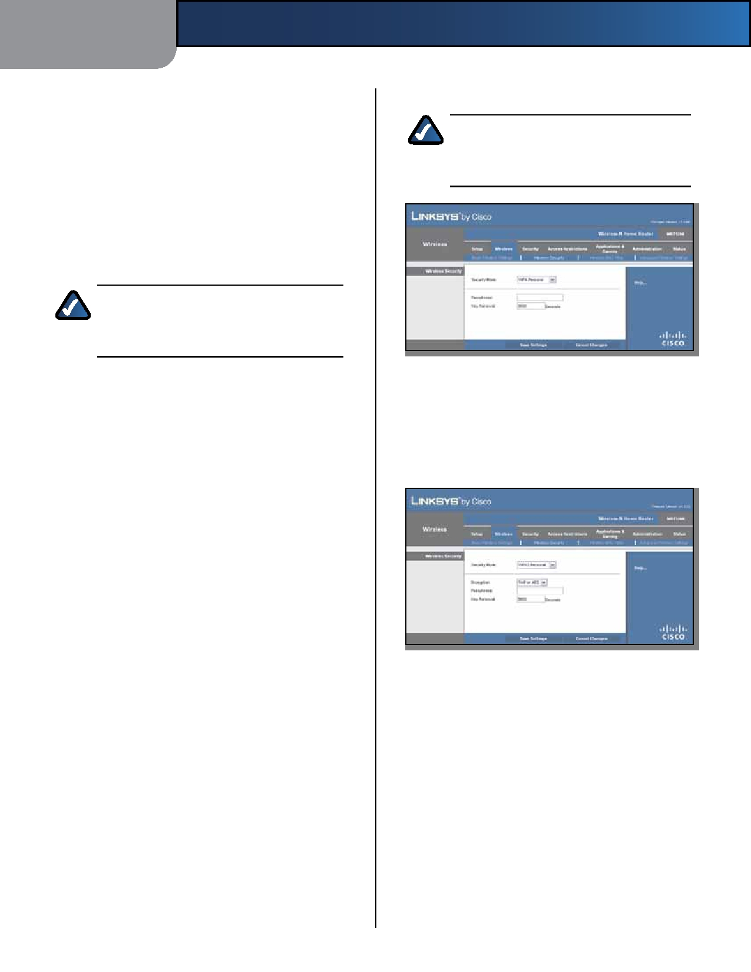
Chapter 3 Advanced Configuration

Method #3 WPA Personal
Use this method if your client device asks for the Router's

PIN number.
1. Enter the PIN number listed on this screen. (It is also
listed on the label on the bottom of the Router.)
2. After the client device has been configured, click
OK. Then refer back to your client device or its documentation for further instructions.
The Wi-Fi Protected Setup Status, Network Name (SSID),
Security, Encryption, and Passphrase are displayed at the bottom of the screen.

NOTE: If you have client devices that do not
support Wi-Fi Protected Setup, note the wireless settings, and then manually configure those client devices.

Wireless > Wireless Security
The Wireless Security screen configures the security of
your wireless network. There are six wireless security mode options supported by the Router: WPA Personal, WPA Enterprise, WPA2 Personal, WPA2 Enterprise, RADIUS, and WEP. (WPA stands for Wi-Fi Protected Access, which is a security standard stronger than WEP encryption. WEP stands for Wired Equivalent Privacy, while RADIUS stands for Remote Authentication Dial-In User Service.) These six are briefly discussed here. For detailed instructions on configuring wireless security for the Router, refer to Chapter 2: Wireless Security Checklist, page 3.
Wireless Security
Security Mode
Select the security method for your wireless network. If
you do not want to use wireless security, keep the default, Disabled.
NOTE: If you are using WPA, then each device in
your wireless network MUST use the same WPA method and shared key, or else the network will not function properly.

Security Mode > WPA Personal

Passphrase Enter a Passphrase of 8-63 characters.
Key Renewal Enter a Key Renewal period, which instructs
the Router how often it should change the encryption keys. The default is 3600 seconds.
WPA2 Personal

Security Mode > WPA2 Personal

Encryption WPA2 supports two encryption methods,
TKIP and AES, with dynamic encryption keys. Select the type of algorithm, AES or TKIP or AES. The default is TKIP or AES.
Passphrase Enter a Passphrase of 8-63 characters.
Key Renewal Enter a Key Renewal period, which instructs
the Router how often it should change the encryption keys. The default is 3600 seconds.

Wireless-N Home Router 12

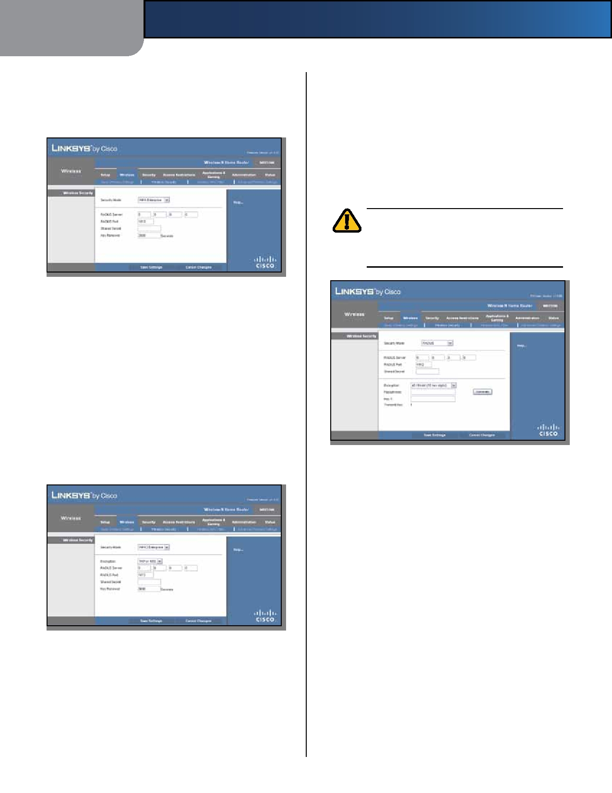
Chapter 3

WPA Enterprise
This option features WPA used with a RADIUS server. (This
should only be used when a RADIUS server is connected
to the Router.)

Security Mode > WPA Enterprise

RADIUS Server Enter the IP address of the server.
RADIUS Port Enter the port number of the server. The
default is 1812.
Shared Secret Enter the key shared between the Router
and the server.
Key Renewal Enter a Key Renewal period, which instructs
the Router how often it should change the encryption keys. The default is 3600 seconds.
WPA2 Enterprise
This option features WPA2 used with a RADIUS server. (This
should only be used when a RADIUS server is connected
to the Router.)

Security Mode > WPA2 Enterprise

Encryption WPA2 supports two encryption methods,
TKIP and AES, with dynamic encryption keys. Select the type of algorithm, AES or TKIP or AES. The default is TKIP or AES.
RADIUS Server Enter the IP address of the server.
RADIUS Port Enter the port number of the server. The
default is 1812.

Wireless-N Home Router
Advanced Configuration

Shared Secret Enter the key shared between the Router
and the server.
Key Renewal Enter a Key Renewal period, which instructs
the Router how often it should change the encryption keys. The default is 3600 seconds.
RADIUS
This option features WEP used with a RADIUS server. (This
should only be used when a RADIUS server is connected
to the Router.)

IMPORTANT: If you are using WEP, then each
device in your wireless network MUST use the same WEP encryption method and key, or else the network will not function properly.

Security Mode > RADIUS

RADIUS Server Enter the IP address of the server.
RADIUS Port Enter the port number of the server. The
default is 1812.
Shared Secret Enter the key shared between the Router
and the server.
Encryption Select a level of WEP encryption,
40/64 bits (10 hex digits) or 104/128 bits (26 hex digits). The default is 40/64 bits (10 hex digits).
Passphrase Enter a Passphrase to automatically generate
WEP keys. Then click Generate.
Key 1 If you did not enter a Passphrase, enter the WEP
key manually.
TX Key TX (Transmit) Key 1 is used.

13

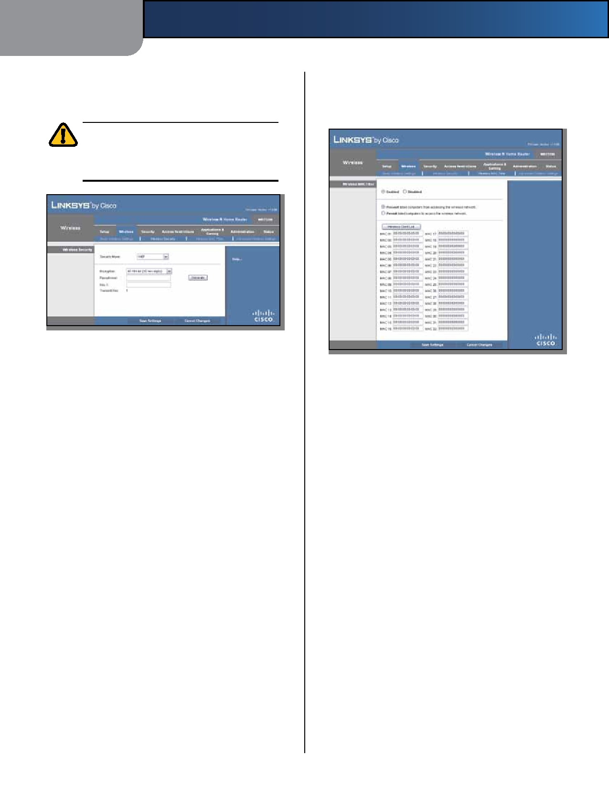
Chapter 3

WEP
WEP is a basic encryption method, which is not as secure
as WPA.

IMPORTANT: If you are using WEP encryption,
then each device in your wireless network MUST use the same WEP encryption method and key,
or else the network will not function properly.
Advanced Configuration

Wireless > Wireless MAC Filter
Wireless access can be filtered by using the MAC addresses of
the wireless devices transmitting within your network's radius.

Security Mode > WEP

Encryption Select a level of WEP encryption,
40/64 bits (10 hex digits) or 104/128 bits (26 hex digits). The default is 40/64 bits (10 hex digits).

Wireless MAC Filter

Wireless > Wireless MAC Filter

Passphrase Enter a Passphrase to automatically generate
WEP keys. Then click Generate.
Key 1 If you did not enter a Passphrase, enter the WEP
key manually.
TX Key TX (Transmit) Key 1 is used.
Click Save Settings to apply your changes, or click Cancel
Changes to clear your changes.
Enabled/Disabled To filter wireless users by MAC Address,
either permitting or blocking access, select Enabled. If you do not wish to filter users by MAC Address, keep the default, Disabled.
Access Restriction
Prevent Select this option to block wireless access by
MAC Address. This button is selected by default.
Permit Select this option to allow wireless access by MAC
Address. This button is not selected by default.
MAC Address Filter List
Wireless Client List Click this button to open the Wireless
Client List screen.

Wireless-N Home Router 14

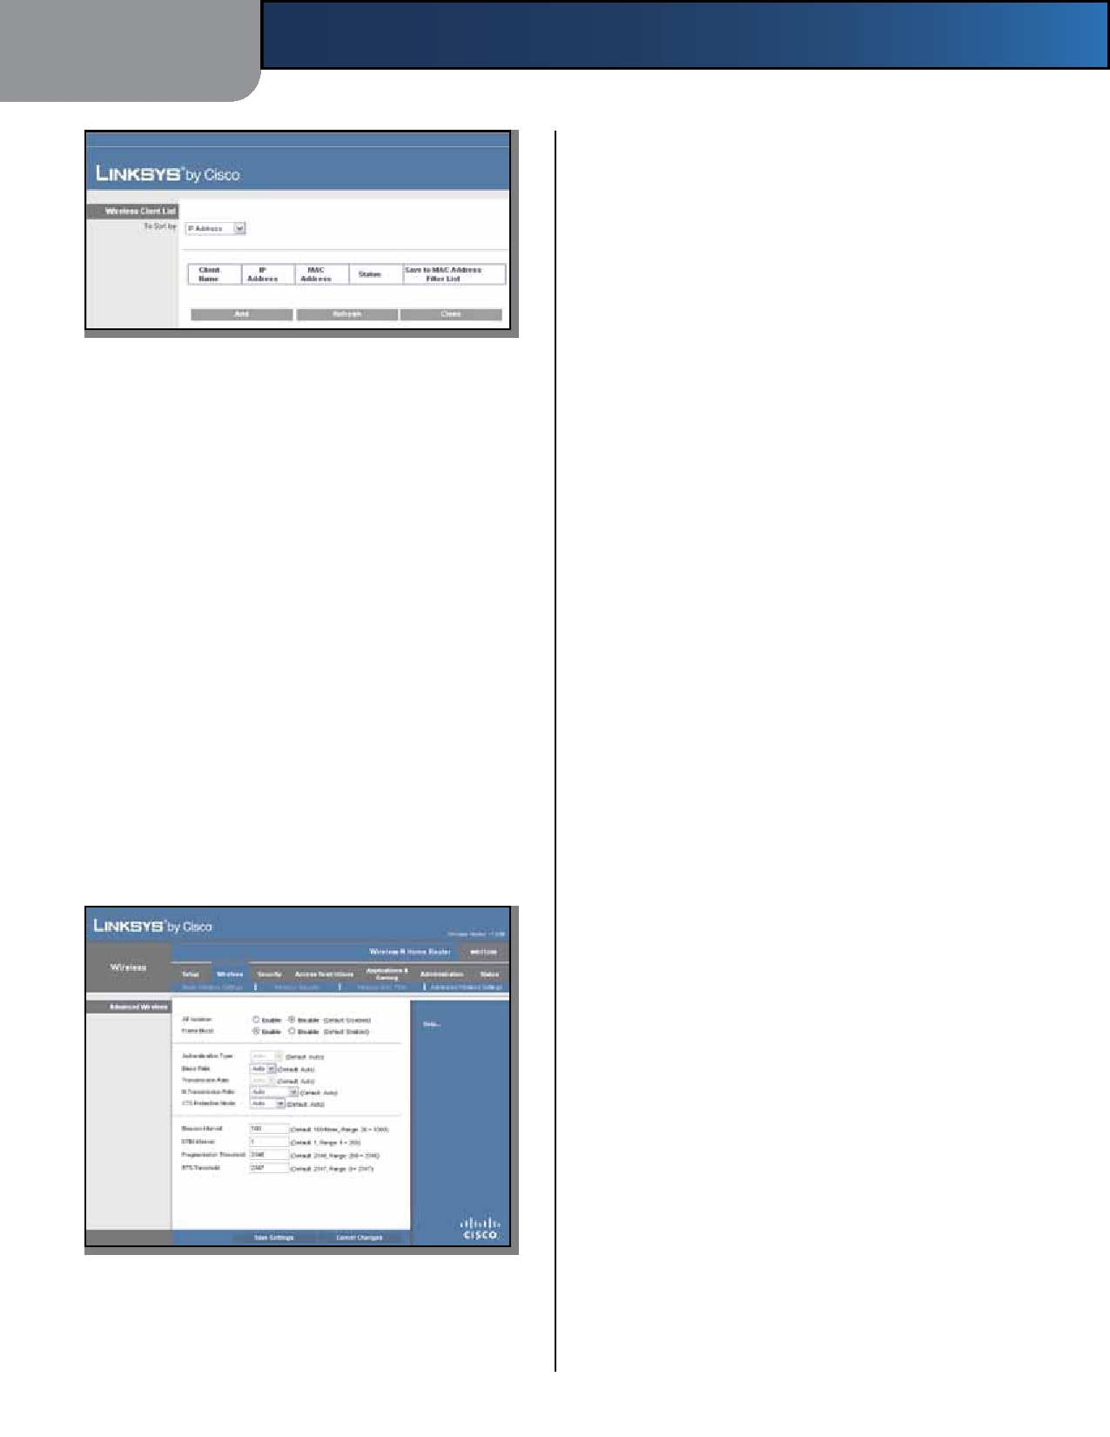
Chapter 3 Advanced Configuration

Advanced Wireless
AP Isolation This option isolates all wireless clients and
wireless devices on your network from each other. Wireless devices will be able to communicate with the Router but not with each other. To use this option, select Enable. AP Isolation is disabled by default.
Frame Burst This option should provide your network
with greater performance, depending on the manufacturer

Wireless Client List
Wireless Client List
of your wireless products. To use this option, keep the
default, Enable. To disable this option, select Disable.
Authentication Type The Authentication Type setting
is available if the Security Mode is RADIUS or WEP. The

This screen shows computers and other devices on the wireless network. The list can be sorted by Client Name, IP Address, MAC Address, and Status.
Select Save to MAC Address Filter List for any device
you want to add to the MAC Address Filter List. Then click Add.
To update the on-screen information, click Refresh.
To exit this screen and return to the Wireless MAC Filter screen, click Close.
MAC 01-32 Enter the MAC addresses of the devices
whose wireless access you want to block or allow.
Click Save Settings to apply your changes, or click Cancel
Changes to clear your changes.
Wireless > Advanced Wireless Settings
This Advanced Wireless Settings screen is used to set up
the Router's advanced wireless functions. These settings should only be adjusted by an expert administrator as incorrect settings can reduce wireless performance.

Wireless > Advanced Wireless Settings

Wireless-N Home Router
default is set to Auto, which allows either Open System
or Shared Key authentication to be used. With Open System authentication, the sender and the recipient do NOT use a WEP key for authentication. With Shared Key authentication, the sender and recipient use a WEP key for authentication. Select Shared Key to only use Shared Key authentication.
Basic Rate The Basic Rate setting is not actually one rate
of transmission but a series of rates at which the Router can transmit. (The Basic Rate is not the actual rate of data transmission. If you want to specify the Router's rate of data transmission, configure the Transmission Rate setting.) The Router will advertise its Basic Rate to the other wireless devices in your network, so they know which rates will be used. The Router will also advertise that it will automatically select the best rate for transmission. The default setting is Auto, when the Router can transmit at all standard wireless rates (1-2 Mbps, 5.5 Mbps, 11 Mbps, 18 Mbps, and 24Mbps). Select 1-2Mbps for use with older wireless technology. Select All, when the Router can transmit at all wireless rates.
Transmission Rate The Transmission setting is available
if the Network Mode is BG-Mixed, Wireless-G Only, or Wireless-B Only.The rate of data transmission should be set depending on the speed of your wireless network. Select from a range of transmission speeds, or keep the default, Auto, to have the Router automatically use the fastest possible data rate and enable the Auto-Fallback feature. Auto-Fallback will negotiate the best possible connection speed between the Router and a wireless client.
N Transmission Rate The N Transmission setting is
available if the Network Mode is Mixed or Wireless-N Only. The rate of data transmission should be set depending on the speed of your Wireless-N networking. Select from a range of transmission speeds, or keep the default, Auto, to have the Router automatically use the fastest possible data rate and enable the Auto-Fallback feature. Auto-Fallback will negotiate the best possible connection speed between the Router and a wireless client.
CTS Protection Mode The Router automatically uses CTS
(Clear-To-Send)ProtectionModewhenyourWireless-Nand

15

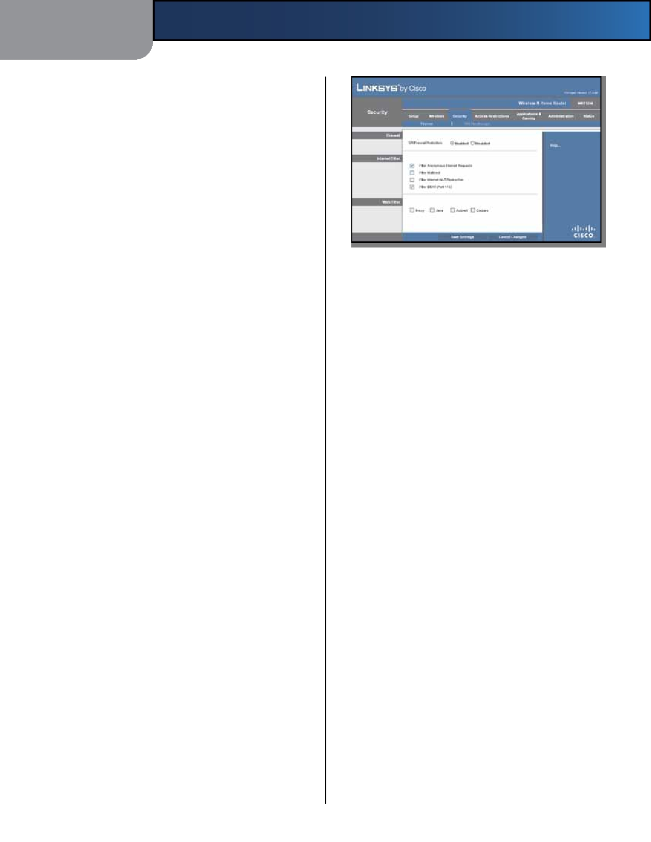
Chapter 3

Wireless-G devices are experiencing severe problems and are not able to transmit to the Router in an environment with heavy 802.11b traffic. This option boosts the Router's ability to catch all Wireless-N and Wireless-G transmissions but severely decreases performance. To use this option, keep the default, Auto. To disable this option, select Disabled.
Beacon Interval Enter a value between 1 and 65,535
milliseconds. The Beacon Interval value indicates the frequency interval of the beacon. A beacon is a packet broadcast by the Router to synchronize the wireless network. The default is 100 milliseconds.
DTIM Interval This value, between 1 and 255, indicates
the interval of the Delivery Traffic Indication Message (DTIM). A DTIM field is a countdown field informing clients of the next window for listening to broadcast

Firewall
Advanced Configuration

Security > Firewall

and multicast messages. When the Router has buffered broadcast or multicast messages for associated clients, it sends the next DTIM with a DTIM Interval value. Its clients hear the beacons and awaken to receive the broadcast and multicast messages. The default value is 1.
Fragmentation Threshold This value specifies the
maximum size for a packet before data is fragmented into multiple packets. If you experience a high packet error rate, you may slightly increase the Fragmentation Threshold. Setting the Fragmentation Threshold too low may result in poor network performance. Only minor reduction of the default value is recommended. In most cases, it should remain at its default value of 2346.
RTS Threshold Should you encounter inconsistent data
flow, only minor reduction of the default value, 2347, is recommended. If a network packet is smaller than the preset RTS threshold size, the RTS/CTS mechanism will not be enabled. The Router sends Request to Send (RTS) frames to a particular receiving station and negotiates the sending of a data frame. After receiving an RTS, the wireless station responds with a Clear to Send (CTS) frame to acknowledge the right to begin transmission. The RTS Threshold value should remain at its default value of 2347.
Click Save Settings to apply your changes, or click Cancel
Changes to clear your changes.
Security > Firewall
The Firewall screen is used to configure a firewall that can
filter out various types of unwanted traffic on the Router's local network.

Wireless-N Home Router
SPI Firewall Protection To use firewall protection,
keep the default selection, Enabled. To turn off firewall protection, select Disabled.
Internet Filter
For the following options, select the option to enable it, or
deselect the option to disable it.
Filter Anonymous Internet Requests This feature makes
it more difficult for outside users to work their way into your network. This feature is enabled by default. Deselect this option to allow anonymous Internet requests.
Filter Multicast Multicasting allows for multiple
transmissions to specific recipients at the same time. If multicasting is permitted, then the Router will allow IP multicast packets to be forwarded to the appropriate computers. Select this option to filter multicasting. This option is disabled by default.
Filter Internet NAT Redirection This feature uses port
forwarding to block access to local servers from local networked computers. Select this option to filter Internet NAT redirection. This option is disabled by default.
Filter IDENT (Port 113) This feature keeps port 113 from
being scanned by devices outside of your local network. This feature is enabled by default. Deselect this option to disable it.
Web Filter
For the following options, select the option to enable it, or
deselect the option to disable it.
Proxy Use of WAN proxy servers may compromise the
Gateway's security. Denying Proxy will disable access to any WAN proxy servers. Select this option to enable proxy filtering. This option is disabled by default.
Java Java is a programming language for websites. If you
deny Java, you run the risk of not having access to Internet sites created using this programming language. Select

16

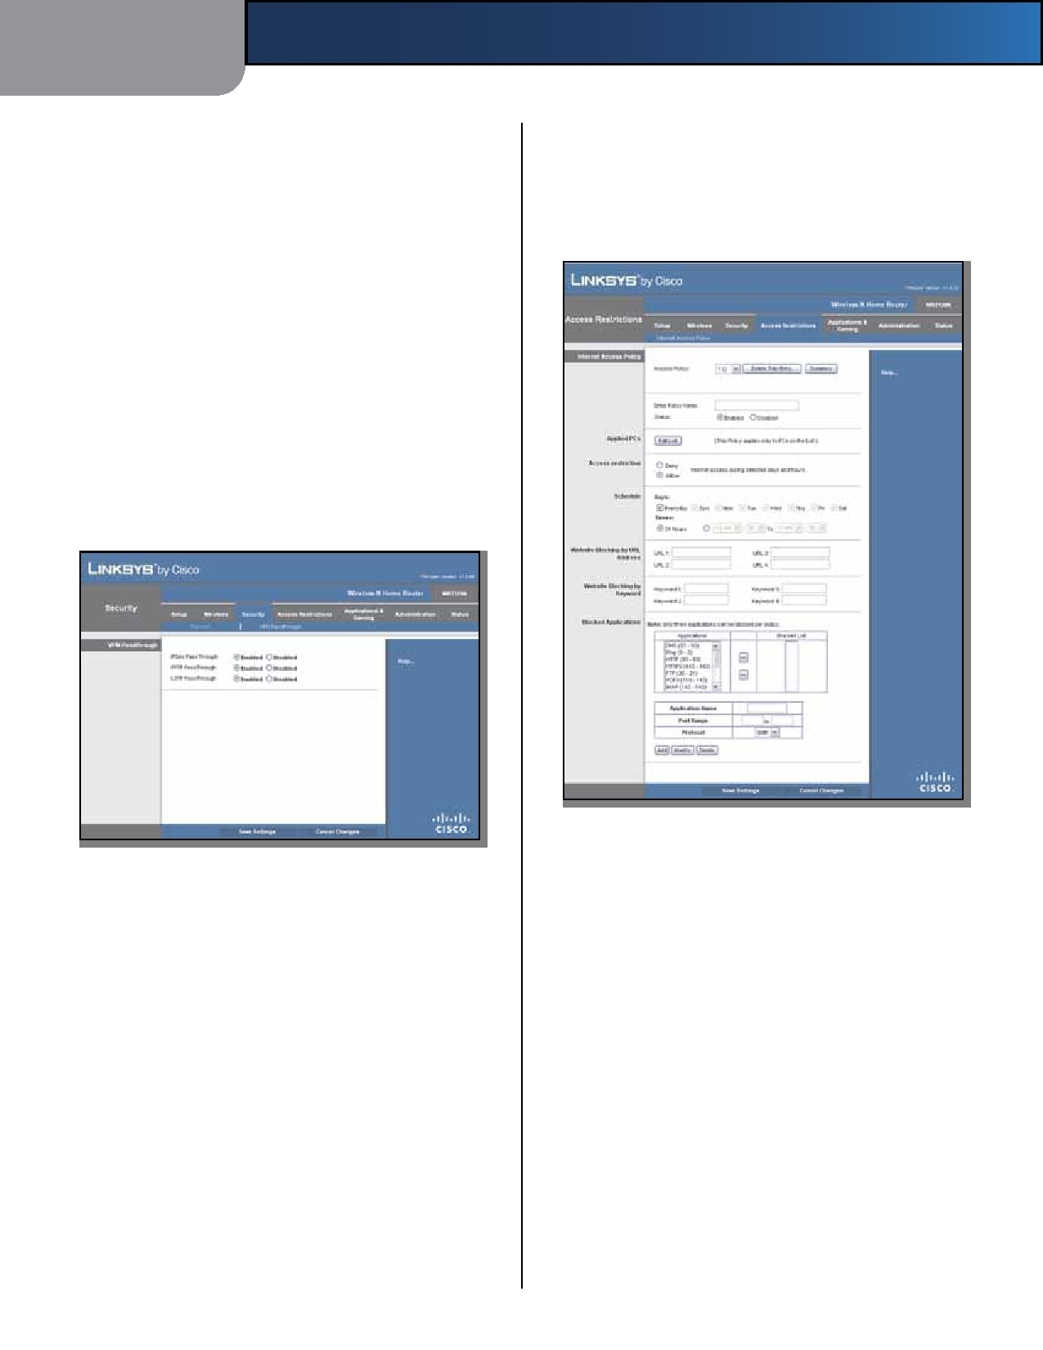
Chapter 3

this option to enable Java filtering. This option is disabled by default.
ActiveX ActiveX is a programming language for websites.
If you deny ActiveX, you run the risk of not having access to Internet sites created using this programming language. Select this option to enable ActiveX filtering. This option is disabled by default.
Cookies A cookie is data stored on your computer and
used by Internet sites when you interact with them. Select this option to filter cookies. This option is disabled by default.
Click Save Settings to apply your changes, or click Cancel
Changes to clear your changes.
Security > VPN Passthrough
The VPN Passthrough screen allows you to enable VPN
tunnels using IPSec, PPTP, or L2TP protocols to pass through the Router's firewall.
Advanced Configuration

Access Restrictions > Internet Access
The Internet Access screen allows you to block or allow
specific kinds of Internet usage and traffic, such as Internet access, designated services, and websites during specific days and times.

Security > VPN Passthrough

Access Restrictions > Internet Access

Internet Access Policy

VPN Passthrough
IPSec Passthrough Internet Protocol Security (IPSec) is
a suite of protocols used to implement secure exchange of packets at the IP layer. To allow IPSec tunnels to pass through the Router, keep the default, Enabled.
PPTP Passthrough Point-to-Point Tunneling Protocol
(PPTP) allows the Point-to-Point Protocol (PPP) to be tunneled through an IP network. To allow PPTP tunnels to pass through the Router, keep the default, Enabled.
L2TP Passthrough Layer 2 Tunneling Protocol is the
method used to enable Point-to-Point sessions via the Internet on the Layer 2 level. To allow L2TP tunnels to pass through the Router, keep the default, Enabled.
Click Save Settings to apply your changes, or click Cancel
Changes to clear your changes.
Access Policy Access can be managed by a policy. Use
the settings on this screen to establish an access policy (after Save Settings is clicked). Selecting a policy from the drop-down menu will display that policy's settings. To delete a policy, select that policy's number and click Delete This Entry. To view all the policies, click Summary.
Summary
The policies are listed with the following information: No.,
Policy Name, Days, and Time of Day. To delete a policy, select the policy's Delete option, and then click Delete.
To return to the Internet Access Policy screen, click Close.

Wireless-N Home Router 17

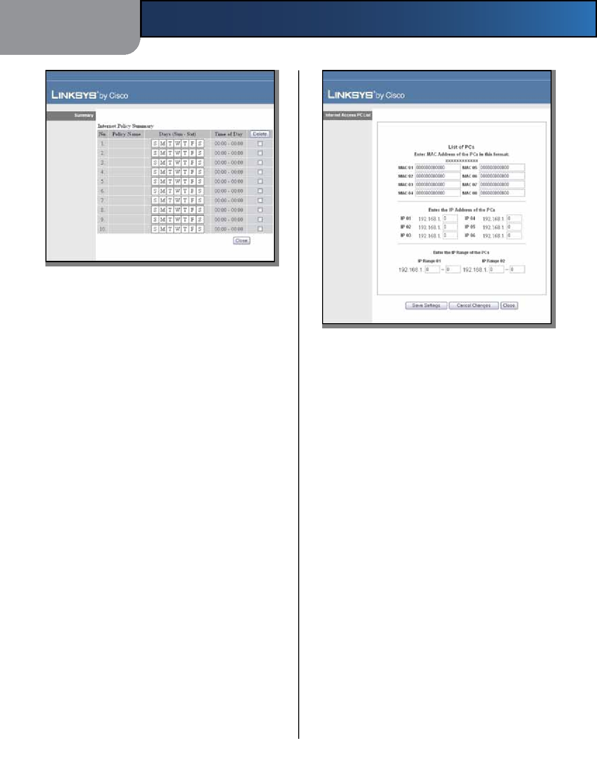
Chapter 3 Advanced Configuration

Summary

Status Policies are disabled by default. To enable a policy,
select the policy number from the drop-down menu, and select Enabled.
To create a policy, follow steps 1-11. Repeat these steps to
create additional policies, one at a time.
1. Select a number from the Access Policy drop-down
menu.
2. Enter a Policy Name in the field provided. 3. To enable this policy, select Enabled.
4. Click Edit List to select which computers will be
affected by the policy. The Internet Access PC List screen appears. You can select a computer by MAC address or IP address. You can also enter a range of IP addresses if you want this policy to affect a group of computers. After making your changes, click Save Settings to apply your changes, or click Cancel Changes to clear your changes. Then click Close.

Wireless-N Home Router

Internet Access PC List

5. Select the appropriate option, Deny or Allow,
depending on whether you want to block or allow Internet access for the computers you listed on the Internet Access PC List screen.
6. Decide which days and what times you want this policy
to be enforced. Select the individual days during which the policy will be in effect, or select Everyday. Then enter a range of hours and minutes during which the policy will be in effect, or select 24 Hours.
7. You can block websites with specific URL addresses.
Enter each URL in a separate Website Blocking by URL Address field.
8. You can also block websites using specific keywords.
Enter each keyword in a separate Website Blocking by Keyword field.
9. You can filter access to various services accessed
over the Internet, such as FTP or telnet. (You can block up to three applications per policy.)

From the Applications list, select the application you want to block. Then click the >> button to move it to the Blocked List. To remove an application from the Blocked List, select it and click the << button.
10. If the application you want to block is not listed or you
want to edit a service's settings, enter the application's name in the Application Name field. Enter its range in the Port Range fields. Select its protocol from the Protocol drop-down menu. Then click Add.
To modify a service, select it from the Application list.
Change its name, port range, and/or protocol setting. Then click Modify.

18

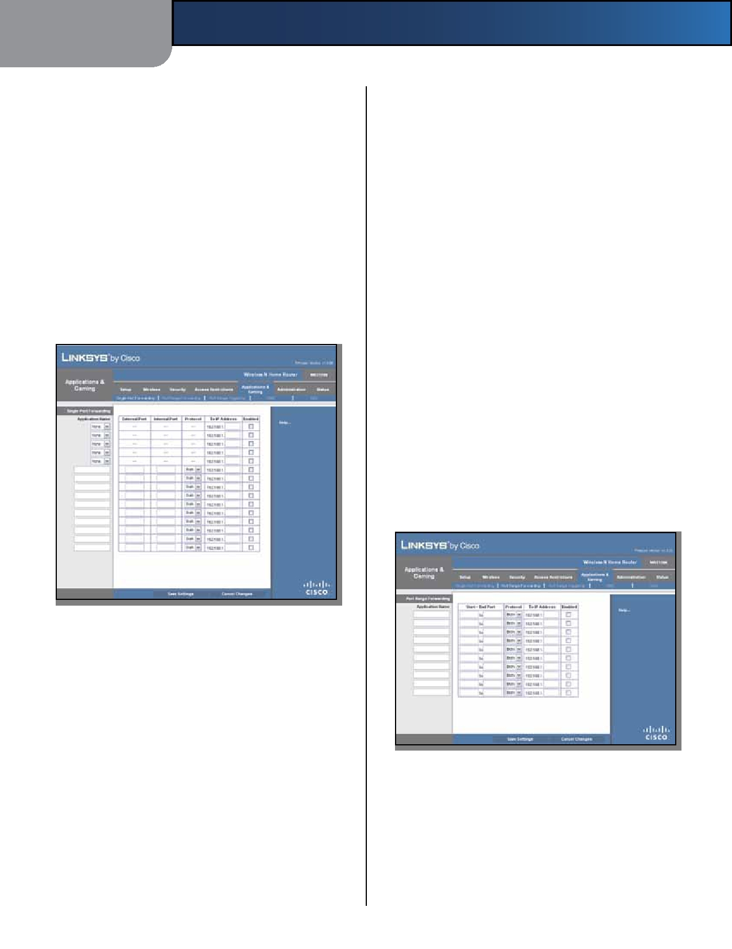
Chapter 3

To delete a service, select it from the Application list. Then click Delete.
11. Click Save Settings to save the policy's settings, or
click Cancel Changes to clear the changes.
Applications and Gaming > Single Port
Forwarding
The Single Port Forwarding screen allows you to customize
port services for common applications on this screen.
When users send these types of requests to your network via
the Internet, the Router will forward those requests to the appropriate servers (computers). Before using forwarding, you should assign static IP addresses to the designated servers (use the DHCP Reservation feature on the Basic Setup screen; refer to DHCP Reservation, page 7).
Advanced Configuration

To IP Address For each application, enter the IP address
of the computer that should receive the requests. If you assigned a static IP address to the computer, then you can look up its IP address; click DHCP Reservation on the Basic Setup screen (refer to DHCP Reservation, page 7).
Enabled For each application, select Enabled to enable
port forwarding.
Click Save Settings to apply your changes, or click Cancel
Changes to clear your changes.
Applications and Gaming > Port Range
Forwarding
The Port Range Forwarding screen allows you to set up
public services on your network, such as web servers, ftp servers, e-mail servers, or other specialized Internet applications. (Specialized Internet applications are any applications that use Internet access to perform functions such as videoconferencing or online gaming. Some Internet
applications may not require any forwarding.)
When users send these types of requests to your network via
the Internet, the Router will forward those requests to the appropriate servers (computers). Before using forwarding, you should assign static IP addresses to the designated servers (use the DHCP Reservation feature on the Basic Setup screen; refer to DHCP Reservation, page 7).
If you need to forward all ports to one computer, click the
DMZ tab.

Applications and Gaming > Single Port Forwarding

Single Port Forwarding
Common applications are available for the first five
entries. Select the appropriate application. Then enter the IP address of the server that should receive these requests. Select Enabled to activate this entry.
For additional applications, complete the following fields: Application Name Enter the name you wish to give the
application. Each name can be up to 12 characters.
External Port Enter the external port number used by
the server or Internet application. Check with the Internet application documentation for more information.
Internal Port Enter the internal port number used by
the server or Internet application. Check with the Internet application documentation for more information.
Protocol Select the protocol(s) used for this application,
TCP, UDP, or Both.
Wireless-N Home Router

Applications and Gaming > Port Range Forwarding

Port Range Forwarding
To forward a port, enter the information on each line for
the criteria required.
Application Name In this field, enter the name you
wish to give the application. Each name can be up to 12 characters.

19

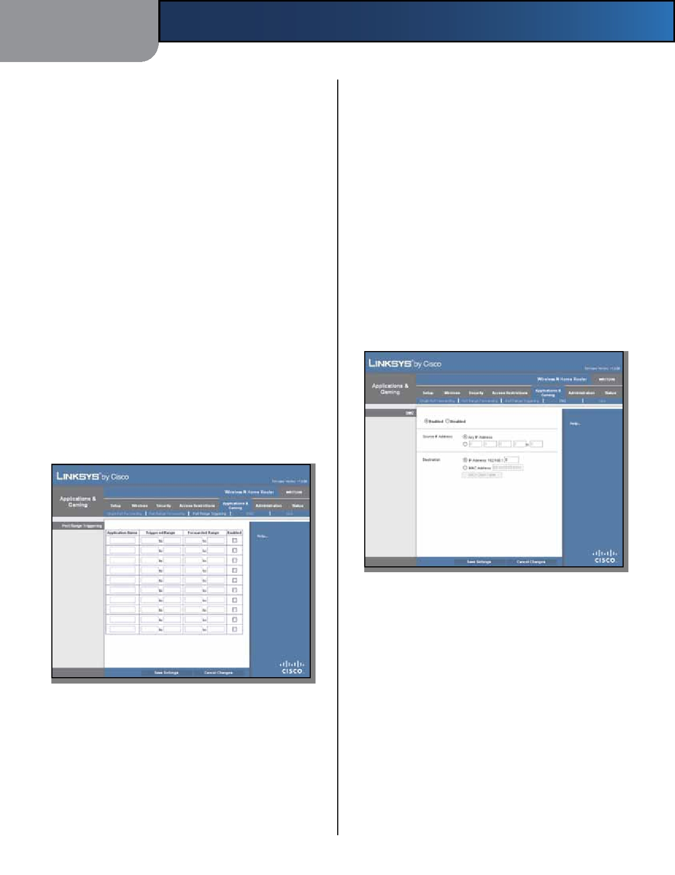
Chapter 3

Start~End Port Enter the number or range of port(s)
used by the server or Internet applications. Check with the Internet application documentation for more information.
Protocol Select the protocol(s) used for this application,
TCP, UDP, or Both.
To IP Address For each application, enter the IP address
of the computer that should receive the requests. If you assigned a static IP address to the computer, then you can look up its IP address; click DHCP Reservation on the Basic Setup screen (refer to DHCP Reservation, page 7).
Enabled Select Enabled to enable port forwarding for
the applications you have defined.
Click Save Settings to apply your changes, or click Cancel
Changes to clear your changes.
Applications & Gaming > Port Range
Triggering
The Port Range Triggering screen allows the Router to
watch outgoing data for specific port numbers. The IP address of the computer that sends the matching data is remembered by the Router, so that when the requested data returns through the Router, the data is pulled back to the proper computer by way of IP address and port mapping rules.
Advanced Configuration

Forwarded Range For each application, enter the starting
and ending port numbers of the forwarded port number range. Check with the Internet application documentation for the port number(s) needed.
Enabled Select Enabled to enable port triggering for the
applications you have defined.
Click Save Settings to apply your changes, or click Cancel
Changes to clear your changes.
Applications and Gaming > DMZ
The DMZ feature allows one network computer to be
exposed to the Internet for use of a special-purpose service such as Internet gaming or videoconferencing. DMZ hosting forwards all the ports at the same time to one computer. The Port Range Forwarding feature is more secure because it only opens the ports you want to have opened, while DMZ hosting opens all the ports of one computer, exposing the computer to the Internet.

Applications and Gaming > DMZ

DMZ
Any computer whose port is being forwarded must have
its DHCP client function disabled and should have a new static IP address assigned to it because its IP address may change when using the DHCP function.

Applications and Gaming > Port Range Triggering

Port Range Triggering
Application Name Enter the application name of the
trigger.
Triggered Range For each application, enter the starting
and ending port numbers of the triggered port number range. Check with the Internet application documentation for the port number(s) needed.

Wireless-N Home Router
Enabled/Disabled To disable DMZ hosting, select
Disabled. To expose one computer, select Enabled. Then
configure the following settings:
Source IP Address If you want any IP address to be the
source, select Any IP Address. If you want to specify an IP address or range of IP addresses as the designated source, select and complete the IP address range fields.
Destination If you want to specify the DMZ host by IP
address, select IP Address and enter the IP address in the field provided. If you want to specify the DMZ host

20

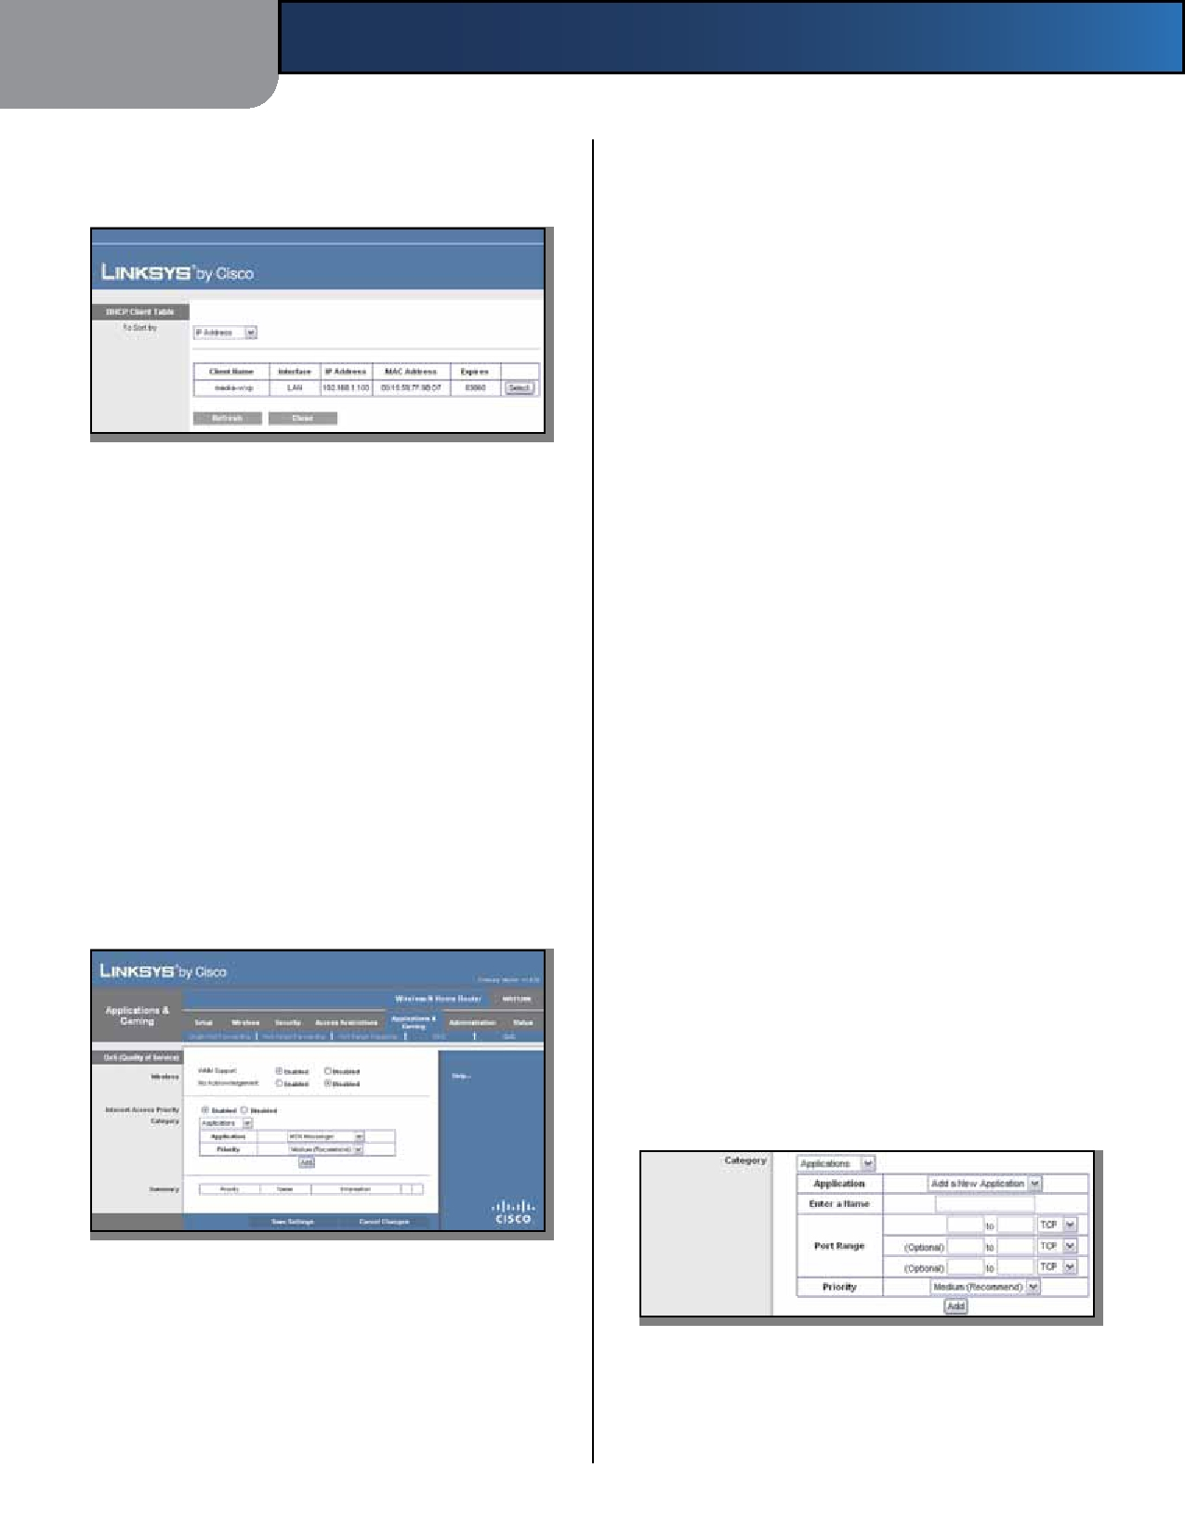
Chapter 3

by MAC address, select MAC Address and enter the MAC
address in the field provided. To retrieve this information, click DHCP Client Table.

DMZ > DHCP Client Table

DHCP Client Table
The DHCP Client Table lists computers and other
devices that have been assigned IP addresses by the Router. The list can be sorted by Client Name, Interface, IP Address, MAC Address, and Expires time (how much time is left for the current IP address). To select a DHCP client, click Select. To update the on-screen information, click Refresh. To exit this screen and return to the DMZ screen, click Close.
Click Save Settings to apply your changes, or click Cancel
Changes to clear your changes.
Applications and Gaming > QoS
Quality of Service (QoS) ensures better service to
high-priority types of network traffic, which may involve demanding, real-time applications, such as videoconferencing.
Advanced Configuration

WMM Support If you have other devices that support
Wi-Fi Multimedia (WMM) on your network, keep the default, Enabled. Otherwise, select Disabled.
No Acknowledgement If you want to disable the Router's
Acknowledgement feature, so the Router will not re-send data if an error occurs, then select Enabled. Otherwise, keep the default, Disabled.
Internet Access Priority
In this section, you can set the bandwidth priority for a
variety of applications and devices. There are four levels priority: High, Medium, Normal, or Low. When you set priority, do not set all applications to High, because this will defeat the purpose of allocating the available bandwidth. If you want to select below normal bandwidth, select Low. Depending on the application, a few attempts may be needed to set the appropriate bandwidth priority.
Enabled/Disabled To use the QoS policies you have set,
keep the default, Enabled. Otherwise, select Disabled.
Category
Select one of the following categories: Applications,
Online Games, MAC Address, Ethernet Port, or Voice
Device. Proceed to the instructions for your selection.
Summary
This lists the QoS entries you have created for your
applications and devices. Refer to Summary, page 22 for more information.
Applications
Application Select the appropriate application. If you
select Add a New Application, follow the Add a New Application instructions.
Priority Select the appropriate priority: High, Medium
(Recommend), Normal, or Low.
Click Add to save your changes. Your new entry appears in
the Summary list.
Add a New Application

Applications and Gaming > QoS

QoS (Quality of Service)
Wireless
You can configure the support and No Acknowledgement
settings in this section.

Wireless-N Home Router

QoS > Add a New Application

Enter a Name Enter any name to indicate the name of
the entry.

21

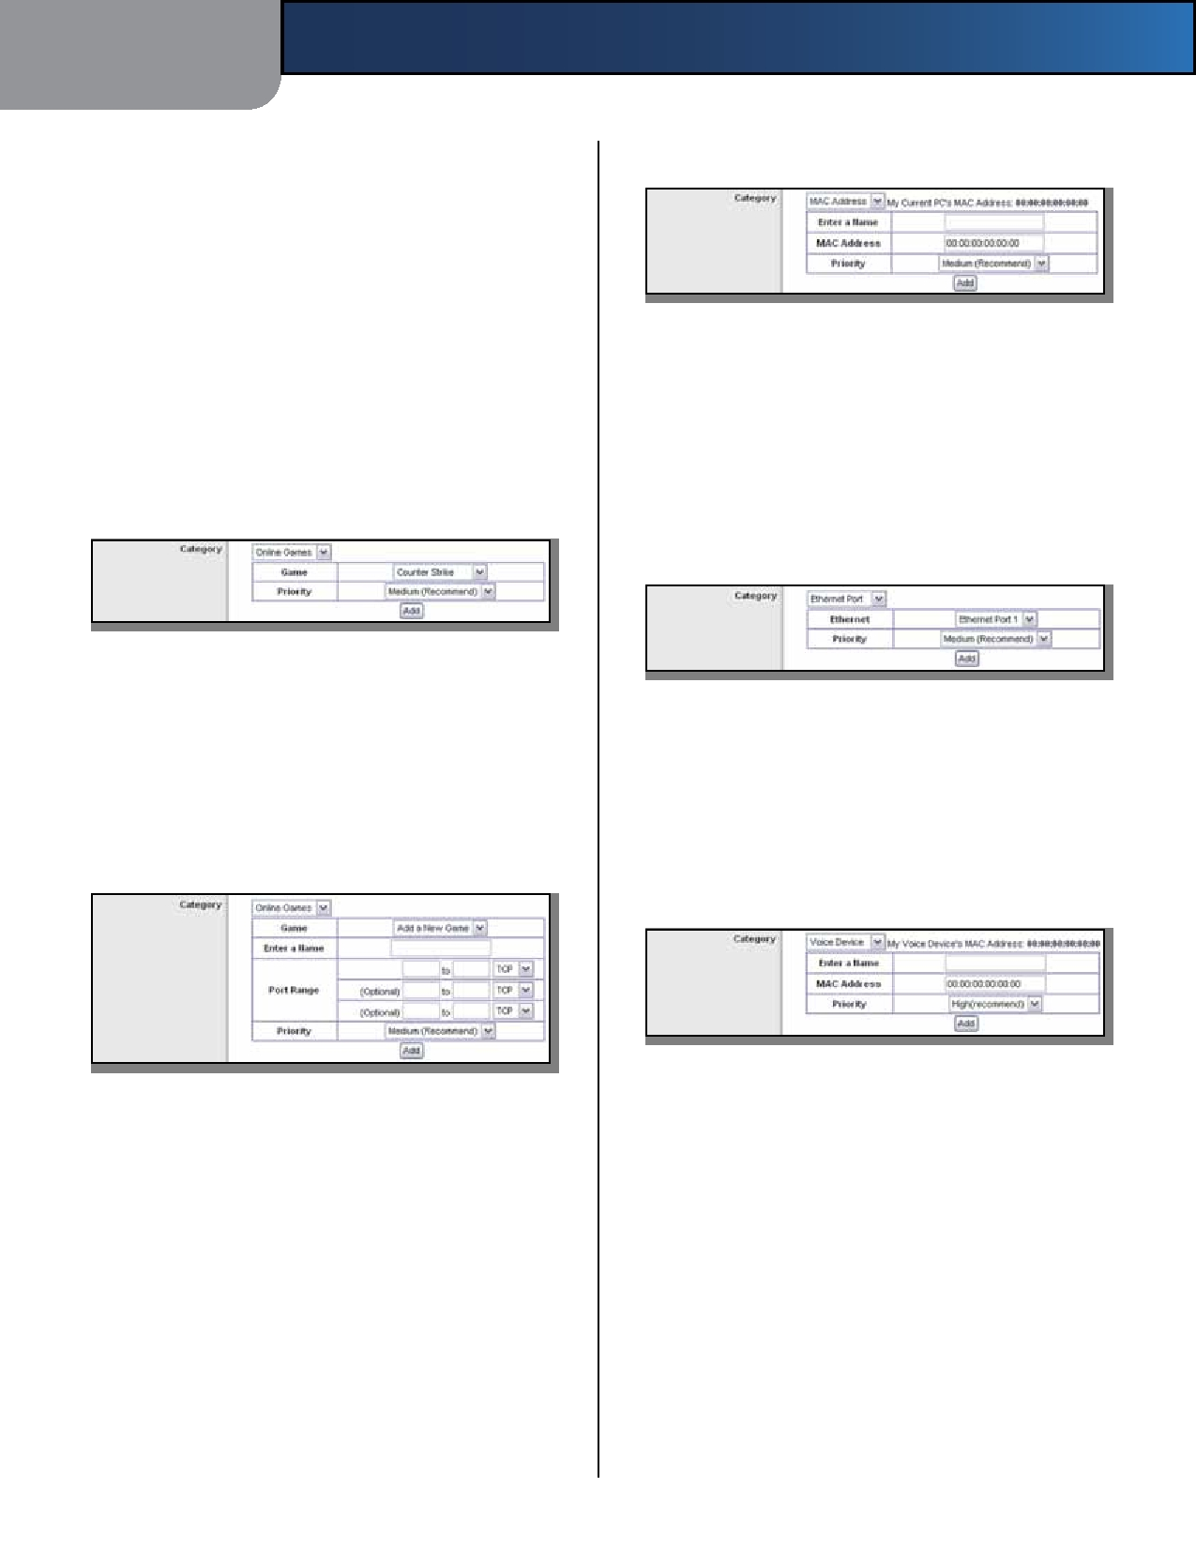
Chapter 3

Port Range Enter the port range that the application will
be using. For example, if you want to allocate bandwidth for FTP, you can enter 21-21. If you need services for an application that uses from 1000 to 1250, you enter 1000- 1250 as your settings. You can have up to three ranges to define for this bandwidth allocation. Port numbers can range from 1 to 65535. Check your application's
documentation for details on the service ports used.

MAC Address
Advanced Configuration

QoS > MAC Address

Select the protocol TCP or UDP, or select Both.
Priority Select the appropriate priority: High, Medium
(Recommend), Normal, or Low.
Click Add to save your changes. Your new entry appears in
the Summary list.
Online Games

Enter a Name Enter a name for your device.
MAC Address Enter the MAC address of your device.
Priority Select the appropriate priority: High, Medium
(Recommend), Normal, or Low.
Click Add to save your changes. Your new entry appears in
the Summary list.
Ethernet Port

QoS > Online Games

Game Select the appropriate game. If you select Add a
New Game, follow the Add a New Game instructions.
Priority Select the appropriate priority: High, Medium
(Recommend), Normal, or Low.
Click Add to save your changes. Your new entry appears in
the Summary list.
Add a New Game

QoS > Ethernet Port

Ethernet Select the appropriate Ethernet port.
Priority Select the appropriate priority: High, Medium
(Recommend), Normal, or Low.
Click Add to save your changes. Your new entry appears in
the Summary list.
Voice Device

QoS > Add a New Game

Enter a Name Enter any name to indicate the name of
the entry.
Port Range Enter the port range that the game will be
using. You can have up to three ranges to define for this

QoS > Voice Device

My Voice Device's MAC Address The MAC address of
your voice device is automatically displayed.
Enter a Name Enter a name for your voice device.
MAC Address Enter the MAC address of your voice
device.

bandwidth allocation. Port numbers can range from 1 to 65535. Check your application's documentation for details on the service ports used.
Priority Select the appropriate priority:
(Recommend), Medium, Normal, or Low.
High

Select the protocol TCP or UDP, or select Both.
Priority Select the appropriate priority: High, Medium
(Recommend), Normal, or Low.
Click Add to save your changes. Your new entry appears in
the Summary list.

Wireless-N Home Router
Click Add to save your changes. Your new entry appears in
the Summary list.
Summary
This lists the QoS entries you have created for your
applications and devices.

22

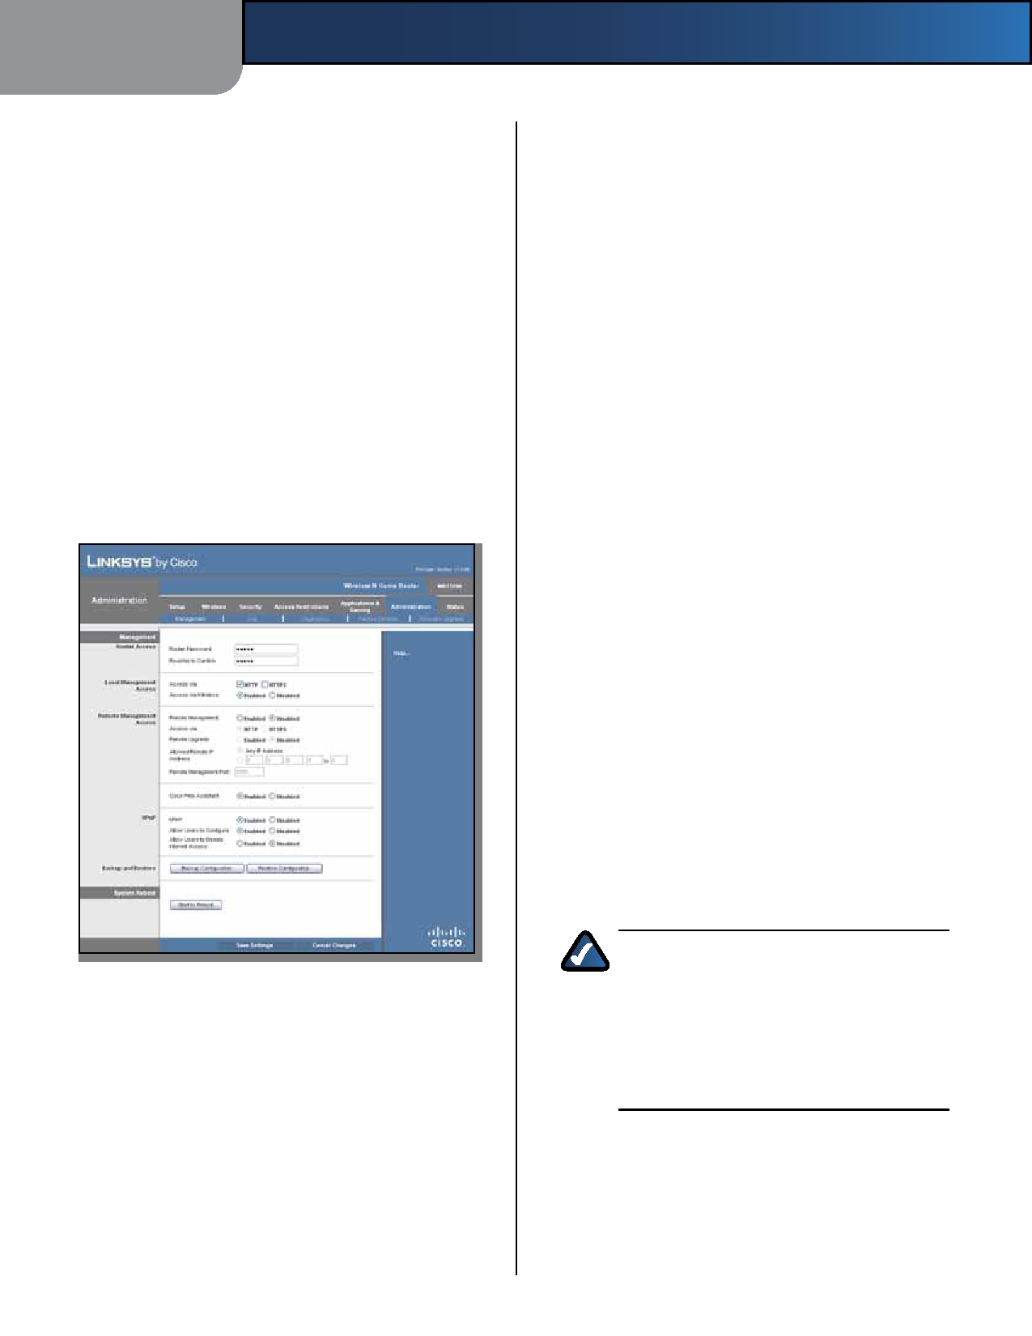
Chapter 3 Advanced Configuration

Priority This column displays the bandwidth priority of Local Management Access
High, Medium, Normal, or Low.

Name This column displays the application, device, or
port name.
Information This column displays the port range or
MAC address entered for your entry. If a pre-configured application or game was selected, there will be no valid entry shown in this section.
Remove Click this button to remove an entry. Edit Click this button to make changes.
Click Save Settings to apply your changes, or click Cancel
Changes to clear your changes.
Administration > Management
The Administration > Management screen allows the
network's administrator to manage specific Router functions for access and security.

Administration > Management
Access via HTTP (HyperText Transport Protocol) is the
communications protocol used to connect to servers on the World Wide Web. HTTPS uses SSL (Secured Socket Layer) to encrypt data transmitted for higher security. Select HTTP or HTTPS. HTTP is the default.
Access via Wireless If you are using the Router in a public
domain where you are giving wireless access to your guests, you can disable wireless access to the Router's browser-based utility. You will only be able to access the utility via a wired connection if you disable the setting. Keep the default, Enabled, to allow wireless access to the utility, or select Disabled to block wireless access to the utility.
Remote Management Access
Remote Management To permit remote access of the
Router, from outside the local network, select Enabled. Otherwise, keep the default, Disabled.
Access via HTTP (HyperText Transport Protocol) is the
communications protocol used to connect to servers on the World Wide Web. HTTPS uses SSL (Secured Socket Layer) to encrypt data transmitted for higher security. Select HTTP or HTTPS. HTTP is the default.
Remote Upgrade If you want to be able to upgrade the
Router remotely, from outside the local network, select Enabled. (You must have the Remote Management feature enabled as well.) Otherwise, keep the default, Disabled.
Allowed Remote IP Address If you want to be able to
access the Router from any external IP address, select Any IP Address. If you want to specify an external IP address or range of IP addresses, then select the second option and complete the fields provided.
Remote Management Port Enter the port number that
will be open to outside access.

NOTE: When you are in a remote location
and wish to manage the Router, enter

http://xxx.xxx.xxx.xxx:yyyy or

Management
https://xxx.xxx.xxx.xxx:yyyy,
depending

Router Access
To ensure the Router's security, you will be asked for your
password when you access the Router's browser-based utility. The default is admin.
Router Password Enter a new password for the Router.
Re-enter to confirm Enter the password again to
confirm.
on whether you use HTTP or HTTPS. Enter the Router's specific Internet IP address in place of xxx.xxx.xxx.xxx, and enter the Remote
Management Port number in place of yyyy.

Wireless-N Home Router 23

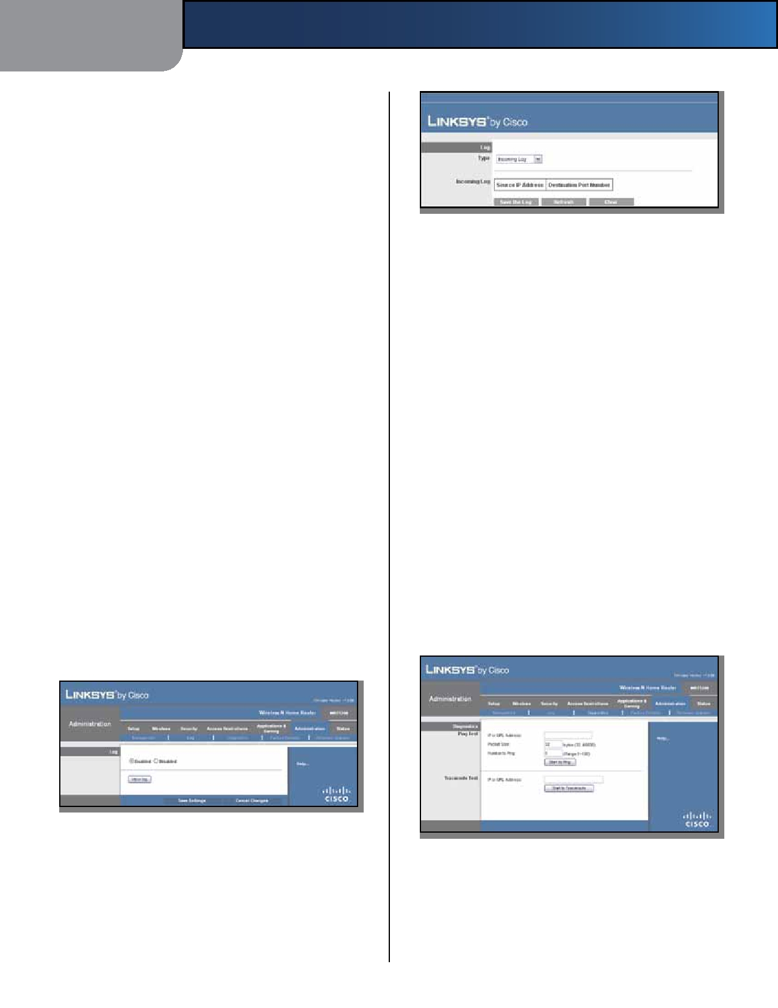
Chapter 3

UPnP
Universal Plug and Play (UPnP) allows the appropriate
Windows operating system to automatically configure the Router for various Internet applications, such as gaming and videoconferencing.
UPnP To use UPnP, keep the default, Enabled. Otherwise,
select Disabled.
Allow Users to Configure Keep the default, Enabled,
if you want to be able to make manual changes to the Router while using the UPnP feature. Otherwise, select Disabled.
Allow Users to Disable Internet Access Select Enabled,
if you want to be able to prohibit any and all Internet connections. Otherwise, keep the default, Disabled.
Backup and Restore
Backup Configuration To back up the Router's
configuration settings, click this button and follow the on-screen instructions.
Restore Configuration To restore the Router's
configuration settings, click this button and follow the on-screen instructions. (You must have previously backed
up the Router's configuration settings.)
System Reboot

Log

•

•
Advanced Configuration

Log > View Log

Type Select Incoming Log, Outgoing Log, Security
Log, or DHCP Client Log.
<Type> Log The Incoming Log displays a temporary
log of the source IP addresses and destination port numbers for the incoming Internet traffic. The Outgoing Log displays a temporary log of the local IP addresses, destination URLs/IP addresses, and service/ port numbers for the outgoing Internet traffic. The Security log displays the login information for the browser-based utility. The DHCP Client Log displays the LAN DHCP server status information.
Click Save the Log to save this information to a file on
your computer's hard drive. Click Refresh to update the log. Click Clear to clear all the information that is displayed.

Start to Reboot If you need to restart the Router, click
this button.
Click Save Settings to apply your changes, or click Cancel
Changes to clear your changes.
Administration > Log
The Router can keep logs of all traffic for your Internet
connection.
Click Save Settings to apply your changes, or click Cancel
Changes to clear your changes.
Administration > Diagnostics
The diagnostic tests (Ping and Traceroute) allow you to
check the connections of your network devices, including connection to the Internet.

Administration > Log

Administration > Diagnostics
Log

Enabled/Disabled To disable the Log function, select
Disabled. To monitor traffic between the network and the Internet, keep the default, Enabled. With logging enabled, you can choose to view temporary logs.
View Log To view the logs, click View Log.

Wireless-N Home Router

24

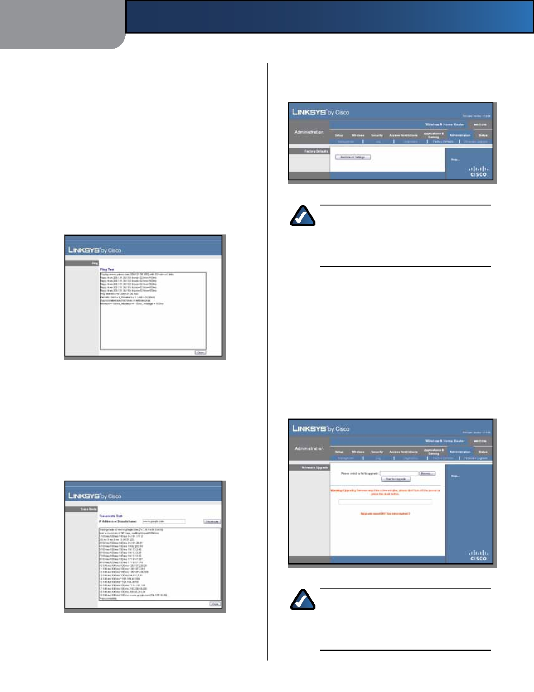
Chapter 3

Diagnostics
Ping Test
Ping checks the status of a connection.
IP or URL Address Enter the address of the computer
whose connection you wish to test.
Packet Size Enter the packet size you want to use. The
default is 32 bytes.
Number to Ping Enter the number of times you wish to
test the connection. The default is 5.
Start to Ping To run the test, click this button. The Ping
screen shows if the test is successful. Click Close to return to the Diagnostics screen.

Diagnostics > Ping

Traceroute Test
Traceroute checks the performance of a connection.
IP or URL Address Enter the address of the computer
whose connection you wish to test.
Start to Traceroute To run the test, click this button. The
Traceroute screen shows if the test is successful. Click Close to return to the Diagnostics screen.
Advanced Configuration

Administration > Factory Defaults
Restore the Router to its factory default settings.

Administration > Factory Defaults

NOTE: Do not restore the factory defaults unless
you are having difficulties with the Router and have exhausted all other troubleshooting measures. Once the Router is reset, you will have to re-enter all of your configuration settings.

Factory Defaults
Restore All Settings To reset the Router's settings to the
defaults, click this button and then follow the on-screen instructions. Any custom settings you have saved will be lost when the default settings are restored.
Administration > Firmware Upgrade
The Firmware Upgrade screen allows you to upgrade the
Router's firmware. Do not upgrade the firmware unless you are experiencing problems with the Router or the new firmware has a feature you want to use.

Administration > Firmware Upgrade

NOTE: The Router may lose the settings you
have customized. Before you upgrade its

Diagnostics > Traceroute
firmware, write down all of your custom settings. After you upgrade its firmware, you may have to re-enter all of your configuration settings.

Wireless-N Home Router 25

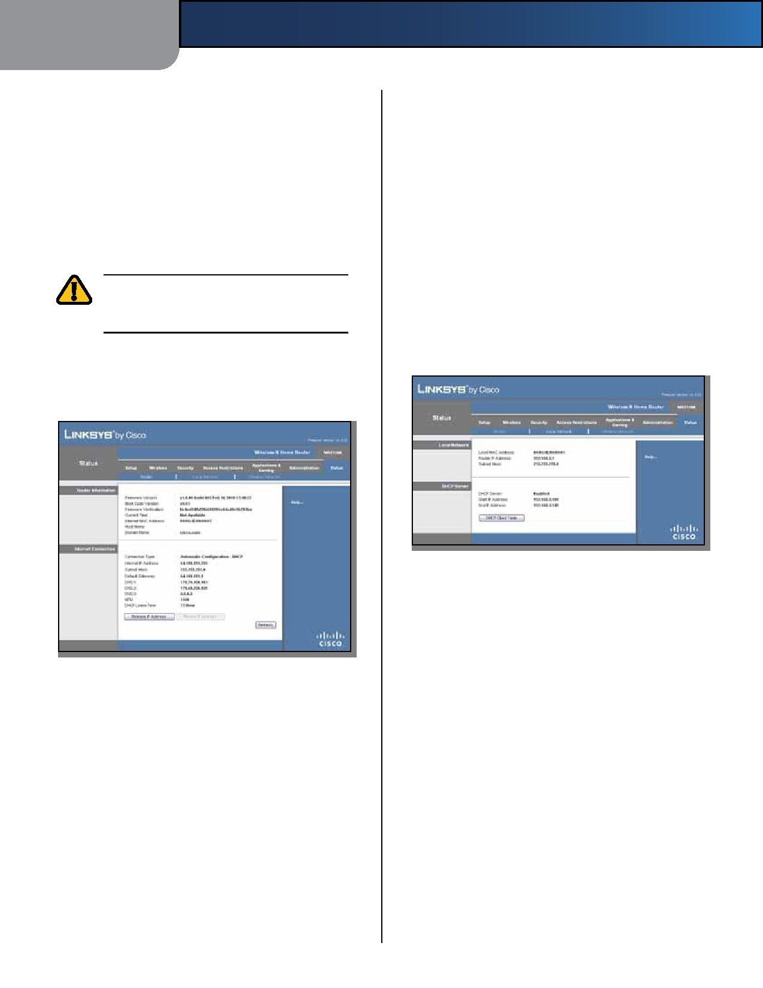
Chapter 3

Firmware Upgrade
Before upgrading the firmware, download the Router's
firmware upgrade file from the Linksys website, www.linksysbycisco.com.
Please select a file to upgrade To select the firmware
upgrade file, click Browse and follow the on-screen instructions.
Start to Upgrade After you have selected the
appropriate file, click this button, and follow the on-screen instructions.

WARNING: The firmware upgrade must not
be interrupted; do not reboot or power off the Router during the firmware upgrade.

Status > Router
The Router screen displays information about the Router
and its current settings.
Advanced Configuration

Domain Name The Domain Name of the Router is
displayed (if it was entered on the Setup > Basic Setup screen).
Internet Connection
This section shows the current network information
stored in the Router. The information varies depending on the Internet connection type selected on the Setup > Basic Setup screen.
Select Release IP Address or Renew IP Address as
appropriate to release or renew a DHCP lease.
Click Refresh to update the on-screen information.
Status > Local Network
The Local Network screen displays information about the
local, wired network.

Status > Local Network

Local Network
Local MAC Address The MAC address of the Router's
local, wired interface is displayed.
Router IP Address The Router's IP address, as it appears

Router Information
Status > Router
on your local network, is displayed.
Subnet Mask The Subnet Mask of the Router is
displayed.

Firmware Version The version number of the Router's
current firmware is displayed.
Boot Code Version The version number of the Router's
boot code is displayed.
Firmware Verification The unique identifier of the
firmware is displayed.
Current Time The time set on the Router is displayed.
Internet MAC Address The Router's MAC Address, as
seen by your ISP, is displayed.
Host Name The Host Name of the Router is displayed (if it
was entered on the Setup > Basic Setup screen).

Wireless-N Home Router
DHCP Server
DHCP Server The status of the Router's DHCP server
function is displayed.
Start IP Address For the range of IP addresses that can
be used by devices on your local network, the starting IP address is displayed.
End IP Address For the range of IP addresses that can
be used by devices on your local network, the ending IP address is displayed.
DHCP Clients Table Click this button to view a list of
computers or other devices that are using the Router as a DHCP server.

26

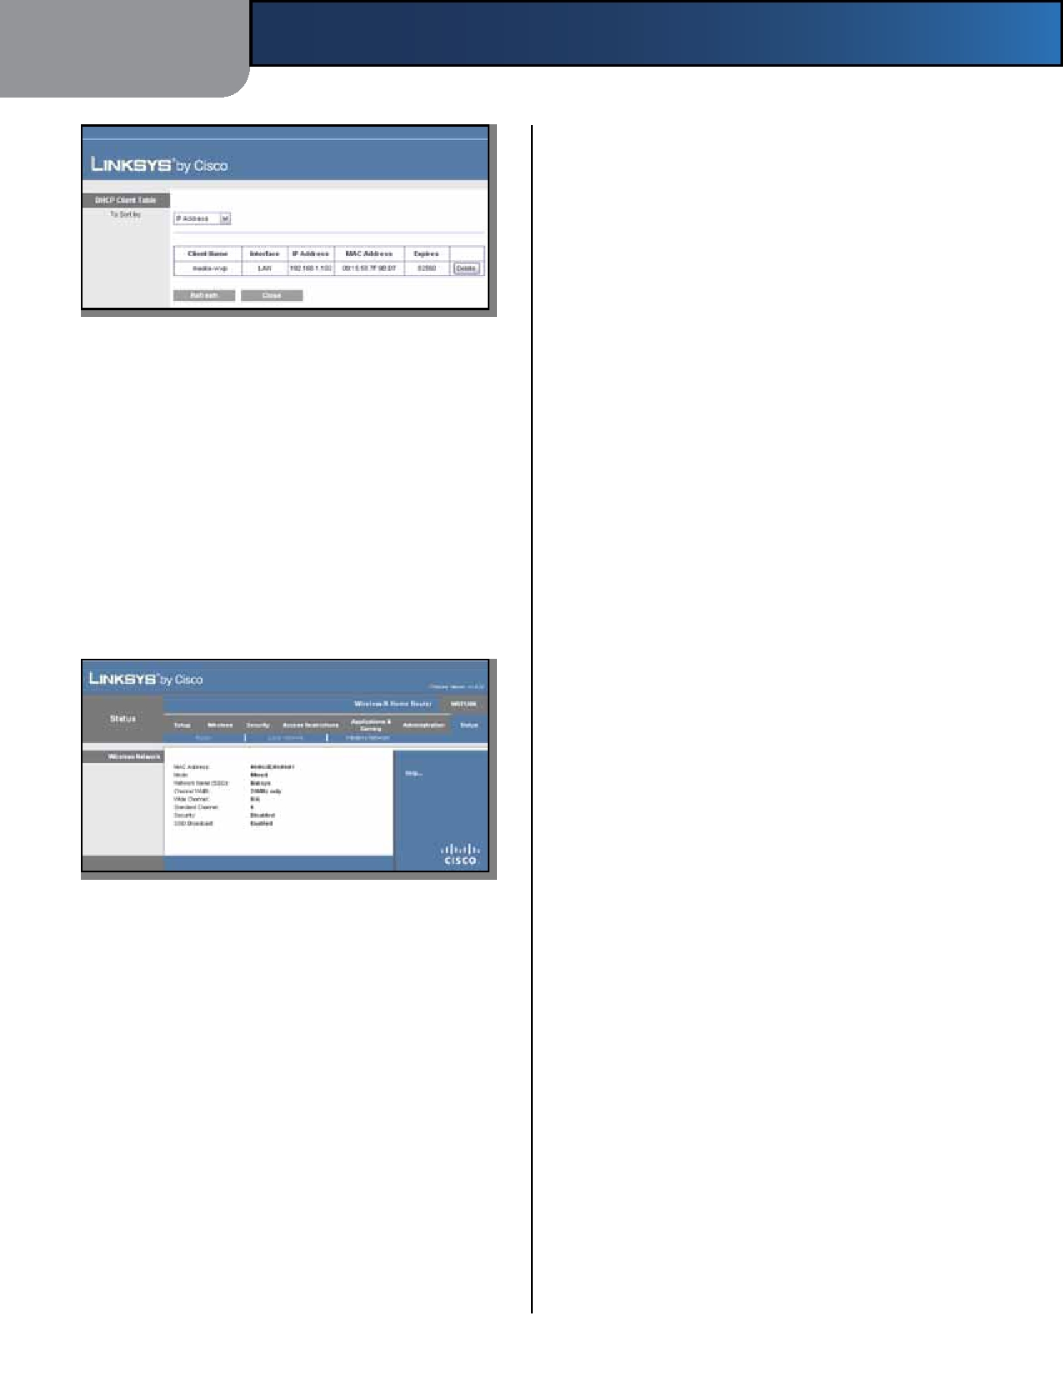
Chapter 3
Advanced Configuration

Security The wireless security method used by the Router
is displayed.
SSID Broadcast The status of the SSID Broadcast feature
is displayed.

DHCP Clients Table

DHCP Client Table
The DHCP Client Table lists computers and other
devices that have been assigned IP addresses by the Router. The list can be sorted by IP Address, MAC Address, Interface, and Client Name. To remove a DHCP client, click Delete. To update the on-screen information, click Refresh. To exit this screen and return to the Local Network screen, click Close.
Status > Wireless Network
The Wireless Network screen displays information about
your wireless network.

Status > Wireless

Wireless Network

MAC Address The MAC address of the Router's local,
wireless interface is displayed.
Mode The wireless mode used by the network is
displayed.
Network Name (SSID) The name of the wireless network,
which is also called the SSID, is displayed.
Channel Width The Channel Width setting (selected on
the Wireless > Basic Wireless Settings screen) is displayed.
Wide Channel The Wide Channel setting (selected on
the Wireless > Basic Wireless Settings screen) is displayed.
Standard Channel The Standard Channel setting
(selected on the Wireless > Basic Wireless Settings screen) is displayed.

Wireless-N Home Router

27


Appendix A

Appendix A:

4. Click OK.
Troubleshooting

Troubleshooting

Your computer cannot connect to the Internet.
Follow these instructions until your computer can connect
to the Internet:
The Router does not have a coaxial port for the cable
connection.
The Router does not replace your modem. You still need
your cable modem in order to use the Router. Connect your cable connection to the cable modem, and then insert the setup CD into your computer. Click Setup and follow the on-screen instructions.

• Make sure that the Router is powered on. The Power
LED should be lit and not flashing. The computer cannot connect wirelessly to the network.
• If the Power LED is flashing, then power off all of Make sure the wireless network name or SSID is the same
your network devices, including the modem, Router, on both the computer and the Router. If you have enabled
and computers. Then power on each device in the wireless security, then make sure the same security
following order: method and key are used by both the computer and the

1.
2. 3.
Cable or DSL modem
Router
Computer
Router.

You need to modify the settings on the Router.
Open the web browser (for example, Internet Explorer or

•
Check the cable connections. The computer should
be connected to one of the ports numbered 1-4 on the Router, and the modem must be connected to the Internet port on the Router.
Firefox), and enter the Router's IP address in the address field (the default IP address is 192.168.1.1). When prompted, enter the password to the Router (the default is admin). Click the appropriate tab to change the settings.

The modem does not have an Ethernet port.
The modem is a dial-up modem for traditional dial-up
service. To use the Router, you need a cable/DSL modem and high-speed Internet connection.

You cannot use the DSL service to connect manually to
the Internet.
After you have installed the Router, it will automatically
connect to your Internet Service Provider (ISP), so you no longer need to connect manually.

The DSL telephone line does not fit into the Router's
Internet port.
The Router does not replace your modem. You still need
your DSL modem in order to use the Router. Connect the telephone line to the DSL modem, and then insert the setup CD into your computer. Click Setup and follow the on-screen instructions.

When you double-click the web browser, you are
prompted for a username and password. If you want to get rid of the prompt, follow these instructions.
Launch the web browser and perform the following steps
(these steps are specific to Internet Explorer but are similar
for other browsers):
1. Select Tools > Internet Options.
2. Click the Connections tab.
3. Select Never dial a connection.

Wireless-N Home Router

WEB: If your questions are not addressed
here, refer to the Linksys website,
www.linksysbycisco.com

28


Appendix A Troubleshooting

Wireless-N Home Router 29


Appendix B

Appendix B:
Specifications

Operating Humidity 10 to 80%, Noncondensing

Specifications
Storage Humidity
5 to 90% Noncondensing

Model
Standards

LEDs

Ports
Buttons
Cabling Type # of Antennas
Detachable (y/n)
Modulations

Transmitted Power
in dBm

Receive Sensitivity
in dBm

WRT120N
IEEE 802.3u, 802.11g, 802.11b,
Draft 802.11n
Power, Internet, Wireless, Wi-Fi
Protected Setup™, Ethernet (1-4)
Internet, Ethernet (1-4), Power Reset, Wi-Fi Protected Setup™
Cat 5
2 (internal)
No
802.11b: CCK/QPSK, BPSK
802.11g: OFDM/BPSK, QPSK,
16-QAM, 64-QAM
802.11n: OFDM/BPSK, QPSK,
16-QAM, 64-QAM

802.11b: 16.5 ± 1.5 dBm (typical) 802.11g: 13.5 ± 1.5 dBm (typical) 802.11n: 13.5 ± 1.5 dBm (typical)

-94 dBm (typical) @ 1 Mbps
-90 dBm (typical) @ 11 Mbps -75 dBm (typical) @ 54 Mbps
-66 dBm (typical) @ 270 Mbps
Specifications are subject to change without notice.

Antenna Gain in dBi 2.0 (max)

UPnP able/cert
Wireless Security

Security Key Bits
OS Requirements

Environmental
Dimensions

Unit Weight
Power
Certifications

Operating Temp.
Storage Temp.

Wireless-N Home Router
Able
Wi-Fi Protected Access™ 2 (WPA2),
WEP, Wireless MAC Filtering
Up to 128-Bit Encryption
Windows XP, Vista, or Vista 64-Bit
Edition with Latest Updates (for
Network Magic and Setup Wizard)
Mac OS X 10.4 or higher (for
Setup Wizard)

7.99" x 1.38" x 6.30" (203 x 35 x 160 mm)
8.4 oz (238 g)
12V, 1A
FCC, UL/cUL, ICES-003, RSS210, CE,
Wi-Fi (IEEE 802.11b/g), WPA2™, WMM®, Wi-Fi Protected Setup™
0 to 40°C (32 to 104°F)
-20 to 60°C (-4 to 140°F)

30

Appendix E

Appendix E:
Warranty Information

Limited Warranty
Linksys warrants that this Linksys hardware product will be
substantially free of defects in materials and workmanship arising under normal use during the Warranty Period, which begins on the date of purchase by the original end-
user purchaser and lasts for the period specified below:
Warranty Information

network on which the product or software is used will be free of vulnerability to intrusion or attack. The product may include or be bundled with third party software or service offerings. This limited warranty shall not apply to such third party software or service offerings. This limited warranty does not guarantee any continued availability of a third party's service for which this product's use or operation may require.
TO THE EXTENT NOT PROHIBITED BY LAW, ALL IMPLIED
WARRANTIES AND CONDITIONS OF MERCHANTABILITY, SATISFACTORY QUALITY OR FITNESS FOR A PARTICULAR PURPOSE ARE LIMITED TO THE DURATION OF THE

•
•
Two (2) years for new product
Ninety (90) days for refurbished product
WARRANTY PERIOD. ALL OTHER EXPRESS OR IMPLIED CONDITIONS, REPRESENTATIONS AND WARRANTIES, INCLUDING, BUT NOT LIMITED TO, ANY IMPLIED

This limited warranty is non-transferable and extends only to the original end-user purchaser. Your exclusive remedy and Linksys' entire liability under this limited warranty will be for Linksys, at its option, to (a) repair the product with new or refurbished parts, (b) replace the product with a reasonably available equivalent new or refurbished Linksys product, or (c) refund the purchase price of the product less any rebates. Any repaired or replacement products will be warranted for the remainder of the original Warranty Period or thirty (30) days, whichever is longer. All products and/or parts that are replaced become the property of Linksys.
This limited warranty shall apply in addition to any
statutory or other rights which you may have under a contract of sale.
Exclusions and Limitations
This limited warranty does not apply if: (a) the product
assembly seal has been removed or damaged, (b) the product has been altered or modified, except by Linksys, (c) the product damage was caused by use with non- Linksys products, (d) the product has not been installed, operated, repaired, or maintained in accordance with instructions supplied by Linksys, (e) the product has been subjected to abnormal physical or electrical stress, misuse, negligence, or accident, (f ) the serial number on the Product has been altered, defaced, or removed, or (g) the product is supplied or licensed for beta, evaluation, testing or demonstration purposes for which Linksys does not charge a purchase price or license fee.
ALLSOFTWAREPROVIDEDBYLINKSYSWITHTHEPRODUCT,
WHETHER FACTORY LOADED ON THE PRODUCT OR CONTAINED ON MEDIA ACCOMPANYING THE PRODUCT, IS PROVIDED "AS IS" WITHOUT ANY WARRANTY OF ANY KIND. Without limiting the foregoing, Linksys does not warrant that the operation of the product or software will be uninterrupted or error free. Also, due to the continual development of new techniques for intruding upon and attacking networks, Linksys does not warrant that the product, service, software or any equipment, system or

Wireless-N Home Router
WARRANTY OF NON-INFRINGEMENT, ARE DISCLAIMED. Some jurisdictions do not allow limitations on how long an implied warranty lasts, so the above limitation may not apply to you. This limited warranty gives you specific legal rights, and you may also have other rights which vary by jurisdiction.
TO THE EXTENT NOT PROHIBITED BY LAW, IN NO EVENT
WILL LINKSYS BE LIABLE FOR ANY LOST DATA, REVENUE OR PROFIT, OR FOR SPECIAL, INDIRECT, CONSEQUENTIAL, INCIDENTAL OR PUNITIVE DAMAGES, REGARDLESS OF THE THEORY OF LIABILITY (INCLUDING NEGLIGENCE), ARISING OUT OF OR RELATED TO THE USE OF OR INABILITY TO USE THE PRODUCT (INCLUDING ANY SOFTWARE), EVEN IF LINKSYS HAS BEEN ADVISED OF THE POSSIBILITY OF SUCH DAMAGES. IN NO EVENT WILL LINKSYS' LIABILITY EXCEED THE AMOUNT PAID BY YOU FOR THE PRODUCT. The foregoing limitations will apply even if any warranty or remedy provided under this limited warranty fails of its essential purpose. Some jurisdictions do not allow the exclusion or limitation of incidental or consequential damages, so the above limitation or exclusion may not apply to you.
Obtaining Warranty Service
If you have a question about your product or experience a
problem with it, please go to www.linksys.com/support where you will find a variety of online support tools and information to assist you with your product. If the product proves defective during the Warranty Period, contact Linksys Technical Support for instructions on how to obtain warranty service. The telephone number for Linksys Technical Support in your area can be found in the product User Guide and at www.linksys.com. Have your product serial number and proof of purchase on hand when calling. A DATED PROOF OF ORIGINAL PURCHASE IS REQUIRED TO PROCESS WARRANTY CLAIMS. If you are requested to return your product, you will be given a Return Materials Authorization (RMA) number. You are responsible for properly packaging and shipping your product to Linksys at your cost and risk. You must include the RMA number

31


Appendix E

and a copy of your dated proof of original purchase when returning your product. Products received without a RMA number and dated proof of original purchase will be rejected. Do not include any other items with the product you are returning to Linksys. Defective product covered by this limited warranty will be repaired or replaced and returned to you without charge. Customers outside of the United States of America and Canada are responsible for all shipping and handling charges, custom duties, VAT and other associated taxes and charges. Repairs or replacements not covered under this limited warranty will be subject to charge at Linksys' then-current rates.
Technical Support
This limited warranty is neither a service nor a
support contract. Information about Linksys' current technical support offerings and policies (including any fees for support services) can be found at
www.linksys.com/support
General
This limited warranty is governed by the laws of the
jurisdiction in which the Product was purchased by you.
If any portion of this limited warranty is found to be void
or unenforceable, its remaining provisions shall remain in full force and effect.
Please direct all inquiries to: Linksys, P.O. Box 18558, Irvine,
CA 92623.
For more information, please contact us
www.linksys.com
Select your country, and then select SUPPORT/
TECHNICAL
For product returns:
Select your Country and then select CUSTOMER SUPPORT
Warranty Information

Wireless-N Home Router 32

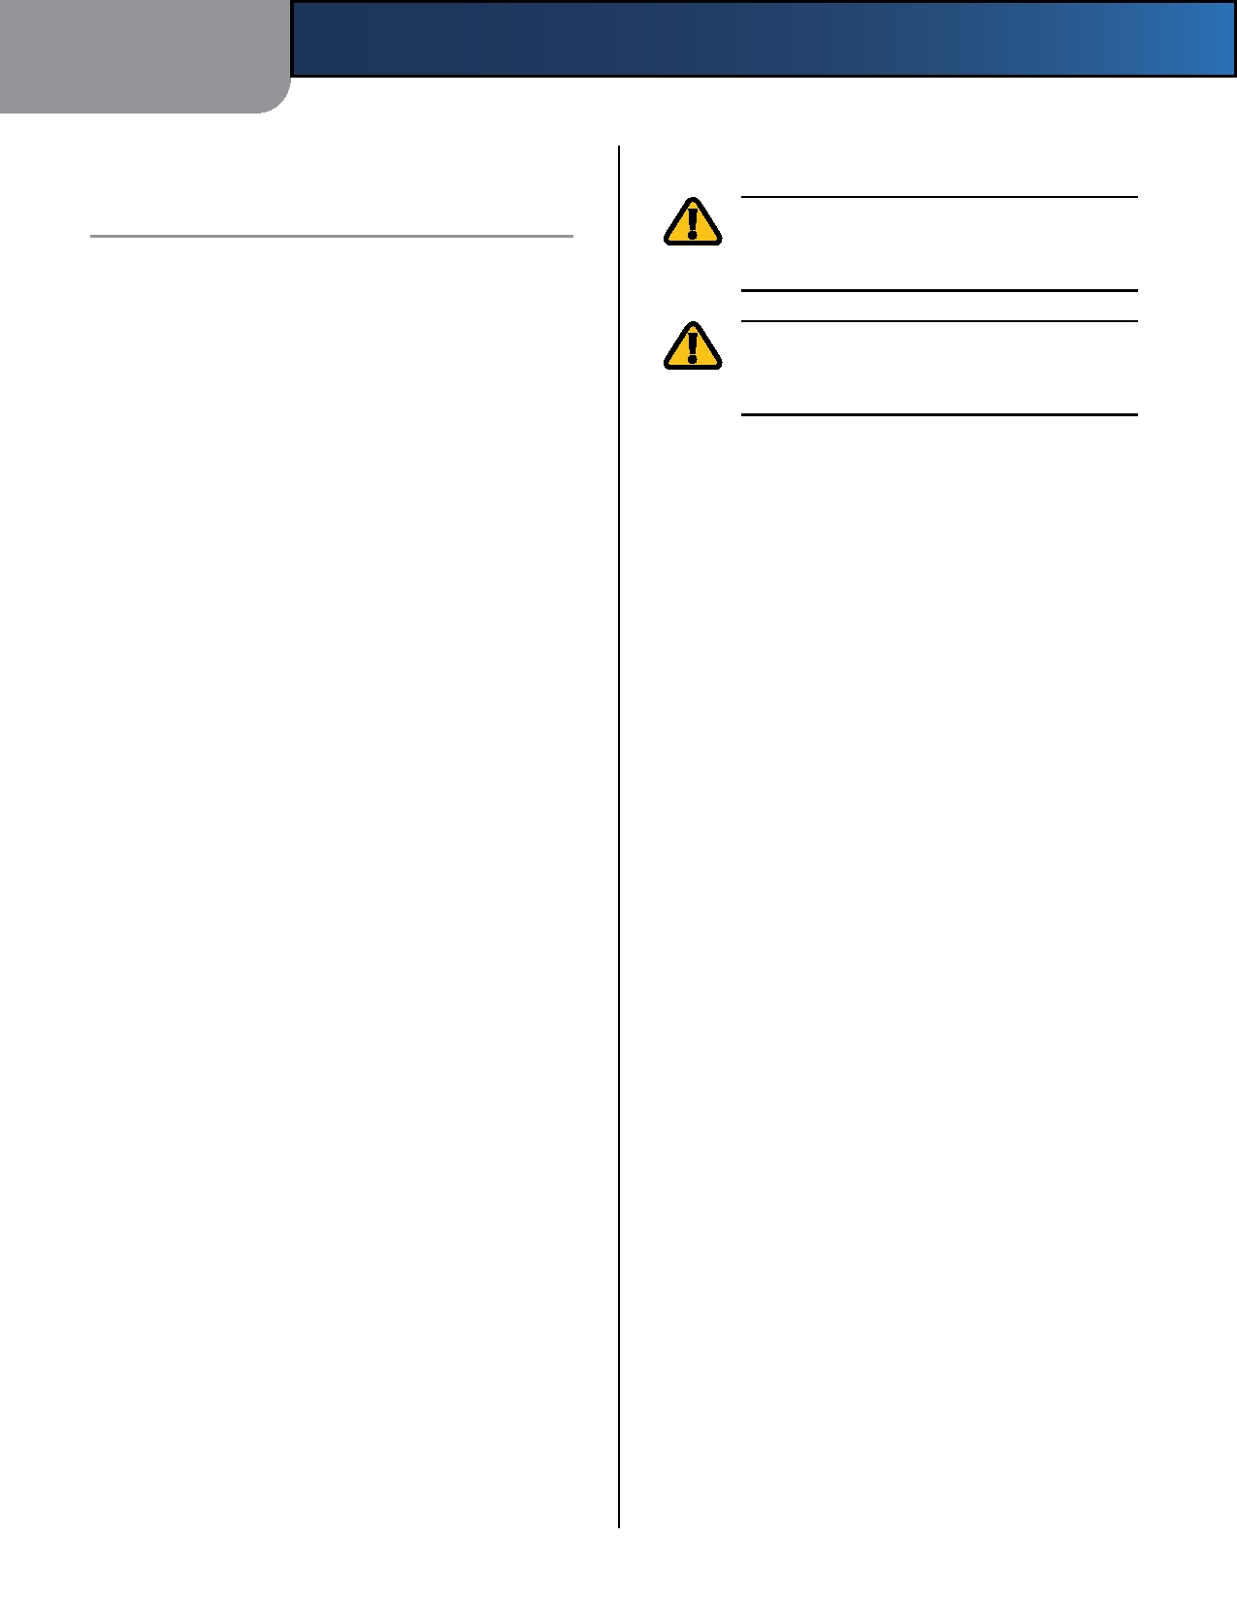
Appendix D

Appendix D:

Safety Notices
Regulatory Information

Regulatory Information

FCC Statement
This device complies with Part 15 of the FCC Rules.
Operation is subject to the following two conditions: (1) This device may not cause harmful interference, and (2) this device must accept any interference received, including interference that may cause undesired operation.
This product has been tested and complies with the
specifications for a Class B digital device, pursuant to Part 15 of the FCC Rules. These limits are designed to provide reasonable protection against harmful interference in a residential installation. This equipment generates, uses, and can radiate radio frequency energy and, if not installed and used according to the instructions, may cause harmful interference to radio communications. However, there is no guarantee that interference will not occur in a particular installation. If this equipment does cause harmful interference to radio or television reception, which is found by turning the equipment off and on, the user is encouraged to try to correct the interference by
one or more of the following measures:

WARNING: Do not use this product near water,
for example, in a wet basement or near a swimming pool.

WARNING: Avoid using this product during an
electrical storm. There may be a remote risk of electric shock from lightning.

• Reorient or relocate the receiving antenna
• Increase the separation between the equipment or
devices
• Connect the equipment to an outlet other than the
receiver's
• Consult a dealer or an experienced radio/TV technician
for assistance
FCC Caution: Any changes or modifications not expressly
approved by the party responsible for compliance could void the user's authority to operate this equipment.
FCC Radiation Exposure Statement
This equipment complies with FCC radiation exposure limits
set forth for an uncontrolled environment. This equipment should be installed and operated with minimum distance 20 cm between the radiator and your body.

Wireless-N Home Router 33

Appendix D

Industry Canada Statement
This Class B digital apparatus complies with Canadian
ICES-003 and RSS210.
Operation is subject to the following two conditions:
1. This device may not cause interference and
2. This device must accept any interference, including
interference that may cause undesired operation of the device.
Industry Canada Radiation Exposure Statement
This equipment complies with IC radiation exposure limits
set forth for an uncontrolled environment. This equipment should be installed and operated with minimum distance 20 cm between the radiator & your body.
This transmitter must not be co-located or operating in
conjunction with any other antenna or transmitter.
Avis d'Industrie Canada
Cet appareil numérique de la classe B est conforme aux
normes NMB-003 et RSS210 du Canada.
L'utilisation de ce dispositif est autorisée seulement aux
conditions suivantes :
1. il ne doit pas produire de brouillage et
2. il doit accepter tout brouillage radioélectrique reçu,
même si ce brouillage est susceptible de compromettre le fonctionnement du dispositif.
Avis d'Industrie Canada concernant l'exposition
aux radiofréquences
Ce matériel est conforme aux limites établies par IC
en matière d'exposition aux radiofréquences dans un environnement non contrôlé. Ce matériel doit être installé et utilisé à une distance d'au moins 20 cm entre l'antenne et le corps de l'utilisateur.
L'émetteur ne doit pas être placé près d'une autre antenne
ou d'un autre émetteur, ou fonctionner avec une autre antenne ou un autre émetteur.
Regulatory Information

Wireless Disclaimer
The maximum performance for wireless is derived from
IEEE Standard 802.11 specifications. Actual performance can vary, including lower wireless network capacity, data throughput rate, range and coverage. Performance depends on many factors, conditions and variables, including distance from the access point, volume of network traffic, building materials and construction, operating system used, mix of wireless products used, interference and other adverse conditions.
Avis de non-responsabilité concernant les
appareils sans fil
Les performances maximales pour les réseaux sans fil
sont tirées des spécifications de la norme IEEE 802.11. Les performances réelles peuvent varier, notamment en fonction de la capacité du réseau sans fil, du débit de la transmission de données, de la portée et de la couverture. Les performances dépendent de facteurs, conditions et variables multiples, en particulier de la distance par rapport au point d'accès, du volume du trafic réseau, des matériaux utilisés dans le bâtiment et du type de construction, du système d'exploitation et de la combinaison de produits sans fil utilisés, des interférences et de toute autre condition défavorable.

Wireless-N Home Router 34

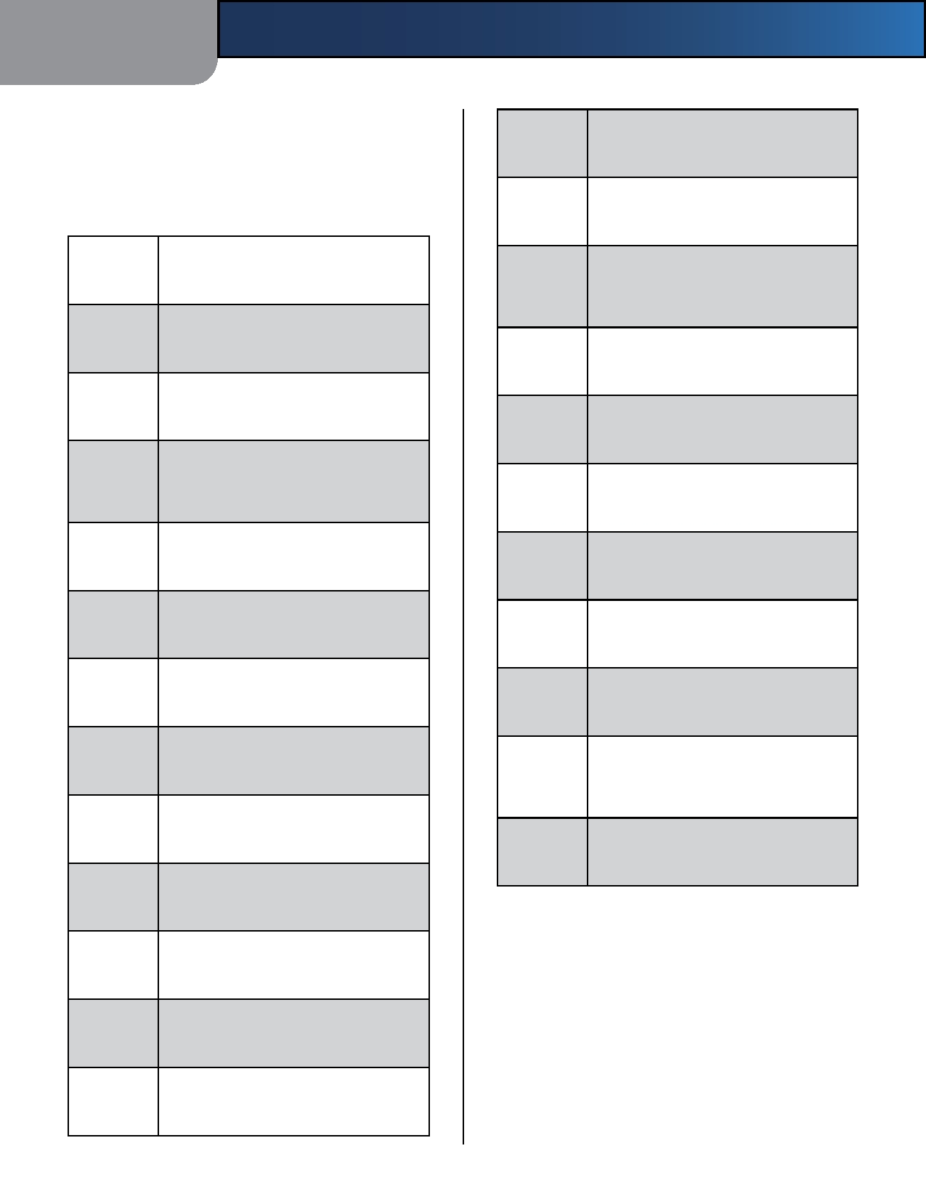
Appendix D

Declaration of Conformity with Regard to EU Directive 1999/5/EC (R&TTE Directive)
Compliance Information for 2,4-GHz and 5-GHz Wireless
Products Relevant to the EU and Other Countries Following
the EU Directive 1999/5/EC (R&TTE Directive)

Nederlands
[Dutch]:

Malti
[Maltese]:
Regulatory Information

Dit apparaat voldoet aan de essentiele eisen en andere van toepassing zijnde bepalingen van de Richtlijn 1999/5/EC.

Dan l-apparat huwa konformi mal-ħtiġiet essenzjali u l-provedimenti l-oħra rilevanti tad-Direttiva 1999/5/EC.

Б ъ л г а р с к и Това оборуядване оприложимисъщлаутвенина

изисквани
и
тговаря на
ес
к зи
те
Ez a készülék teljesíti az alapvető

[Bulgarian]
Magyar
követelményeket
és
más
1999/5/EK

Директива 1999/5/ЕС.
[Hungarian]:
irányelvben
meghatározott
vonatkozó

Česky
[Czech]:

Dansk
[Danish]:
Toto zařízení je v souladu se základními
požadavky a ostatními odpovídajícími ustanoveními Směrnice 1999/5/EC.

Dette udstyr er i overensstemmelse med de væsentlige krav og andre relevante bestemmelser i Direktiv 1999/5/EF.

Dieses Gerät entspricht den grundlegenden

Norsk
[Norwegian]:

Polski
[Polish]:
rendelkezéseket.

Dette utstyret er i samsvar med de grunnleggende krav og andre relevante
bestemmelser i EU-direktiv 1999/5/EF.

Urządzenie jest zgodne z ogólnymi wymaganiami oraz szczególnymi warunkami określonymi Dyrektywą UE: 1999/5/EC.

Deutsch
Anforderungen
und
den
weiteren
Este equipamento está em conformidade com

[German]:

Eesti
[Estonian]:

English:

Español
[Spanish]:

Ελληνική
[Greek]:

Français [French]:

Íslenska
entsprechenden Vorgaben der Richtlinie 1999/5/EU.

See seade vastab direktiivi 1999/5/EÜ olulistele nõuetele ja teistele asjakohastele sätetele.

This equipment is in compliance with the essential requirements and other relevant provisions of Directive 1999/5/EC.

Este equipo cumple con los requisitos esenciales asi como con otras disposiciones de la Directiva 1999/5/CE.

Αυτός ο εξοπλισµός είναι σε συµµόρφωση µε τις ουσιώδεις απαιτήσεις και άλλες σχετικές διατάξεις της Οδηγίας 1999/5/EC.

Cet appareil est conforme aux exigences essentielles et aux autres dispositions pertinentes de la Directive 1999/5/EC.

Þetta tæki er samkvæmt grunnkröfum og öðrum viðeigandi ákvæðum Tilskipunar
Português
[Portuguese]:

Română
[Romanian]

Slovensko
[Slovenian]:

Slovensky
[Slovak]:

Suomi
[Finnish]:

Svenska
[Swedish]:
os requisitos essenciais e outras provisões relevantes da Directiva 1999/5/EC.

Acest echipament este in conformitate cu cerintele esentiale si cu alte prevederi relevante ale Directivei 1999/5/EC.

Ta naprava je skladna z bistvenimi zahtevami in ostalimi relevantnimi pogoji Direktive 1999/5/EC.

Toto zariadenie je v zhode so základnými požiadavkamiainýmipríslušnýminariadeniami direktív: 1999/5/EC.

Tämä laite täyttää direktiivin 1999/5/EY olennaiset vaatimukset ja on siinä asetettujen muiden laitetta koskevien määräysten mukainen.

Denna utrustning är i överensstämmelse med de väsentliga kraven och andra relevanta bestämmelser i Direktiv 1999/5/EC.

[Icelandic]:
1999/5/EC.
For all products, the Declaration of Conformity (DofC) is
available through one or more of these options:

Italiano [Italian]:

Latviski
[Latvian]:

Questo apparato é conforme ai requisiti essenziali ed agli altri principi sanciti dalla Direttiva 1999/5/CE.

Šī iekārta atbilst Direktīvas 1999/5/ EK būtiskajām prasībām un citiem ar to saistītajiem noteikumiem.

•
••
A pdf file is included on the product's CD.
A print copy is included with the product.
A pdf file is available on the product's webpage.
Visit www.linksysbycisco.com/international and select your country or region. Then select your product.

Lietuvių
[Lithuanian]:

Šis įrenginys tenkina 1999/5/EB Direktyvos esminius reikalavimus ir kitas šios direktyvos nuostatas.
If you need any other technical documentation, see the
"Technical Documents on www.linksysbycisco.com/
international" section, as shown later in this appendix.

Wireless-N Home Router 35

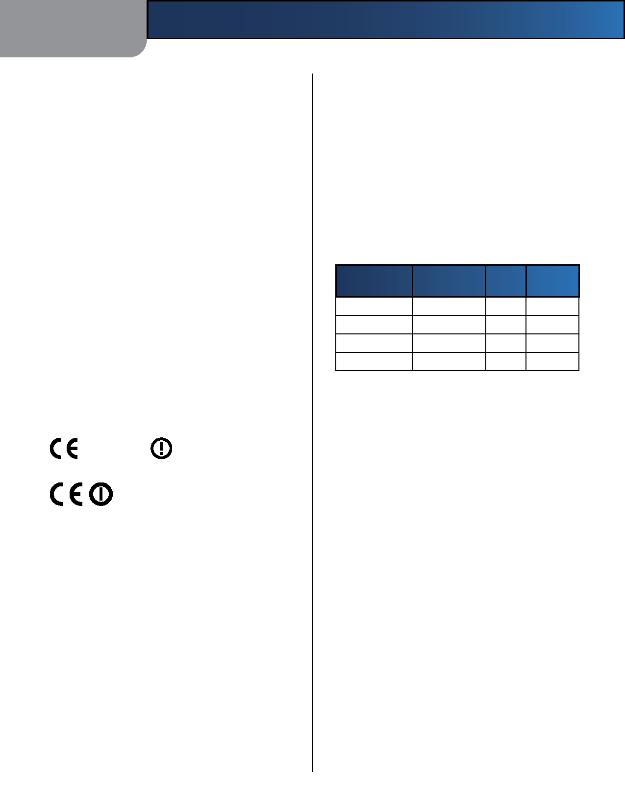
Appendix D

Wireless Equipment (Wireless-N/G/A/B
Products)
The following standards were applied during the
assessment of the product against the requirements of
the Directive 1999/5/EC:
Regulatory Information

In the majority of the EU and other European countries, the 2,4- and 5-GHz bands have been made available for the use of wireless local area networks (LANs). The table labeled "Overview of Regulatory Requirements for Wireless LANs" provides an overview of the regulatory
requirements applicable for the 2,4- and 5-GHz bands.
Later in this document you will find an overview of

•
••
Radio: EN 300 328 and/or EN 301 893 as applicable
EMC: EN 301 489-1, EN 301 489-17
Safety: EN 60950 and either EN 50385 or EN 50371
countries in which additional restrictions or requirements or both are applicable.
The requirements for any country may evolve. Linksys

Dynamic Frequency Selection (DFS) and Transmit Power
Control (TPC) are required for operation in the 5 GHz band.
DFS: The equipment meets the DFS requirements as
defined in ETSI EN 301 893. This feature is required by
recommends that you check with the local authorities for the latest status of their national regulations for both the 2,4- and 5-GHz wireless LANs.

Overview of Regulatory Requirements for Wireless LANs

the regulations to avoid interference with Radio Location Services (radars).
TPC: For operation in the 5 GHz band, the maximum power
level is 3 dB or more below the applicable limit. As such, TPC is not required.
CE Marking
Frequency
Band (MHz)

2400-2483,5
5150-5250

5250-5350†

5470-5725†
Max Power Level
(EIRP) (mW)

100
200 200
1000
Indoor
ONLY

X
X
Indoor &
Outdoor

X

X

For the Linksys Wireless-N, -G, -B, and/or -A products,
the following CE mark, notified body number (where applicable), and class 2 identifier are added to the equipment.
†Dynamic Frequency Selection and Transmit Power Control are required
in the frequency ranges of 5250-5350 MHz and 5470-5725 MHz.

The following countries have restrictions and/or requirements in addition to those given in the table labeled "Overview of Regulatory Requirements for

or
XXXX
Wireless LANs":
Croatia
License is required in the band 5150-5350 MHz.
Za pojas od 5150-5350 MHz potrebna je licenca.

Check the CE label on the product to find out which
notified body was involved during the assessment.
National Restrictions
This product may be used in all EU countries (and other
countries following the EU directive 1999/5/EC) without any limitation except for the countries mentioned below:
Ce produit peut être utilisé dans tous les pays de l'UE (et dans
tous les pays ayant transposés la directive 1999/5/CE) sans aucune limitation, excepté pour les pays mentionnés ci-
dessous:
Questo prodotto è utilizzabile in tutte i paesi EU (ed in tutti
gli altri paesi che seguono le direttive EU 1999/5/EC) senza nessuna limitazione, eccetto per i paesi menzionati di
seguito:
Das Produkt kann in allen EU Staaten ohne Einschränkungen
eingesetzt werden (sowie in anderen Staaten die der EU Direktive 1999/5/CE folgen) mit Außnahme der folgenden
aufgeführten Staaten:
Wireless-N Home Router
Denmark
In Denmark, the band 5150 - 5350 MHz is also allowed for
outdoor usage.
I Danmark må frekvensbåndet 5150 - 5350 også anvendes
udendørs.
France
For 2,4 GHz, the product is allowed to be used outdoors
in the band 2454 - 2483,5 MHz with the condition of eirp limited to 10mW (10 dBm). When operating in the band 2400-2454 MHz, it is restricted for indoor and outdoor use with eirp limited to 100mW (20 dBm). Check http://www.arcep.fr/ for more details.
Pour la bande 2,4 GHz, l'équipement peut être utilisé en
extérieur dans la bande 2 454 - 2 483,5 MHz, seulement si la puissance PIRE ne dépasse pas 10 mW (10 dBm). Lors du fonctionnement dans la bande 2 400 - 2 454 MHz, l'utilisation est limitée en intérieur et en extérieur avec une

36

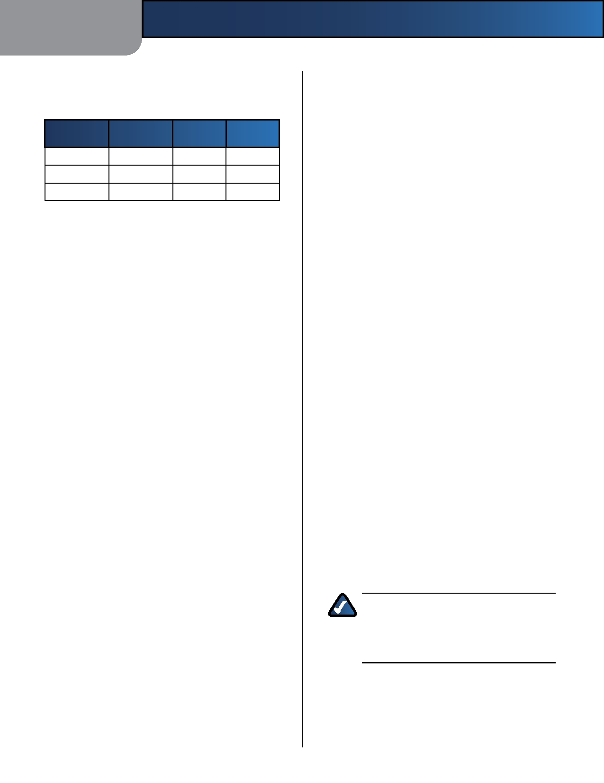
Appendix D

puissance PIRE de à 100 mW (20 dBm) maximum. Consultez http://www.arcep.fr/ pour de plus amples détails.

2,4 GHz Restrictions
Regulatory Information

Applicable Power Levels in France
This product is designed for use with the standard, integral or dedicated (external) antenna(s) that is/are shipped together with the equipment. However, some applications

Frequency
Band (MHz)
2400-2454
2454-2483,5 2454-2483,5

Italy
Power Level
(EIRP), (mW)
100 (20 dBm)
100 (20 dBm)
10 (10 dBm)
Indoor

X
X
Outdoor

X

X
may require the antenna(s), if removable, to be separated from the product and installed remotely from the device by using extension cables. For these applications, Linksys offers an R-SMA extension cable (AC9SMA) and an R-TNC extension cable (AC9TNC). Both of these cables are 9 meters long and have a cable loss (attenuation) of 5 dB. To compensate for the attenuation, Linksys also offers higher gain antennas, the HGA7S (with R-SMA connector) and HGA7T (with R-TNC connector). These antennas have a

This product meets the National Radio Interface and
the requirements specified in the National Frequency Allocation Table for Italy. Unless this 2,4-GHz wireless LAN product is operating within the boundaries of the owner's property, its use requires a"general authorization". Bands 5150-5350 MHz and 5470-5725 MHz require general authorization if used outdoors. Please check http://www.comunicazioni.it/it/ for more details.
Questo prodotto è conforme alla specifiche di Interfaccia
Radio Nazionali e rispetta il Piano Nazionale di ripartizione delle frequenze in Italia. Se non viene installato all'interno del proprio fondo, l'utilizzo di prodotti Wireless LAN a 2,4 GHz richiede una "Autorizzazione Generale". L'utilizzo all'aperto delle bande di frequenza 5150-5350 MHz e 5470- 5725 MHz è soggetto ad autorizzazione generale. Consultare http://www.comunicazioni.it/it/ per maggiori dettagli.
Latvia
The outdoor usage of the 2,4 GHz band requires an
authorization from the Electronic Communications Office. Please check http://www.esd.lv for more details.
2,4 GHz frekveču joslas izmantošanai ārpus telpām
nepieciešama atļauja no Elektronisko sakaru direkcijas. Vairāk informācijas: http://www.esd.lv.
Notes:
1. Although Norway, Switzerland and Liechtenstein are
not EU member states, the EU Directive 1999/5/EC has also been implemented in those countries.
2. The regulatory limits for maximum output power are
specified in EIRP. The EIRP level of a device can be calculated by adding the gain of the antenna used (specified in dBi) to the output power available at the connector (specified in dBm).
Product Usage Restrictions
This product is designed for indoor usage only. Outdoor
usage is not recommended, unless otherwise noted.
gain of 7 dBi and may only be used with either the R-SMA or R-TNC extension cable.
Combinations of extension cables and antennas resulting
in a radiated power level exceeding 100 mW EIRP are illegal.
Third-Party Software or Firmware
The use of software or firmware not supported/provided
by Linksys may result that the equipment is no longer compliant with the regulatory requirements.
Technical Documents on
www.linksysbycisco.com/international
Follow these steps to access technical documents:
1. Enter http://www.linksysbycisco.com/international
in your web browser.
2. Select the country or region in which you live. 3. Click the Products tab.
4. Select the appropriate product category.
5. Select the product sub-category, if necessary. 6. Select the product.
7. Select the type of documentation you want from the
More Information section. The document will open in PDF format if you have Adobe Acrobat installed on your computer.

NOTE: If you have questions regarding
the compliance of this product or you cannot find the information you need, please contact your local sales office or visit
www.linksysbycisco.com/international

Wireless-N Home Router 37

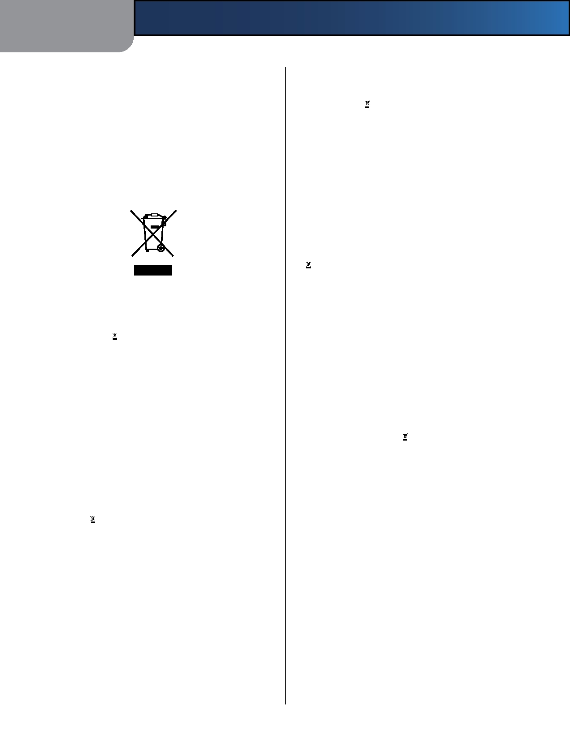
Appendix D

User Information for Consumer Products
Covered by EU Directive 2002/96/EC on
Waste Electric and Electronic Equipment
(WEEE)
This document contains important information for users
with regards to the proper disposal and recycling of Linksys products. Consumers are required to comply with this notice for all electronic products bearing the following
symbol:

English - Environmental Information for Customers in
the European Union
European Directive 2002/96/EC requires that the equipment
bearing this symbol on the product and/or its packaging must not be disposed of with unsorted municipal waste. The symbol indicates that this product should be disposed of separately from regular household waste streams. It is your responsibility to dispose of this and other electric and electronic equipment via designated collection facilities appointed by the government or local authorities. Correct disposal and recycling will help prevent potential negative consequences to the environment and human health. For more detailed information about the disposal of your old equipment, please contact your local authorities, waste disposal service, or the shop where you purchased the product.

Български (Bulgarian) - Информация относно
опазването на околната среда за потребители в
Европейския съюз
Европейска директива 2002/96/EC изисква уредите, носещи
този символ върху изделието и/или опаковката му, да не се изхвърля т с несортирани битови отпадъци. Символът обозначава, че изделието трябва да се изхвърля отделно от сметосъбирането на обикновените битови отпадъци. Ваша е отговорността този и другите електрически и електронни уреди да се изхвърлят в предварително определени от държавните или общински органи специализирани пунктове за събиране. Правилното изхвърляне и рециклиране ще спомогнат да се предотвратят евентуални вредни за околната среда и здравето на населението последствия. За по-подробна информация относно изхвърлянето на вашите стари уреди се обърнете към местните власти, службите за
сметосъбиране или магазина, от който сте закупили уреда.
Regulatory Information

Čeština (Czech) - Informace o ochraně životního
prostředí pro zákazníky v zemích Evropské unie
Evropská směrnice 2002/96/ES zakazuje, aby zařízení označené
tímto symbolem na produktu anebo na obalu bylo likvidováno s netříděným komunálním odpadem. Tento symbol udává, že daný produkt musí být likvidován odděleně od běžného komunálního odpadu. Odpovídáte za likvidaci tohoto produktu a dalších elektrických a elektronických zařízení prostřednictvím určených sběrných míst stanovených vládou nebo místními úřady. Správná likvidace a recyklace pomáhá předcházet potenciálním negativním dopadům na životní prostředí a lidské zdraví. Podrobnější informace o likvidaci starého vybavení si laskavě vyžádejte od místních úřadů, podniku zabývajícího se likvidací komunálních odpadů nebo obchodu, kde jste produkt zakoupili.

Dansk (Danish) - Miljøinformation for kunder i EU
EU-direktiv 2002/96/EF kræver, at udstyr der bærer dette symbol
på produktet og/eller emballagen ikke må bortskaffes som usorteret kommunalt affald. Symbolet betyder, at dette produkt skal bortskaffes adskilt fra det almindelige husholdningsaffald. Det er dit ansvar at bortskaffe dette og andet elektrisk og elektronisk udstyr via bestemte indsamlingssteder udpeget af staten eller de lokale myndigheder. Korrekt bortskaffelse og genvinding vil hjælpe med til at undgå mulige skader for miljøet og menneskers sundhed. Kontakt venligst de lokale myndigheder, renovationstjenesten eller den butik, hvor du har købt produktet, angående mere detaljeret information om bortskaffelse af dit gamle udstyr.

Deutsch (German) - Umweltinformation für Kunden
innerhalb der Europäischen Union
Die Europäische Richtlinie 2002/96/EC verlangt, dass technische
Ausrüstung, die direkt am Gerät und/oder an der Verpackung mit diesem Symbol versehen ist , nicht zusammen mit unsortiertem Gemeindeabfall entsorgt werden darf. Das Symbol weist darauf hin, dass das Produkt von regulärem Haushaltmüll getrennt entsorgt werden sollte. Es liegt in Ihrer Verantwortung, dieses Gerät und andere elektrische und elektronische Geräte über die dafür zuständigen und von der Regierung oder örtlichen Behörden dazu bestimmten Sammelstellen zu entsorgen. Ordnungsgemäßes Entsorgen und Recyceln trägt dazu bei, potentielle negative Folgen für Umwelt und die menschliche Gesundheit zu vermeiden. Wenn Sie weitere Informationen zur Entsorgung Ihrer Altgeräte benötigen, wenden Sie sich bitte an die örtlichen Behörden oder städtischen Entsorgungsdienste oder an den Händler, bei dem Sie das Produkt erworben haben.

Wireless-N Home Router 38


Appendix D

Eesti (Estonian) - Keskkonnaalane informatsioon
Euroopa Liidus asuvatele klientidele
Euroopa Liidu direktiivi 2002/96/EÜ nõuete kohaselt on
seadmeid, millel on tootel või pakendil käesolev sümbol , keelatud kõrvaldada koos sorteerimata olmejäätmetega. See sümbol näitab, et toode tuleks kõrvaldada eraldi tavalistest olmejäätmevoogudest. Olete kohustatud kõrvaldama käesoleva ja ka muud elektri- ja elektroonikaseadmed riigi või kohalike ametiasutuste poolt ette nähtud kogumispunktide kaudu. Seadmete korrektne kõrvaldamine ja ringlussevõtt aitab vältida võimalikke negatiivseid tagajärgi keskkonnale ning inimeste tervisele. Vanade seadmete kõrvaldamise kohta täpsema informatsiooni saamiseks võtke palun ühendust kohalike ametiasutustega, jäätmekäitlusfirmaga või kauplusega, kust te toote ostsite.

Español (Spanish) - Información medioambiental para
clientes de la Unión Europea
La Directiva 2002/96/CE de la UE exige que los equipos que
lleven este símbolo en el propio aparato y/o en su embalaje no deben eliminarse junto con otros residuos urbanos no
Regulatory Information

Français (French) - Informations environnementales
pour les clients de l'Union européenne
La directive européenne 2002/96/CE exige que l'équipement
sur lequel est apposé ce symbole sur le produit et/ou son emballage ne soit pas jeté avec les autres ordures ménagères. Ce symbole indique que le produit doit être éliminé dans un circuit distinct de celui pour les déchets des ménages. Il est de votre responsabilité de jeter ce matériel ainsi que tout autre matériel électrique ou électronique par les moyens de collecte indiqués par le gouvernement et les pouvoirs publics des collectivités territoriales. L'élimination et le recyclage en bonne et due forme ont pour but de lutter contre l'impact néfaste potentiel de ce type de produits sur l'environnement et la santé publique. Pour plus d'informations sur le mode d'élimination de votre ancien équipement, veuillez prendre contact avec les pouvoirs publics locaux, le service de traitement des déchets, ou l'endroit où vous avez acheté le produit.

Italiano (Italian) - Informazioni relative all'ambiente
per i clienti residenti nell'Unione Europea
La direttiva europea 2002/96/EC richiede che le apparecchiature

seleccionados. El símbolo indica que el producto en cuestión contrassegnate con questo simbolo sul prodotto e/o

debe separarse de los residuos domésticos convencionales con vistas a su eliminación. Es responsabilidad suya desechar este y cualesquiera otros aparatos eléctricos y electrónicos a través de los puntos de recogida que ponen a su disposición el gobierno y las autoridades locales. Al desechar y reciclar correctamente estos aparatos estará contribuyendo a evitar posibles consecuencias negativas para el medio ambiente y la salud de las personas. Si desea obtener información más detallada sobre la eliminación segura de su aparato usado, consulte a las autoridades locales, al servicio de recogida y eliminación de residuos de su zona o pregunte en la tienda donde adquirió el producto.

Ελληνικά (Greek) - Στοιχεία περιβαλλοντικής
προστασίας για πελάτες εντός της Ευρωπαϊκής
Ένωσης
Σύμφωνα με την Κοινοτική Οδηγία 2002/96/EC, ο εξοπλισμός που
φέρει αυτό το σύμβολο στο προϊόν ή/και τη συσκευασία του δεν πρέπει να απορρίπτεται μαζί με τα μη διαχωρισμένα αστικά απορρίμματα. Το σύμβολο υποδεικνύει ότι αυτό το προϊόν θα πρέπει να απορρίπτεται ξεχωριστά από τα συνήθη οικιακά απορρίμματα. Είστε υπεύθυνος για την απόρριψη του παρόντος και άλλου ηλεκτρικού και ηλεκτρονικού εξοπλισμού μέσω των καθορισμένων εγκαταστάσεων συγκέντρωσης απορριμμάτων, οι οποίες ορίζονται από το κράτος ή τις αρμόδιες τοπικές αρχές. Η σωστή απόρριψη και ανακύκλωση συμβάλλει στην πρόληψη ενδεχόμενων αρνητικών επιπτώσεων στο περιβάλλον και την υγεία. Για περισσότερες πληροφορίες σχετικά με την απόρριψη του παλαιού σας εξοπλισμού, επικοινωνήστε με τις τοπικές αρχές, τις υπηρεσίες αποκομιδής απορριμμάτων ή το κατάστημα από το οποίο αγοράσατε το προϊόν.
sull'imballaggio non siano smaltite insieme ai rifiuti urbani non differenziati. Il simbolo indica che questo prodotto non deve essere smaltito insieme ai normali rifiuti domestici. È responsabilità del proprietario smaltire sia questi prodotti sia le altre apparecchiature elettriche ed elettroniche mediante le specifiche strutture di raccolta indicate dal governo o dagli enti pubblici locali. Il corretto smaltimento ed il riciclaggio aiuteranno a prevenire conseguenze potenzialmente negative per l'ambiente e per la salute dell'essere umano. Per ricevere informazioni più dettagliate circa lo smaltimento delle vecchie apparecchiature in Vostro possesso, Vi invitiamo a contattare gli enti pubblici di competenza, il servizio di smaltimento rifiuti o il negozio nel quale avete acquistato il prodotto.

Latviešu valoda (Latvian) - Ekoloģiska informācija
klientiem Eiropas Savienības jurisdikcijā
Direktīvā 2002/96/EK ir prasība, ka aprīkojumu, kam pievienota
zīme uz paša izstrādājuma vai uz tā iesaiņojuma, nedrīkst izmest nešķirotā veidā kopā ar komunālajiem atkritumiem (tiem, ko rada vietēji iedzīvotāji un uzņēmumi). Šī zīme nozīmē to, ka šī ierīce ir jāizmet atkritumos tā, lai tā nenonāktu kopā ar parastiem mājsaimniecības atkritumiem. Jūsu pienākums ir šo un citas elektriskas un elektroniskas ierīces izmest atkritumos, izmantojot īpašus atkritumu savākšanas veidus un līdzekļus, ko nodrošina valsts un pašvaldību iestādes. Ja izmešana atkritumos un pārstrāde tiek veikta pareizi, tad mazinās iespējamais kaitējums dabai un cilvēku veselībai. Sīkākas ziņas par novecojuša aprīkojuma izmešanu atkritumos jūs varat saņemt vietējā pašvaldībā, atkritumu savākšanas dienestā, kā arī veikalā, kur iegādājāties šo izstrādājumu.

Wireless-N Home Router 39


Appendix D

Lietuvškai (Lithuanian) - Aplinkosaugos informacija,
skirta Europos Sąjungos vartotojams
Europos direktyva 2002/96/EC numato, kad įrangos, kuri ir
kurios pakuotė yra pažymėta šiuo simboliu (įveskite simbolį), negalima šalinti kartu su nerūšiuotomis komunalinėmis atliekomis. Šis simbolis rodo, kad gaminį reikia šalinti atskirai nuo bendro buitinių atliekų srauto. Jūs privalote užtikrinti, kad ši ir kita elektros ar elektroninė įranga būtų šalinama per tam tikras nacionalinės ar vietinės valdžios nustatytas atliekų rinkimo sistemas. Tinkamai šalinant ir perdirbant atliekas, bus išvengta galimos žalos aplinkai ir žmonių sveikatai. Daugiau informacijos apie jūsų senos įrangos šalinimą gali pateikti vietinės valdžios institucijos, atliekų šalinimo tarnybos arba parduotuvės, kuriose įsigijote tą gaminį.

Malti (Maltese) - Informazzjoni Ambjentali għal Klijenti
fl-Unjoni Ewropea
Id-Direttiva Ewropea 2002/96/KE titlob li t-tagħmir li jkun fih
Regulatory Information

Nederlands (Dutch) - Milieu-informatie voor klanten
in de Europese Unie
De Europese Richtlijn 2002/96/EC schrijft voor dat apparatuur die
is voorzien van dit symbool op het product of de verpakking, niet mag worden ingezameld met niet-gescheiden huishoudelijk afval. Dit symbool geeft aan dat het product apart moet worden ingezameld. U bent zelf verantwoordelijk voor de vernietiging van deze en andere elektrische en elektronische apparatuur via de daarvoor door de landelijke of plaatselijke overheid aangewezen inzamelingskanalen. De juiste vernietiging en recycling van deze apparatuur voorkomt mogelijke negatieve gevolgen voor het milieu en de gezondheid. Voor meer informatie over het vernietigen van uw oude apparatuur neemt u contact op met de plaatselijke autoriteiten of afvalverwerkingsdienst, of met de winkel waar u het product hebt aangeschaft.

Norsk (Norwegian) - Miljøinformasjon for kunder i EU
EU-direktiv 2002/96/EF krever at utstyr med følgende symbol

is-simbolu fuq il-prodott u/jew fuq l-ippakkjar ma jistax avbildet på produktet og/eller pakningen, ikke må kastes

jintrema ma' skart muniċipali li ma ġiex isseparat. Is-simbolu jindika li dan il-prodott għandu jintrema separatament minn ma' l-iskart domestiku regolari. Hija responsabbiltà tiegħek li tarmi dan it-tagħmir u kull tagħmir ieħor ta' l-elettriku u elettroniku permezz ta' faċilitajiet ta' ġbir appuntati apposta mill-gvern jew mill-awtoritajiet lokali. Ir-rimi b'mod korrett u r-riċiklaġġ jgħin jipprevjeni konsegwenzi negattivi potenzjali għall-ambjent u għas-saħħa tal-bniedem. Għal aktar informazzjoni dettaljata dwar ir-rimi tat-tagħmir antik tiegħek, jekk jogħġbok ikkuntattja lill-awtoritajiet lokali tiegħek, is-servizzi għar-rimi ta' l-iskart, jew il-ħanut minn fejn xtrajt il-prodott.

Magyar (Hungarian) - Környezetvédelmi információ az
európai uniós vásárlók számára
A 2002/96/EC számú európai uniós irányelv megkívánja, hogy
azokat a termékeket, amelyeken, és/vagy amelyek csomagolásán az alábbi címke megjelenik, tilos a többi szelektálatlan lakossági hulladékkal együtt kidobni. A címke azt jelöli, hogy az adott termék kidobásakor a szokványos háztartási hulladékelszállítási rendszerektõl elkülönített eljárást kell alkalmazni. Az Ön felelõssége, hogy ezt, és más elektromos és elektronikus berendezéseit a kormányzati vagy a helyi hatóságok által kijelölt gyűjtõredszereken keresztül számolja fel. A megfelelõ hulladékfeldolgozás segít a környezetre és az emberi egészségre potenciálisan ártalmas negatív hatások megelõzésében. Ha elavult berendezéseinek felszámolásához további részletes információra van szüksége, kérjük, lépjen kapcsolatba a helyi hatóságokkal, a hulladékfeldolgozási szolgálattal, vagy azzal üzlettel, ahol a terméket vásárolta.
sammen med usortert avfall. Symbolet indikerer at dette produktet skal håndteres atskilt fra ordinær avfallsinnsamling for husholdningsavfall. Det er ditt ansvar å kvitte deg med dette produktet og annet elektrisk og elektronisk avfall via egne innsamlingsordninger slik myndighetene eller kommunene bestemmer. Korrekt avfallshåndtering og gjenvinning vil være med på å forhindre mulige negative konsekvenser for miljø og helse. For nærmere informasjon om håndtering av det kasserte utstyret ditt, kan du ta kontakt med kommunen, en innsamlingsstasjon for avfall eller butikken der du kjøpte produktet.

Polski (Polish) - Informacja dla klientów w Unii
Europejskiej o przepisach dotyczących ochrony
środowiska
Dyrektywa Europejska 2002/96/EC wymaga, aby sprzęt
oznaczony symbolem znajdującym się na produkcie i/lub jego opakowaniu nie był wyrzucany razem z innymi niesortowanymi odpadami komunalnymi. Symbol ten wskazuje, że produkt nie powinien być usuwany razem ze zwykłymi odpadami z gospodarstw domowych. Na Państwu spoczywa obowiązek wyrzucania tego i innych urządzeń elektrycznych oraz elektronicznychwpunktachodbioruwyznaczonychprzezwładze krajowe lub lokalne. Pozbywanie się sprzętu we właściwy sposób i jego recykling pomogą zapobiec potencjalnie negatywnym konsekwencjom dla środowiska i zdrowia ludzkiego. W celu uzyskania szczegółowych informacji o usuwaniu starego sprzętu, prosimy zwrócić się do lokalnych władz, służb oczyszczania miasta lub sklepu, w którym produkt został nabyty.

Wireless-N Home Router 40


Appendix D

Português (Portuguese) - Informação ambiental para
clientes da União Europeia
A Directiva Europeia 2002/96/CE exige que o equipamento
que exibe este símbolo no produto e/ou na sua embalagem não seja eliminado junto com os resíduos municipais não separados. O símbolo indica que este produto deve ser eliminado separadamente dos resíduos domésticos regulares. É da sua responsabilidade eliminar este e qualquer outro equipamento eléctrico e electrónico através das instalações de recolha designadas pelas autoridades governamentais ou locais. A eliminação e reciclagem correctas ajudarão a prevenir as consequências negativas para o ambiente e para a saúde humana. Para obter informações mais detalhadas sobre a forma de eliminar o seu equipamento antigo, contacte as autoridades locais, os serviços de eliminação de resíduos ou o estabelecimento comercial onde adquiriu o produto.
Regulatory Information

Slovenščina (Slovene) - Okoljske informacije za stranke
v Evropski uniji
Evropska direktiva 2002/96/ES prepoveduje odlaganje opreme s
tem simbolom - na izdelku in/ali na embalaži z nesortiranimi komunalnimi odpadki. Ta simbol opozarja, da je treba izdelek zavreči ločeno od preostalih gospodinjskih odpadkov. Vaša odgovornost je, da to in preostalo električno in elektronsko opremo oddate na posebna zbirališča, ki jih določijo državne ustanove ali lokalne oblasti. S pravilnim odlaganjem in recikliranjem boste preprečili morebitne škodljive vplive na okolje in zdravje ljudi. Če želite izvedeti več o odlaganju stare opreme, se obrnite na lokalne oblasti, odlagališče odpadkov ali trgovino, kjer ste izdelek kupili.

Suomi (Finnish) - Ympäristöä koskevia tietoja EU-
alueen asiakkaille
EU-direktiivi 2002/96/EY edellyttää, että jos laitteistossa on tämä

Română (Romanian) - Informaţii de mediu pentru
symboli
itse tuotteessa ja/tai sen pakkauksessa, laitteistoa

clienţii din Uniunea Europeană
Directiva europeană 2002/96/CE impune ca echipamentele care
prezintă acest simbol pe produs şi/sau pe ambalajul acestuia să nu fie casate împreună cu gunoiul menajer municipal. Simbolul indică faptul că acest produs trebuie să fie casat separat de gunoiul menajer obişnuit. Este responsabilitatea dvs. să casaţi acest produs şi alte echipamente electrice şi electronice prin intermediul unităţilor de colectare special desemnate de guvern sau de autorităţile locale. Casarea şi reciclarea corecte vor ajuta la prevenirea potenţialelor consecinţe negative asupra sănătăţii mediului şi a oamenilor. Pentru mai multe informaţii detaliate cu privire la casarea acestui echipament vechi, contactaţi autorităţile locale, serviciul de salubrizare sau magazinul de la care aţi achiziţionat produsul.

Slovenčina (Slovak) - Informácie o ochrane životného
prostredia pre zákazníkov v Európskej únii
Podľa európskej smernice 2002/96/ES zariadenie s týmto
ei saa hävittää lajittelemattoman yhdyskuntajätteen mukana. Symboli merkitsee sitä, että tämä tuote on hävitettävä erillään tavallisesta kotitalousjätteestä. Sinun vastuullasi on hävittää tämä elektroniikkatuote ja muut vastaavat elektroniikkatuotteet viemällä tuote tai tuotteet viranomaisten määräämään keräyspisteeseen. Laitteiston oikea hävittäminen estää mahdolliset kielteiset vaikutukset ympäristöön ja ihmisten terveyteen. Lisätietoja vanhan laitteiston oikeasta hävitystavasta saa paikallisilta viranomaisilta, jätteenhävityspalvelusta tai siitä myymälästä, josta ostit tuotteen.

Svenska (Swedish) - Miljöinformation för kunder i
Europeiska unionen
Det europeiska direktivet 2002/96/EC kräver att utrustning med
denna symbol på produkten och/eller förpackningen inte får kastas med osorterat kommunalt avfall. Symbolen visar att denna produktbörkastasefterattdenavskiljtsfrånvanligthushållsavfall. Det faller på ditt ansvar att kasta denna och annan elektrisk och

symbolom na produkte a/alebo jeho balení nesmie byť elektronisk utrustning på fastställda insamlingsplatser utsedda

likvidované spolu s netriedeným komunálnym odpadom. Symbol znamená, že produkt by sa mal likvidovať oddelene od bežného odpadu z domácností. Je vašou povinnosťou likvidovať toto i ostatné elektrické a elektronické zariadenia prostredníctvom špecializovaných zberných zariadení určených vládou alebo miestnymi orgánmi. Správna likvidácia a recyklácia pomôže zabrániť prípadným negatívnym dopadom na životné prostredie a zdravie ľudí. Ak máte záujem o podrobnejšie informácie o likvidácii starého zariadenia, obráťte sa, prosím, na miestne orgány, organizácie zaoberajúce sa likvidáciou odpadov alebo obchod, v ktorom ste si produkt zakúpili.
av regeringen eller lokala myndigheter. Korrekt kassering och återvinning skyddar mot eventuella negativa konsekvenser för miljön och personhälsa. För mer detaljerad information om kassering av din gamla utrustning kontaktar du dina lokala myndigheter, avfallshanteringen eller butiken där du köpte produkten.

WEB: For additional information, please visit
www.linksysbycisco.com

Wireless-N Home Router 41


Appendix E

Appendix E: Software End
User License Agreement

Cisco Products
This product from Cisco Systems, Inc. or its subsidiary
licensing the Software instead of Cisco Systems, Inc. ("Cisco")containssoftware(includingfirmware)originating from Cisco and its suppliers and may also contain software
Software End User License Agreement

THE RETURN PROCESS AND POLICIES OF THE PARTY FROM WHICH YOU PURCHASED SUCH PRODUCT OR SOFTWARE.
IN THE EVENT THAT YOU HAVE ELECTED TO OBTAIN A
SUBSCRIPTION LICENSE, AS INDICATED IN YOUR ORDER, YOU ADDITIONALLY AGREE TO BE BOUND BY THE "TERMS
OF SERVICE" SET FORTH IN SCHEDULE 2 IF APPLICABLE.
Software Licenses
The software licenses applicable to software
from Cisco are made available at the Cisco public

from the open source community.
web
site
at:
www.linksysbycisco.com
and

Any software originating from Cisco and its suppliers is
licensed under the Cisco Software License Agreement contained at Schedule 1 below. You may also be prompted toreviewandaccepttheCiscoSoftwareLicenseAgreement upon installation of the software. Separate terms and features of Network Magic, a Cisco Software product, are set forth in Schedule 2 below.
Any software from the open source community is licensed
under the specific license terms applicable to that software made available by Cisco at www.linksysbycisco.com/gpl orasprovidedforinSchedule3below.ByusingtheSoftware, you acknowledge that you have reviewed such license terms and that you agree to be bound by the terms of such licenses. Where such specific license terms entitle you to the source code of such software, that source code is available upon request at cost from Cisco for at least three years from the purchase date of this product and may also be available for download from www.linksysbycisco.com/gpl. For detailed license terms and additional information on open source software in Cisco products please look at the Cisco public web site at: www.linksysbycisco.com/gpl/ or Schedule 3 below as applicable. If you would like a copy of the GPL or certain other open source code in this Software on a CD, Cisco will mail to you a CD with such code for $9.99 plus the cost of shipping, upon request.
THIS SOFTWARE END USER LICENSE AGREEMENT IS
A LEGAL AGREEMENT BETWEEN YOU AND CISCO. READ IT CAREFULLY BEFORE INSTALLING AND USING THE SOFTWARE. IT PROVIDES A LICENSE TO USE THE SOFTWARE AND CONTAINS WARRANTY INFORMATION AND LIABILITY DISCLAIMERS. BY CHECKING THE "I ACCEPT"BOX, DOWNLOADING, INSTALLING OR USING THE SOFTWARE, OR USING THE PRODUCT CONTAINING THE SOFTWARE, YOU ARE CONFIRMING YOUR ACCEPTANCE OF THE SOFTWARE AND CONSENTING TO BE BOUND BY THIS AGREEMENT. IF YOU DO NOT AGREE TO ALL OF THESE TERMS, THEN DO NOT CLICK ON THE "I ACCEPT" BUTTON AND DO NOT DOWNLOAD, INSTALL OR USE THE SOFTWARE. YOU MAY RETURN UNUSED SOFTWARE (OR, IF THE SOFTWARE IS SUPPLIED AS PART OF ANOTHER PRODUCT, THE UNUSED PRODUCT) FOR A FULL REFUND UP TO 30 DAYS AFTER ORIGINAL PURCHASE, SUBJECT TO

Wireless-N Home Router
www.linksysbycisco.com/gpl/ respectively. For your
convenience of reference, a copy of the Cisco Software License Agreement and the main open source code licenses used by Cisco in its products are contained in the Schedules below.
Schedule 1
Cisco Software License Agreement
License. Subject to the terms and conditions of this
Agreement, Cisco grants the original end user purchaser of the Software a nonexclusive license to (i) use the Software solely as embedded in, as a stand-alone application or (where authorized in the applicable documentation) for communication with such product, each solely at Cisco's discretion; (ii) if the Software is purchased separately from any Cisco Product, install the Software on personal computers within a single household or business location according to the maximum number of licenses you have purchased; and (iii) make one copy of the Software in machine-readable form and one copy of the Documentation, solely for backup purposes. This license may not be sublicensed, and is not transferable except to a person or entity to which you transfer ownership of the complete Cisco product containing the Software or complete Software product, provided you permanently transfer all rights under this Agreement and do not retain any full or partial copies of the Software, and the recipient agrees to the terms of this Agreement.
"Software" includes, and this Agreement will apply to
(a) the software of Cisco or its suppliers purchased separately or provided in or with the applicable Cisco product, and (b) any upgrades, updates, bug fixes or modified versions ("Upgrades") or backup copies of the Software supplied to you by Cisco or an authorized reseller (whether or not for a fee), provided you already hold a valid license to the original software and have paid any applicable fee for the Upgrade.
"Documentation" means all documentation and other
related materials supplied by Cisco to you pursuant to this Agreement.
License Restrictions. Other than as set forth in this
Agreement, you may not (i) make or distribute copies

42

Appendix E

of the Software or its related Documentation, or electronically transfer the Software or Documentation from one computer to another or over a network; (ii) alter, merge, modify, adapt, decrypt or translate the Software or related Documentation, or decompile, reverse engineer, disassemble, or otherwise reduce the Software to a human-perceivable form (except to the extent expressly permitted by law notwithstanding this provision); (iii) share, sell, rent, lease, or sublicense the Software or related Documentation; (iv) modify the Software or create derivative works based upon the Software; (v) if you make a backup copy of the Software and Documentation, you must reproduce all copyright notices and any other proprietary legends found on the original Software and Documentation; (vi) use the Software for management of a business network with more than 8 computers; (vii) use the Software under any circumstances for competitive evaluation, including developing competing software; (ix) to the extent permitted under applicable law, assign, sublicense or otherwise transfer the Software unless the prospective assignee, sublicensee or transferee expressly agrees to all the terms and conditions under this Agreement.
The Software and Documentation contain trade secrets
and/or copyrighted materials of Cisco or its suppliers. You will not disclose or make available such trade secrets or copyrighted material in any form to any third party.
In the event that you fail to comply with this Agreement,
the license granted to you will automatically terminate, at which time you must immediately (i) stop using the Cisco Product in which the Software is embedded, or (ii) uninstall the Software and destroy all copies of the Software and Documentation where the Software is purchased separately. All other rights of both parties and all other provisions of this Agreement will survive this termination.
Ownership. The Software and Documentation are
licensed and not sold to you by Cisco and the relevant third parties set forth in Schedule 3. Cisco and its licensors retain all right, title and interest, including all copyright and intellectual property rights, in and to, the Software and Documentation and all copies and portions thereof. All rights not specifically granted to you in this Agreement are reserved by Cisco and its licensors. Your use of any software product from an entity other than Cisco that may have been recommended by Cisco is governed by such software product's end user license agreement.
Links and Advertising. Cisco may provide from within
the Software links to websites or third party software products that are beyond our control. Cisco makes no representations as to the quality, suitability, functionality, or legality of any sites or products to which links may be provided, and you hereby waive any claim you might have against Cisco with respect to such sites or third party software products. Your correspondence or

Wireless-N Home Router
Software End User License Agreement

business dealings with, or participation in promotions of advertisers found through the Software and any other terms, conditions, warranties, or representations associated with such dealings, are solely between you and such advertiser. You agree that Cisco is not responsible or liable for any loss or damage of any sort incurred as the result of any such dealings or as the result of the presence of such advertisers in the Cisco Software.
Collection and Processing of Information. You agree
that Cisco and/or its affiliates may, from time to time, collect and process information about your Cisco product and/or the Software and/or your use of either in order (i) to enable Cisco to offer you Upgrades; (ii) to provide support and assistance with your product and/or the Software; (iii) to ensure that your Cisco product and/or the Software is being used in accordance with the terms of this Agreement; (iv) to provide improvements to the way Cisco delivers technology to you and to other Cisco customers; (v) to provide reports regarding the status and health of the network, including network traffic and application usage; (vi) to enable Cisco to comply with the terms of any agreements it has with any third parties regarding your Cisco product and/or Software; and/or (vii) to enable Cisco to comply with all applicable laws and/or regulations, or the requirements of any regulatory authority or government agency. Cisco and/ or its affiliates may collect and process this information provided that it does not identify you personally.
The reports feature of certain Software allows you to
monitor the activity of computers running the Software in your home or small office. You must activate this feature in order to receive reports. If you activate the reports feature, you agree to the following: (a) the Software tracks and monitors the following components and activities in your home or office: network traffic (e.g. megabytes per hour), application usage (the foreground window is tracked and the time each application is in the foreground during active usage of the computer) and internet history. (b) For all computers on which reports feature is enabled, the above information is transmitted to servers at Cisco and/ or a third party at periodic intervals while the computer is online. This information is associated and stored with the email address supplied by you when you activated the reports feature. This information is summarized into a formal report and is emailed to the identified email address. (c) Any computer on the network running the Software can enable any other computer (on the same primary network) to generate reports. When a computer is enabled, that computer shows a notification that it is being monitored. As long as that computer is enabled, each time the Software is started the user of that particular computer will see a notification that it is being monitored by the reports feature. Any computer on the network with the Software installed can enable or disable any other computer from the reports feature.

43

Appendix E

In addition, Cisco may collect and store detailed information regarding your network configuration and usage for the purpose of providing you technical networking support. The information is associated with you only when you provide a unique ID number to the support representative while you are receiving help. The unique ID is generated randomly on your computer upon installation and is completely under your control.
Your use of your Cisco product and/or the Software
constitutes consent by you to Cisco's and/or its affiliates' collection and use of such information and, for European Economic Area (EEA) customers, to the transfer of such information to a location outside the EEA. Any information collected by your Cisco product and/or the Software is done and utilized in accordance with our Privacy Policy available at Privacy Statement. Your election to use the Cisco product and/or Software indicates your acceptance of the terms of the Cisco Privacy Policy, so please review the policy carefully and check the Web site above to review updates to it.
Software Upgrades etc. If the Software enables you to
receive Upgrades, you may elect at any time to receive these Upgrades either automatically or manually. If you elect to receive Upgrades manually or you otherwise elect not to receive or be notified of any Upgrades, you may expose your Cisco product and/or the Software to serious security threats and/or some features within your Cisco product and/or Software may become inaccessible. There may be circumstances where we apply an Upgrade automatically in order to comply with changes in legislation, legal, security or regulatory requirements or as a result of requirements to comply with the terms of any agreements Cisco has with any third parties regarding your Cisco product and/or the Software. You will always be notified of any Upgrades being delivered to you. The terms of this license will apply to any such Upgrade unless the Upgrade in question is accompanied by a separate license, in which event the terms of that license will apply.
Term and Termination. You may terminate this License
at any time by destroying all copies of the Software and documentation. Your rights under this License will terminate immediately without notice from Cisco if you fail to comply with any provision of this Agreement.
Limited Warranty. Cisco additionally warrants that any
media on which the Software may be provided will be free from defects in materials and workmanship under normal use for a period of ninety (90) days from the date of original purchase. Your exclusive remedy and Cisco's entire liability under this limited warranty will be for Cisco, at its option, to (a) replace the Software media, or (b) refund the purchase price of the Software media.
EXCEPT FOR THE LIMITED WARRANTY ON MEDIA SET
FORTH ABOVE ANDTOTHE MAXIMUM EXTENT PERMITTED BY APPLICABLE LAW, ALL SOFTWARE PROVIDED BY CISCO
Wireless-N Home Router
Software End User License Agreement

IS PROVIDED "AS IS" WITH ALL FAULTS AND WITHOUT WARRANTY OF ANY KIND. Without limiting the foregoing, Cisco does not warrant that the operation of the product or software will be uninterrupted or error free. Also, due to the continual development of new techniques for intruding upon and attacking networks, Cisco does not warrant that the product, software or any equipment, system or network on which the product or software is used will be free of vulnerability to intrusion or attack. The product may include or be bundled with third party software or service offerings. This limited warranty shall not apply to such third party software or service offerings. This limited warranty does not guarantee any continued availability of a third party's service for which this product's use or operation may require.
TO THE EXTENT NOT PROHIBITED BY APPLICABLE
LAW, ALL IMPLIED WARRANTIES AND CONDITIONS OF MERCHANTABILITY, SATISFACTORY QUALITY OR FITNESS FOR A PARTICULAR PURPOSE ARE LIMITED TO THE DURATION OF THE WARRANTY PERIOD. ALL OTHER EXPRESS OR IMPLIED CONDITIONS, REPRESENTATIONS AND WARRANTIES ARE DISCLAIMED. Some jurisdictions do not allow limitations on how long an implied warranty lasts, so the above limitation may not apply to you. This limited warranty gives you specific legal rights, and you may also have other rights which vary by jurisdiction.
Disclaimer of Liabilities. TO THE EXTENT NOT PROHIBITED
BY APPLICABLE LAW, IN NO EVENT WILL CISCO BE LIABLE FOR ANY LOST DATA, REVENUE OR PROFIT, OR FOR SPECIAL, INDIRECT, CONSEQUENTIAL, INCIDENTAL OR PUNITIVE DAMAGES, REGARDLESS OF THE THEORY OF LIABILITY (INCLUDING NEGLIGENCE), ARISING OUT OF OR RELATED TO THE USE OF OR INABILITY TO USE THE PRODUCT, SOFTWARE OR ANY SERVICES PROVIDED IN RESPECT OF SUCH PRODUCT OR SOFTWARE, EVEN IF CISCO HAS BEEN ADVISED OF THE POSSIBILITY OF SUCH DAMAGES. TO THE EXTENT NOT PROHIBITED BY APPLICABLE LAW, IN NO EVENT WILL CISCO'S LIABILITY EXCEED THE AMOUNT PAID BY YOU FOR THE PRODUCT. The foregoing limitations will apply even if any warranty or remedy provided under this limited warranty fails of its essential purpose.
Technical Support. This limited warranty is neither
a service nor a support contract. Information about Cisco's current technical support offerings and policies (including any fees for support services) can be found at www.linksysbycisco.com/support.
Export. Software, including technical data, may be subject
to U.S. export control laws and regulations and/or export or import regulations in other countries. You agree to comply strictly with all such laws and regulations.
U.S. Government Users.The Software and Documentation
qualify as "commercial items" as defined at 48 C.F.R. 2.101 and 48 C.F.R. 12.212. All Government users acquire the Software and Documentation with only those rights herein that apply to non-governmental customers. Use of

44

Appendix E

either the Software or Documentation or both constitutes agreement by the Government that the Software and Documentation are "commercial computer software" and "commercial computer software documentation," and constitutes acceptance of the rights and restrictions herein.
General Terms. This Agreement will be governed by and
construed in accordance with the laws of the State of California, without reference to conflict of laws principles. The United Nations Convention on Contracts for the International Sale of Goods will not apply. If any portion of this Agreement is found to be void or unenforceable, the remaining provisions will remain in full force and effect. This Agreement constitutes the entire agreement between the parties with respect to the Software and supersedes any conflicting or additional terms contained in any purchase order or elsewhere.
Linksys, Cisco and the Cisco Logo and other trademarks
contained in the Software and Documentation are trademarks or registered trademarks of Linksys, Cisco, its licensors and third parties, as the case may be. You may not remove or alter any trademark, trade names, product names, logo, copyright or other proprietary notices, legends, symbols or labels in the Software and Documentation. This Agreement does not authorize you to use Cisco's or its licensors' names or respective trademarks.
END OF SCHEDULE 1
Schedule 2
Network Magic Features
Network Magic License Restrictions. Other than as set
forth in this Agreement, you may not install or execute the Network Magic Software on any non-personal computer product, including, but not limited to, a Web appliance, set top box, handheld device, phone, Web pad device, or any device running the Microsoft Windows CE operating system.
Terms of Service for Subscription Licenses. These Terms
of Service only apply if you have obtained a subscription license to Network Magic as specified in your order.
1. Network Magic Cancellation. You may cancel the
Services at any time. If you cancel the Services, Cisco will not be obligated to provide you any Network Magic product Upgrades. To the extent not prohibited by applicable law, you understand and agree that cancellation of your Services is your sole remedy with respect to any dispute with Cisco.
2. Modifications. Cisco may modify or cancel the terms of
thisAgreementortheprice,content,ornatureoftheServices (including discontinuing the Services program), upon notice to you. If Cisco modifies any of these terms, you may cancel the Service by providing written notice to Cisco via

Wireless-N Home Router
Software End User License Agreement

www.networkmagic.com/support of such cancellation
and uninstalling the Software and discontinuing your use of the Service. Cisco may provide notice by e-mail, via Network Magic, or by publishing the changes on its Web site.
3. Email Notification. Cisco may send you email from time
to time to let you know about new products and services that are available to you. You will be able to opt-out of receiving these emails using the link provided within the email. Cisco reserves the right, however, to send you Service relatedemailmessagesaslongasyouareasubscribertothe Service. If you wish to opt-out of receiving Service related email messages, you may cancel the Service by providing written notice via www.networkmagic.com/support to Cisco of such cancellation and uninstalling the Software and discontinuing your use of the Service.
4. WARRANTY DISCLAIMER FOR SERVICES. TO THE
EXTENT NOT PROHIBITED BY APPLICABLE LAW THE SERVICES ARE PROVIDED ON AN "AS-IS" BASIS, AND CISCO AND ITS SUPPLIERS DISCLAIM ALL WARRANTIES AND REPRESENTATIONS REGARDING THE SERVICES, WHETHER EXPRESS, IMPLIED, OR OTHERWISE, INCLUDING THE WARRANTIES OF MERCHANTABILITY, FITNESS FOR A PARTICULAR PURPOSE, NON-INFRINGEMENT, TITLE, QUIET ENJOYMENT, QUALITY, AND ACCURACY. CISCO DOES NOT WARRANT THAT THE SERVICE IS ERROR-FREE OR THAT THE
SERVICE WILL OPERATE WITHOUT INTERRUPTION
END OF SCHEDULE 2
Schedule 3
Open Source and Third Party Licenses
Schedule 3-A
If this Cisco product contains open source software
licensed under Version 2 of the "GNU General Public License" then the license terms below in this Schedule 3-A will apply to that open source software. The license terms below in this Schedule 3-A are from the public web site at
http://www.gnu.org/copyleft/gpl.html
GNU GENERAL PUBLIC LICENSE
This is an unofficial translation of the GNU General Public
License into [language]. It was not published by the Free Software Foundation, and does not legally state the distribution terms for software that uses the GNU GPL— only the original English text of the GNU GPL does that. However, we hope that this translation will help [language] speakers understand the GNU GPL better.
Version 2, June 1991
Copyright © 1989, 1991 Free Software Foundation, Inc.
51 Franklin Street, Fifth Floor, Boston, MA 02110-1301,
USA

45

Appendix E

Everyone is permitted to copy and distribute verbatim copies of this license document, but changing it is not allowed.
Preamble
The licenses for most software are designed to take away
your freedom to share and change it. By contrast, the GNU General Public License is intended to guarantee your freedom to share and change free software--to make sure the software is free for all its users. This General Public License applies to most of the Free Software Foundation's software and to any other program whose authors commit to using it. (Some other Free Software Foundation software is covered by the GNU Lesser General Public
License instead.) You can apply it to your programs, too.
When we speak of free software, we are referring to
freedom, not price. Our General Public Licenses are designed to make sure that you have the freedom to distribute copies of free software (and charge for this service if you wish), that you receive source code or can get it if you want it, that you can change the software or use pieces of it in new free programs; and that you know you can do these things.
To protect your rights, we need to make restrictions that
forbid anyone to deny you these rights or to ask you to surrender the rights. These restrictions translate to certain responsibilities for you if you distribute copies of the software, or if you modify it.
For example, if you distribute copies of such a program,
whether gratis or for a fee, you must give the recipients all the rights that you have. You must make sure that they, too, receive or can get the source code. And you must show them these terms so they know their rights.
We protect your rights with two steps: (1) copyright the
software, and (2) offer you this license which gives you legal permission to copy, distribute and/or modify the software.
Also, for each author's protection and ours, we want to
make certain that everyone understands that there is no warranty for this free software. If the software is modified by someone else and passed on, we want its recipients to know that what they have is not the original, so that any problems introduced by others will not reflect on the original authors' reputations.
Finally, any free program is threatened constantly by
software patents. We wish to avoid the danger that redistributors of a free program will individually obtain patent licenses, in effect making the program proprietary. To prevent this, we have made it clear that any patent must
be licensed for everyone's free use or not licensed at all.
The precise terms and conditions for copying, distribution
and modification follow.

Wireless-N Home Router
Software End User License Agreement

TERMS AND CONDITIONS FOR COPYING, DISTRIBUTION AND
MODIFICATION
0. This License applies to any program or other work
which contains a notice placed by the copyright holder saying it may be distributed under the terms of this General Public License. The "Program", below, refers to any such program or work, and a "work based on the Program" means either the Program or any derivative work under copyright law: that is to say, a work containing the Program or a portion of it, either verbatim or with modifications and/ or translated into another language. (Hereinafter, translation is included without limitation in the term "modification".) Each licensee is addressed as "you".

Activities other than copying, distribution and modification are not covered by this License; they are outside its scope. The act of running the Program is not restricted, and the output from the Program is covered only if its contents constitute a work based on the Program (independent of having been made by running the Program). Whether that is true depends on what the Program does.
1. You may copy and distribute verbatim copies of the
Program's source code as you receive it, in any medium, provided that you conspicuously and appropriately publish on each copy an appropriate copyright notice and disclaimer of warranty; keep intact all the notices that refer to this License and to the absence of any warranty; and give any other recipients of the Program a copy of this License along with the Program.

You may charge a fee for the physical act of transferring a copy, and you may at your option offer warranty protection in exchange for a fee.
2. You may modify your copy or copies of the Program
or any portion of it, thus forming a work based on the Program, and copy and distribute such modifications or work under the terms of Section 1 above, provided
that you also meet all of these conditions:
a. You must cause the modified files to carry
prominent notices stating that you changed the files and the date of any change.
b. You must cause any work that you distribute or
publish, that in whole or in part contains or is derived from the Program or any part thereof, to be licensed as a whole at no charge to all third parties under the terms of this License.

46

Appendix E

c. If the modified program normally reads commands
interactively when run, you must cause it, when started running for such interactive use in the most ordinary way, to print or display an announcement including an appropriate copyright notice and a notice that there is no warranty (or else, saying that you provide a warranty) and that users may redistribute the program under these conditions, and telling the user how to view a copy of this License. (Exception: if the Program itself is interactive but does not normally print such an announcement, your work based on the Program
is not required to print an announcement.)
These requirements apply to the modified work as
a whole. If identifiable sections of that work are not derived from the Program, and can be reasonably considered independent and separate works in themselves, then this License, and its terms, do not apply to those sections when you distribute them as separate works. But when you distribute the same sections as part of a whole which is a work based on the Program, the distribution of the whole must be on the terms of this License, whose permissions for other licensees extend to the entire whole, and thus to each and every part regardless of who wrote it.
Thus, it is not the intent of this section to claim rights
or contest your rights to work written entirely by you; rather, the intent is to exercise the right to control the distribution of derivative or collective works based on the Program.
In addition, mere aggregation of another work not
based on the Program with the Program (or with a work based on the Program) on a volume of a storage or distribution medium does not bring the other work under the scope of this License.
3. You may copy and distribute the Program (or a
work based on it, under Section 2) in object code or executable form under the terms of Sections 1 and 2 above provided that you also do one of the following:
a. Accompany it with the complete corresponding
machine-readable source code, which must be distributed under the terms of Sections 1 and 2 above on a medium customarily used for software
interchange; or,
b. Accompany it with a written offer, valid for at least
three years, to give any third party, for a charge no more than your cost of physically performing source distribution, a complete machine-readable copy of the corresponding source code, to be distributed under the terms of Sections 1 and 2 above on a medium customarily used for software
interchange; or,
Software End User License Agreement

c. Accompany it with the information you received as
to the offer to distribute corresponding source code. (This alternative is allowed only for noncommercial distribution and only if you received the program in object code or executable form with such an
offer, in accord with Subsection b above.)
The source code for a work means the preferred form
of the work for making modifications to it. For an executable work, complete source code means all the source code for all modules it contains, plus any associated interface definition files, plus the scripts used to control compilation and installation of the executable. However, as a special exception, the source code distributed need not include anything that is normally distributed (in either source or binary form) with the major components (compiler, kernel, and so on) of the operating system on which the executable runs, unless that component itself accompanies the executable.
If distribution of executable or object code is made
by offering access to copy from a designated place, then offering equivalent access to copy the source code from the same place counts as distribution of the source code, even though third parties are not compelled to copy the source along with the object code.
4. You may not copy, modify, sublicense, or distribute
the Program except as expressly provided under this License. Any attempt otherwise to copy, modify, sublicense or distribute the Program is void, and will automatically terminate your rights under this License. However, parties who have received copies, or rights, from you under this License will not have their licenses terminated so long as such parties remain in full compliance.
5. You are not required to accept this License, since you
have not signed it. However, nothing else grants you permission to modify or distribute the Program or its derivative works. These actions are prohibited by law if you do not accept this License. Therefore, by modifying or distributing the Program (or any work based on the Program), you indicate your acceptance of this License to do so, and all its terms and conditions for copying, distributing or modifying the Program or works based on it.
6. Each time you redistribute the Program (or any work
based on the Program), the recipient automatically receives a license from the original licensor to copy, distribute or modify the Program subject to these terms and conditions. You may not impose any further restrictions on the recipients' exercise of the rights granted herein. You are not responsible for enforcing compliance by third parties to this License.

Wireless-N Home Router 47

Appendix E

7. If, as a consequence of a court judgment or allegation
of patent infringement or for any other reason (not limited to patent issues), conditions are imposed on you (whether by court order, agreement or otherwise) that contradict the conditions of this License, they do not excuse you from the conditions of this License. If you cannot distribute so as to satisfy simultaneously your obligations under this License and any other pertinent obligations, then as a consequence you may not distribute the Program at all. For example, if a patent license would not permit royalty-free redistribution of the Program by all those who receive copies directly or indirectly through you, then the only way you could satisfy both it and this License would be to refrain entirely from distribution of the Program.
If any portion of this section is held invalid or
unenforceable under any particular circumstance, the balance of the section is intended to apply and the section as a whole is intended to apply in other circumstances.
It is not the purpose of this section to induce you to
infringe any patents or other property right claims or to contest validity of any such claims; this section has the sole purpose of protecting the integrity of the free software distribution system, which is implemented by public license practices. Many people have made generous contributions to the wide range of software distributed through that system in reliance on consistent application of that system; it is up to the author/donor to decide if he or she is willing to distribute software through any other system and a licensee cannot impose that choice.
This section is intended to make thoroughly clear
what is believed to be a consequence of the rest of this License.
8. If the distribution and/or use of the Program is
restricted in certain countries either by patents or by copyrighted interfaces, the original copyright holder who places the Program under this License may add an explicit geographical distribution limitation excluding those countries, so that distribution is permitted only in or among countries not thus excluded. In such case, this License incorporates the limitation as if written in the body of this License.
9. The Free Software Foundation may publish revised
and/or new versions of the General Public License from time to time. Such new versions will be similar in spirit to the present version, but may differ in detail to address new problems or concerns.
Each version is given a distinguishing version number.
If the Program specifies a version number of this License which applies to it and "any later version", you have the option of following the terms and conditions either of that version or of any later version published by the Free Software Foundation. If the Program does
Wireless-N Home Router
Software End User License Agreement

not specify a version number of this License, you may choose any version ever published by the Free Software Foundation.
10. If you wish to incorporate parts of the Program into
other free programs whose distribution conditions are different, write to the author to ask for permission. For software which is copyrighted by the Free Software Foundation, write to the Free Software Foundation; we sometimes make exceptions for this. Our decision will be guided by the two goals of preserving the free status of all derivatives of our free software and of promoting the sharing and reuse of software generally.
NO WARRANTY
11. BECAUSETHE PROGRAM IS LICENSED FREE OF CHARGE,
THERE IS NO WARRANTY FOR THE PROGRAM, TO THE EXTENT PERMITTED BY APPLICABLE LAW. EXCEPT WHEN OTHERWISE STATED INWRITINGTHE COPYRIGHT HOLDERS AND/OR OTHER PARTIES PROVIDE THE PROGRAM "AS IS" WITHOUT WARRANTY OF ANY KIND, EITHER EXPRESSED OR IMPLIED, INCLUDING, BUT NOT LIMITED TO, THE IMPLIED WARRANTIES OF MERCHANTABILITY AND FITNESS FOR A PARTICULAR PURPOSE. THE ENTIRE RISK AS TO THE QUALITY AND PERFORMANCE OF THE PROGRAM IS WITH YOU. SHOULD THE PROGRAM PROVE DEFECTIVE, YOU ASSUME THE COST OF ALL NECESSARY SERVICING, REPAIR OR CORRECTION.
12. INNOEVENTUNLESSREQUIREDBYAPPLICABLELAWOR
AGREEDTO INWRITINGWILL ANY COPYRIGHT HOLDER, OR ANY OTHER PARTY WHO MAY MODIFY AND/OR REDISTRIBUTE THE PROGRAM AS PERMITTED ABOVE, BE LIABLE TO YOU FOR DAMAGES, INCLUDING ANY GENERAL, SPECIAL, INCIDENTAL OR CONSEQUENTIAL DAMAGES ARISING OUT OF THE USE OR INABILITY TO USE THE PROGRAM (INCLUDING BUT NOT LIMITED TO LOSS OF DATA OR DATA BEING RENDERED INACCURATE OR LOSSES SUSTAINED BY YOU OR THIRD PARTIES OR A FAILURE OF THE PROGRAM TO OPERATE WITH ANY OTHER PROGRAMS), EVEN IF SUCH HOLDER OR OTHER PARTY HAS BEEN ADVISED OF THE POSSIBILITY OF SUCH DAMAGES.
END OF TERMS AND CONDITIONS
END OF SCHEDULE 3-A
Schedule 3-B
IfthisCiscoproductcontainsopensourcesoftwarelicensed
under Version 2.1 of the "GNU Lesser General Public License" then the license terms below in this Schedule 3-B will apply to that open source software. The license terms below in this Schedule 3-B are from the public web site at http://www.gnu.org/licenses/old-licenses/lgpl-2.1.html

48

Appendix E

GNU LESSER GENERAL PUBLIC LICENSE
This is an unofficial translation of the GNU Lesser General
Public License into [language]. It was not published by the Free Software Foundation, and does not legally state the distribution terms for software that uses the GNU LGPL— only the original English text of the GNU LGPL does that. However, we hope that this translation will help [language] speakers understand the GNU LGPL better.
Version 2.1, February 1999
Copyright (C) 1991, 1999 Free Software Foundation, Inc.
51 Franklin Street, Fifth Floor, Boston, MA 02110-1301,
USA
Everyone is permitted to copy and distribute verbatim
copies of this license document, but changing it is not allowed.
[This is the first released version of the Lesser GPL. It also
counts as the successor of the GNU Library Public License,
version 2, hence the version number 2.1.]
Preamble
The licenses for most software are designed to take away
your freedom to share and change it. By contrast, the GNU General Public Licenses are intended to guarantee your freedom to share and change free software—to make sure the software is free for all its users.
This license, the Lesser General Public License, applies to
some specially designated software packages—typically libraries—of the Free Software Foundation and other authors who decide to use it. You can use it too, but we suggest you first think carefully about whether this license or the ordinary General Public License is the better strategy to use in any particular case, based on the explanations below.
When we speak of free software, we are referring to
freedom of use, not price. Our General Public Licenses are designed to make sure that you have the freedom to distribute copies of free software (and charge for this service if you wish); that you receive source code or can get it if you want it; that you can change the software and use pieces of it in new free programs; and that you are informed that you can do these things.
To protect your rights, we need to make restrictions that
forbid distributors to deny you these rights or to ask you to surrender these rights. These restrictions translate to certain responsibilities for you if you distribute copies of the library or if you modify it.
For example, if you distribute copies of the library,
whether gratis or for a fee, you must give the recipients all the rights that we gave you. You must make sure that they, too, receive or can get the source code. If you link other code with the library, you must provide complete object files to the recipients, so that they can relink them

Wireless-N Home Router
Software End User License Agreement

with the library after making changes to the library and recompiling it. And you must show them these terms so they know their rights.
We protect your rights with a two-step method: (1) we
copyright the library, and (2) we offer you this license, which gives you legal permission to copy, distribute and/ or modify the library.
To protect each distributor, we want to make it very clear
that there is no warranty for the free library. Also, if the library is modified by someone else and passed on, the recipients should know that what they have is not the original version, so that the original author's reputation will not be affected by problems that might be introduced by others.
Finally, software patents pose a constant threat to the
existence of any free program. We wish to make sure that a company cannot effectively restrict the users of a free program by obtaining a restrictive license from a patent holder. Therefore, we insist that any patent license obtained for a version of the library must be consistent with the full freedom of use specified in this license.
Most GNU software, including some libraries, is covered
by the ordinary GNU General Public License. This license, the GNU Lesser General Public License, applies to certain designated libraries, and is quite different from the ordinary General Public License. We use this license for certain libraries in order to permit linking those libraries into non-free programs.
When a program is linked with a library, whether
statically or using a shared library, the combination of the two is legally speaking a combined work, a derivative of the original library. The ordinary General Public License therefore permits such linking only if the entire combination fits its criteria of freedom. The Lesser General Public License permits more lax criteria for linking other code with the library.
We call this license the "Lesser" General Public License
because it does Less to protect the user's freedom than the ordinary General Public License. It also provides other free software developers Less of an advantage over competing non-free programs. These disadvantages are the reason we use the ordinary General Public License for many libraries. However, the Lesser license provides advantages in certain special circumstances.
For example, on rare occasions, there may be a special
need to encourage the widest possible use of a certain library, so that it becomes a de-facto standard. To achieve this, non-free programs must be allowed to use the library. A more frequent case is that a free library does the same job as widely used non-free libraries. In this case, there is little to gain by limiting the free library to free software only, so we use the Lesser General Public License.

49

Appendix E

In other cases, permission to use a particular library in non- free programs enables a greater number of people to use a large body of free software. For example, permission to use the GNU C Library in non-free programs enables many more people to use the whole GNU operating system, as well as its variant, the GNU/Linux operating system.
Although the Lesser General Public License is Less
protective of the users' freedom, it does ensure that the user of a program that is linked with the Library has the freedom and the wherewithal to run that program using a modified version of the Library.
The precise terms and conditions for copying, distribution
and modification follow. Pay close attention to the difference between a "work based on the library" and a "work that uses the library". The former contains code derived from the library, whereas the latter must be combined with the library in order to run.
GNU LESSER GENERAL PUBLIC LICENSE

TERMS AND CONDITIONS FOR COPYING, DISTRIBUTION AND
MODIFICATION
0. This License Agreement applies to any software library
or other program which contains a notice placed by the copyright holder or other authorized party saying it may be distributed under the terms of this Lesser General Public License (also called "this License"). Each licensee is addressed as "you".
A "library" means a collection of software functions
and/or data prepared so as to be conveniently linked with application programs (which use some of those functions and data) to form executables.
The "Library", below, refers to any such software library
or work which has been distributed under these terms. A "work based on the Library" means either the Library or any derivative work under copyright law: that is to say, a work containing the Library or a portion of it, either verbatim or with modifications and/or translated straightforwardly into another language. (Hereinafter, translation is included without limitation in the term
"modification".)
"Source code" for a work means the preferred form of
the work for making modifications to it. For a library, complete source code means all the source code for all modules it contains, plus any associated interface definition files, plus the scripts used to control compilation and installation of the library.
Activities other than copying, distribution and
modification are not covered by this License; they are outside its scope. The act of running a program using the Library is not restricted, and output from such a program is covered only if its contents constitute a work based on the Library (independent of the use of the Library in a tool for writing it). Whether that is

Wireless-N Home Router
Software End User License Agreement

true depends on what the Library does and what the program that uses the Library does.
1. You may copy and distribute verbatim copies of the
Library's complete source code as you receive it, in any medium, provided that you conspicuously and appropriately publish on each copy an appropriate copyright notice and disclaimer of warranty; keep intact all the notices that refer to this License and to the absence of any warranty; and distribute a copy of this License along with the Library.
You may charge a fee for the physical act of transferring
a copy, and you may at your option offer warranty protection in exchange for a fee.
2. You may modify your copy or copies of the Library or
any portion of it, thus forming a work based on the Library, and copy and distribute such modifications or work under the terms of Section 1 above, provided
that you also meet all of these conditions:
a) The modified work must itself be a software
library.
b) You must cause the files modified to carry
prominent notices stating that you changed the files and the date of any change.
c) You must cause the whole of the work to be
licensed at no charge to all third parties under the terms of this License.
d) If a facility in the modified Library refers to a function
or a table of data to be supplied by an application program that uses the facility, other than as an argument passed when the facility is invoked, then you must make a good faith effort to ensure that, in the event an application does not supply such function or table, the facility still operates, and performs whatever part of its purpose remains meaningful.
(For example, a function in a library to compute
square roots has a purpose that is entirely well- defined independent of the application. Therefore, Subsection 2d requires that any application- supplied function or table used by this function must be optional: if the application does not supply it, the square root function must still compute
square roots.)
These requirements apply to the modified work as
a whole. If identifiable sections of that work are not derived from the Library, and can be reasonably considered independent and separate works in themselves, then this License, and its terms, do not apply to those sections when you distribute them as separate works. But when you distribute the same sections as part of a whole which is a work based on the Library, the distribution of the whole must be on the terms of this License, whose

50

Appendix E

permissions for other licensees extend to the entire whole, and thus to each and every part regardless of who wrote it.
Thus, it is not the intent of this section to claim
rights or contest your rights to work written entirely by you; rather, the intent is to exercise the right to control the distribution of derivative or collective works based on the Library.
In addition, mere aggregation of another work
not based on the Library with the Library (or with a work based on the Library) on a volume of a storage or distribution medium does not bring the other work under the scope of this License.
3. You may opt to apply the terms of the ordinary GNU
General Public License instead of this License to a given copy of the Library. To do this, you must alter all the notices that refer to this License, so that they refer to the ordinary GNU General Public License, version 2, instead of to this License. (If a newer version than version 2 of the ordinary GNU General Public License has appeared, then you can specify that version instead if you wish.) Do not make any other change in these notices.
Once this change is made in a given copy, it is
irreversible for that copy, so the ordinary GNU General Public License applies to all subsequent copies and derivative works made from that copy.
This option is useful when you wish to copy part of the
code of the Library into a program that is not a library.
4. You may copy and distribute the Library (or a portion
or derivative of it, under Section 2) in object code or executable form under the terms of Sections 1 and 2 above provided that you accompany it with the complete corresponding machine-readable source code, which must be distributed under the terms of Sections 1 and 2 above on a medium customarily used for software interchange.
If distribution of object code is made by offering
access to copy from a designated place, then offering equivalent access to copy the source code from the same place satisfies the requirement to distribute the source code, even though third parties are not compelled to copy the source along with the object code.
5. A program that contains no derivative of any portion
of the Library, but is designed to work with the Library by being compiled or linked with it, is called a "work that uses the Library". Such a work, in isolation, is not a derivative work of the Library, and therefore falls outside the scope of this License.
However, linking a "work that uses the Library" with
the Library creates an executable that is a derivative of the Library (because it contains portions of the

Wireless-N Home Router
Software End User License Agreement

Library), rather than a "work that uses the library". The executable is therefore covered by this License. Section 6 states terms for distribution of such executables.
When a "work that uses the Library" uses material from
a header file that is part of the Library, the object code for the work may be a derivative work of the Library even though the source code is not. Whether this is true is especially significant if the work can be linked without the Library, or if the work is itself a library. The threshold for this to be true is not precisely defined by law.
If such an object file uses only numerical parameters,
data structure layouts and accessors, and small macros and small inline functions (ten lines or less in length), then the use of the object file is unrestricted, regardless of whether it is legally a derivative work. (Executables containing this object code plus portions of the Library
will still fall under Section 6.)
Otherwise, if the work is a derivative of the Library, you
may distribute the object code for the work under the terms of Section 6. Any executables containing that work also fall under Section 6, whether or not they are linked directly with the Library itself.
6. As an exception to the Sections above, you may also
combine or link a "work that uses the Library" with the Library to produce a work containing portions of the Library, and distribute that work under terms of your choice, provided that the terms permit modification of the work for the customer's own use and reverse engineering for debugging such modifications.
You must give prominent notice with each copy of
the work that the Library is used in it and that the Library and its use are covered by this License. You must supply a copy of this License. If the work during execution displays copyright notices, you must include the copyright notice for the Library among them, as well as a reference directing the user to the copy of this
License. Also, you must do one of these things:
a) Accompany the work with the complete
corresponding machine-readable source code for the Library including whatever changes were used in the work (which must be distributed under Sections 1 and 2 above); and, if the work is an executable linked with the Library, with the complete machine-readable "work that uses the Library", as object code and/or source code, so that the user can modify the Library and then relink to produce a modified executable containing the modified Library. (It is understood that the user who changes the contents of definitions files in the Library will not necessarily be able to recompile the
application to use the modified definitions.)

51

Appendix E

b) Use a suitable shared library mechanism for linking
with the Library. A suitable mechanism is one that (1) uses at run time a copy of the library already present on the user's computer system, rather than copying library functions into the executable, and (2) will operate properly with a modified version of the library, if the user installs one, as long as the modified version is interface-compatible with the version that the work was made with.
c) Accompany the work with a written offer, valid
for at least three years, to give the same user the materials specified in Subsection 6a, above, for a charge no more than the cost of performing this distribution.
d) If distribution of the work is made by offering access
to copy from a designated place, offer equivalent access to copy the above specified materials from the same place.
e) Verify that the user has already received a copy of
these materials or that you have already sent this user a copy.
For an executable, the required form of the "work that
uses the Library" must include any data and utility programs needed for reproducing the executable from it. However, as a special exception, the materials to be distributed need not include anything that is normally distributed (in either source or binary form) with the major components (compiler, kernel, and so on) of the operating system on which the executable runs, unless that component itself accompanies the executable.
It may happen that this requirement contradicts the
license restrictions of other proprietary libraries that do not normally accompany the operating system. Such a contradiction means you cannot use both them and the Library together in an executable that you distribute.
7. You may place library facilities that are a work based
on the Library side-by-side in a single library together with other library facilities not covered by this License, and distribute such a combined library, provided that the separate distribution of the work based on the Library and of the other library facilities is otherwise permitted, and provided that you do these two
things:
a) Accompany the combined library with a copy of the
same work based on the Library, uncombined with any other library facilities. This must be distributed under the terms of the Sections above.
b) Give prominent notice with the combined library of
the fact that part of it is a work based on the Library, and explaining where to find the accompanying uncombined form of the same work.

Wireless-N Home Router
Software End User License Agreement

8. You may not copy, modify, sublicense, link with, or
distribute the Library except as expressly provided under this License. Any attempt otherwise to copy, modify, sublicense, link with, or distribute the Library is void, and will automatically terminate your rights under this License. However, parties who have received copies, or rights, from you under this License will not have their licenses terminated so long as such parties remain in full compliance.
9. You are not required to accept this License, since you
have not signed it. However, nothing else grants you permission to modify or distribute the Library or its derivative works. These actions are prohibited by law if you do not accept this License. Therefore, by modifying or distributing the Library (or any work based on the Library), you indicate your acceptance of this License to do so, and all its terms and conditions for copying, distributing or modifying the Library or works based on it.
10. Each time you redistribute the Library (or any work
based on the Library), the recipient automatically receives a license from the original licensor to copy, distribute, link with or modify the Library subject to these terms and conditions. You may not impose any further restrictions on the recipients' exercise of the rights granted herein. You are not responsible for enforcing compliance by third parties with this License.
11. If, as a consequence of a court judgment or allegation
of patent infringement or for any other reason (not limited to patent issues), conditions are imposed on you (whether by court order, agreement or otherwise) that contradict the conditions of this License, they do not excuse you from the conditions of this License. If you cannot distribute so as to satisfy simultaneously your obligations under this License and any other pertinent obligations, then as a consequence you may not distribute the Library at all. For example, if a patent license would not permit royalty-free redistribution of the Library by all those who receive copies directly or indirectly through you, then the only way you could satisfy both it and this License would be to refrain entirely from distribution of the Library.
If any portion of this section is held invalid or
unenforceable under any particular circumstance, the balance of the section is intended to apply, and the section as a whole is intended to apply in other circumstances.
It is not the purpose of this section to induce you to
infringe any patents or other property right claims or to contest validity of any such claims; this section has the sole purpose of protecting the integrity of the free software distribution system which is implemented by public license practices. Many people have made generous contributions to the wide range of

52

Appendix E

software distributed through that system in reliance on consistent application of that system; it is up to the author/donor to decide if he or she is willing to distribute software through any other system and a licensee cannot impose that choice.
This section is intended to make thoroughly clear
what is believed to be a consequence of the rest of this License.
12. If the distribution and/or use of the Library is restricted
in certain countries either by patents or by copyrighted interfaces, the original copyright holder who places the Library under this License may add an explicit geographical distribution limitation excluding those countries, so that distribution is permitted only in or among countries not thus excluded. In such case, this License incorporates the limitation as if written in the body of this License.
13. The Free Software Foundation may publish revised
and/or new versions of the Lesser General Public License from time to time. Such new versions will be similar in spirit to the present version, but may differ in detail to address new problems or concerns.
Each version is given a distinguishing version number.
If the Library specifies a version number of this License which applies to it and "any later version", you have the option of following the terms and conditions either of that version or of any later version published by the Free Software Foundation. If the Library does not specify a license version number, you may choose any version ever published by the Free Software Foundation.
14. If you wish to incorporate parts of the Library into
other free programs whose distribution conditions are incompatible with these, write to the author to ask for permission. For software which is copyrighted by the Free Software Foundation, write to the Free Software Foundation; we sometimes make exceptions for this. Our decision will be guided by the two goals of preserving the free status of all derivatives of our free software and of promoting the sharing and reuse of software generally.

Wireless-N Home Router
Software End User License Agreement

NO WARRANTY
15. BECAUSE THE LIBRARY IS LICENSED FREE OF CHARGE,
THERE IS NO WARRANTY FOR THE LIBRARY, TO THE EXTENT PERMITTED BY APPLICABLE LAW. EXCEPT WHEN OTHERWISE STATED INWRITINGTHE COPYRIGHT HOLDERS AND/OR OTHER PARTIES PROVIDE THE LIBRARY "AS IS" WITHOUT WARRANTY OF ANY KIND, EITHER EXPRESSED OR IMPLIED, INCLUDING, BUT NOT LIMITED TO, THE IMPLIED WARRANTIES OF MERCHANTABILITY AND FITNESS FOR A PARTICULAR PURPOSE. THE ENTIRE RISK AS TO THE QUALITY AND PERFORMANCE OF THE LIBRARY IS WITH YOU. SHOULD THE LIBRARY PROVE DEFECTIVE, YOU ASSUME THE COST OF ALL NECESSARY SERVICING, REPAIR OR CORRECTION.
16. IN NO EVENT UNLESS REQUIRED BY APPLICABLE LAW
OR AGREED TO IN WRITING WILL ANY COPYRIGHT HOLDER, OR ANY OTHER PARTY WHO MAY MODIFY AND/OR REDISTRIBUTE THE LIBRARY AS PERMITTED ABOVE, BE LIABLE TO YOU FOR DAMAGES, INCLUDING ANY GENERAL, SPECIAL, INCIDENTAL OR CONSEQUENTIAL DAMAGES ARISING OUT OF THE USE OR INABILITY TO USE THE LIBRARY (INCLUDING BUT NOT LIMITED TO LOSS OF DATA OR DATA BEING RENDERED INACCURATE OR LOSSES SUSTAINED BY YOU OR THIRD PARTIES OR A FAILURE OF THE LIBRARY TO OPERATE WITH ANY OTHER SOFTWARE), EVEN IF SUCH HOLDER OR OTHER PARTY HAS BEEN ADVISED OF THE POSSIBILITY OF SUCH DAMAGES.
END OF TERMS AND CONDITIONS
END OF SCHEDULE 3-B

Schedule 3-C
OPENSSL LICENSE
If this Cisco product contains open source software
licensed under the OpenSSL license:
This product includes software developed by the
OpenSSL Project for use in the OpenSSL Toolkit. (http://www.openssl.org/).
This product includes cryptographic software written
by Eric Young (eay@cryptsoft.com).
This product includes software written by Tim Hudson
(tjh@cryptsoft.com).
In addition, if this Cisco product contains open source
software licensed under the OpenSSL license then the license terms below in this Schedule 3-C will apply to that open source software. The license terms below in this Schedule 3-C are from the public web site at http://www.openssl.org/source/license.html.

53

Appendix E

The OpenSSL toolkit stays under a dual license, i.e. both the conditions of the OpenSSL License and the original SSLeay license apply to the toolkit. See below for the actual license texts. Actually both licenses are BSD-style Open Source licenses. In case of any license issues related to OpenSSL please contact openssl-core@openssl.org.
OpenSSL License
Copyright © 1998-2007 The OpenSSL Project. All rights
reserved.
Redistribution and use in source and binary forms, with
or without modification, are permitted provided that the
following conditions are met:
1. Redistributions of source code must retain the above
copyright notice, this list of conditions and the following disclaimer.
2. Redistributions in binary form must reproduce the
above copyright notice, this list of conditions and the following disclaimer in the documentation and/or other materials provided with the distribution.
3. All advertising materials mentioning features or
use of this software must display the following acknowledgment: "This product includes software developed by the OpenSSL Project for use in the
OpenSSL Toolkit. (http://www.openssl.org/)"
4. The names "OpenSSL Toolkit" and "OpenSSL Project"
must not be used to endorse or promote products derived from this software without prior written permission. For written permission, please contact openssl-core@openssl.org.
5. Products derived from this software may not be called
"OpenSSL" nor may "OpenSSL" appear in their names without prior written permission of the OpenSSL Project.
6. Redistributions of any form whatsoever must retain
the following acknowledgment:"This product includes software developed by the OpenSSL Project for use in
the OpenSSL Toolkit (http://www.openssl.org/)"
THIS SOFTWARE IS PROVIDED BY THE OpenSSL PROJECT
"AS IS" AND ANY EXPRESSED OR IMPLIED WARRANTIES, INCLUDING, BUT NOT LIMITED TO, THE IMPLIED WARRANTIES OF MERCHANTABILITY AND FITNESS FOR A PARTICULAR PURPOSE ARE DISCLAIMED. IN NO EVENT SHALL THE OpenSSL PROJECT OR ITS CONTRIBUTORS BE LIABLE FOR ANY DIRECT, INDIRECT, INCIDENTAL, SPECIAL, EXEMPLARY, OR CONSEQUENTIAL DAMAGES (INCLUDING, BUT NOT LIMITED TO, PROCUREMENT OF SUBSTITUTE GOODS OR SERVICES; LOSS OF USE, DATA, OR PROFITS; OR BUSINESS INTERRUPTION) HOWEVER CAUSED AND ON ANY THEORY OF LIABILITY, WHETHER IN CONTRACT, STRICT LIABILITY, OR TORT (INCLUDING NEGLIGENCE OR OTHERWISE) ARISING IN ANY WAY OUT OF THE USE OF THIS SOFTWARE, EVEN IF ADVISED OF THE POSSIBILITY OF SUCH DAMAGE.

Wireless-N Home Router
Software End User License Agreement

This product includes cryptographic software written by Eric Young (eay@cryptsoft.com). This product includes software written by Tim Hudson (tjh@cryptsoft.com).
Original SSLeay License
Copyright © 1995-1998 Eric Young (eay@cryptsoft.com)
All rights reserved.
This package is an SSL implementation written by Eric
Young (eay@cryptsoft.com).
The implementation was written so as to conform with
Netscape's SSL.
This library is free for commercial and non-commercial
use as long as the following conditions are adhered to. The following conditions apply to all code found in this distribution, be it the RC4, RSA, lhash, DES, etc., code; not just the SSL code. The SSL documentation included with this distribution is covered by the same copyright terms except that the holder is Tim Hudson (tjh@cryptsoft. com).
Copyright remains Eric Young's, and as such any Copyright
notices in the code are not to be removed.
If this package is used in a product, Eric Young should be
given attribution as the author of the parts of the library used. This can be in the form of a textual message at program startup or in documentation (online or textual) provided with the package.
Redistribution and use in source and binary forms, with
or without modification, are permitted provided that the
following conditions are met:
1. Redistributions of source code must retain the
copyright notice, this list of conditions and the following disclaimer.
2. Redistributions in binary form must reproduce the
above copyright notice, this list of conditions and the following disclaimer in the documentation and/or other materials provided with the distribution.
3. All advertising materials mentioning features or
use of this software must display the following
acknowledgement:
"This product includes cryptographic software written
by Eric Young (eay@cryptsoft.com)"
The word 'cryptographic' can be left out if the routines
from the library being used are not cryptographic related.
4. If you include anyWindows specific code (or a derivative
thereof ) from the apps directory (application code) you must include an acknowledgement: "This product includes software written by Tim Hudson (tjh@
cryptsoft.com)"
THIS SOFTWARE IS PROVIDED BY ERIC YOUNG "AS IS" AND
ANY EXPRESS OR IMPLIED WARRANTIES, INCLUDING,

54

Appendix E

BUT NOT LIMITED TO, THE IMPLIED WARRANTIES OF MERCHANTABILITY AND FITNESS FOR A PARTICULAR PURPOSE ARE DISCLAIMED. IN NO EVENT SHALL THE AUTHOR OR CONTRIBUTORS BE LIABLE FOR ANY DIRECT, INDIRECT, INCIDENTAL, SPECIAL, EXEMPLARY, OR CONSEQUENTIAL DAMAGES (INCLUDING, BUT NOT LIMITED TO, PROCUREMENT OF SUBSTITUTE GOODS OR SERVICES; LOSS OF USE, DATA, OR PROFITS; OR BUSINESS INTERRUPTION) HOWEVER CAUSED AND ON ANY THEORY OF LIABILITY, WHETHER IN CONTRACT, STRICT LIABILITY, OR TORT (INCLUDING NEGLIGENCE OR OTHERWISE) ARISING IN ANY WAY OUT OF THE USE OF THIS SOFTWARE, EVEN IF ADVISED OF THE POSSIBILITY OF SUCH DAMAGE.
The license and distribution terms for any publicly available
version or derivative of this code cannot be changed. i.e. this code cannot simply be copied and put under another
distribution license [including the GNU Public License.]
END OF SCHEDULE 3-C
Software End User License Agreement

9031310NC-JL
Wireless-N Home Router 55

