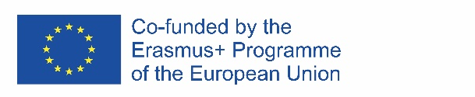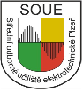
Erasmus+ Programme – Strategic Partnership
Project Nr: 2017-1-CZ01-KA219-035417_1
Project: Folk heritage around the Europe - keep our traditions
The project is built on the basic concept of European integration, which is richness in diversity.
The general objective of the project is using modern technology and methods of students and teachers teamwork from different European countries to recognize cultural differences and unifying elements in the context of the unique history of each country and the common history of Europe. This also reflects the choice of partner countries and specific schools.
The specific objective is realization of five activities and creating the same number of outputs. The main goal of activities will be recognizing the open air museums of national history – ethnographic museums in partners´ countries, meeting original crafts, seeing how the national heritage is kept for the future in each country, learning national traditions etc. The main method used in the project activities will be Experiential Education. This method enables support of creative approaches, active negotiations, creating better informal relations and particularly intense learning from experience. The basic activity will constitute the workshops, which will be implemented in the context of learning activities.
Each output will have a general part (open air museums of national history – ethnographic museums, original crafts, original recipes, traditions, festivals ...), which will enable comparison and specific part. Each of the participating schools will process an output with emphasis on the area in which the school is unique and possesses unique know-how and contacts to competent experts and institutions in this area and therefore where there is potential for the transfer of these unique skills. These outputs will be dealt with in advance of relevant learning activities and interactive way then presented to participants from other countries using external experts, lectures, workshops, exhibitions, sightseeing tours and excursions. Based on feedback from these events the outputs will be processed to their final form.
Participating pupils and other users of created outputs we want to show that the history, culture and traditions of individual countries are vital part of society, they can be known by a fun and interactive way to contribute understanding and development of cooperation between European nations. Participants will know a different culture and customs, but also they learn to think about their own culture and traditions in a broader context.
Activities done:
Transnational meeting of teachers in the Czech Republic: September 15 – 17, 2017
Activity in the Czech republic October 15 – 21, 2017

Participating schools:
Střední odborné učiliště elektrotechnické, Plzeň, the Czech Republic
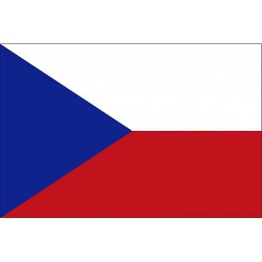
Liceul Technologic "SFANTUL PANTELIMON", Bucharest, Romania
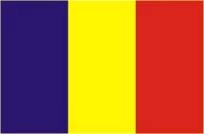
Centro de Enseñanzas Greguerias Sociedad Cooperativa Andaluza, San Sebastian, Spain
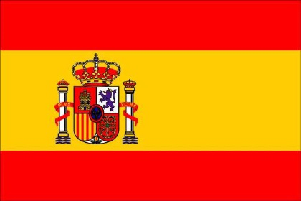
Gminne Centrum Edukacji w Wawrzenczycach, Poland
Liceo Linguistico Paritario Sant'Apollinare, Roma, Italy
